Reusable Amberlyst 16 catalyst for acetic acid esterification relevant for pyrolysis bio-oil upgrading process
Mangesh R. Avhad*, Miriam V. Osborg, Jorge M. Marchetti
Faculty of Science and Technology, Norwegian University of Life Sciences, Drøbakveien 31, Ås 1432, Norway.
* Correspondence and requests for materials should be addressed to M.R. Avhad (E-mail: avhad.mangesh@ymail.com).

Abstract
The current research article addresses the ability of heterogeneous Amberlyst 16 to catalyze the esterification reaction between acetic acid and ethanol, as well as the modelling of the chemical kinetics. The effects of pretreatment, reaction temperature, ethanol-to-acid molar ratio, catalyst dose and time on the rate of ethyl acetate production were systematically investigated. Furthermore, the recyclability of Amberlyst 16 to accelerate the esterification reaction was carefully examined. Amberlyst 16 was found to be a suitable catalyst for this process giving a final conversion of 93.3 % using reaction temperature of 60 ºC, ethanol-to-acid molar ratio of 6:1, catalyst dose of 10 wt. % and 200 rpm stirring intensity after 1680 min, and can be successfully utilized for 4 recycle tests. A detailed kinetic model has been developed and tested for the described process, which was based on a four-step mechanism equivalent to the Langmuir-Hinshelwood one. It was found that that the esterification reaction occurred between ethoxide ions and acetic acid chemisorbed on the neighboring catalytic surfaces, whereas, the overall process was controlled by the surface reaction step.

Keywords: Acetic acid; Amberlyst 16; Esterification; Ethyl acetate; Kinetic modeling.

- Introduction
Carboxylic acid esters are commercially important fine chemicals that have a wide range of applications. Ethyl acetate finds its high relevance as biodiesel and an intermediate in food, paints, coatings, inks and adhesives industries [1, 2]. The demand for ethyl acetate was augmented by more than 80 % from 2004 to 2011. The global ethyl acetate production in 2012 has been recognized to be 3.12 million tonnes. China is the dominant producer of ethyl acetate followed by India, United Kingdom, Japan and Brazil. These five nations together produced over 2.57 million tonnes of ethyl acetate in the year 2012 [3, 4]. Its increasing utilization is in favor with the ecosystem by minimizing the usage of aromatic compounds such as, toluene that has hazardous effects on the environment and human health [5]. There are several routes tested for both laboratory- and industrial-scale production of ethyl acetate [6]. One of the possible methodologies for the synthesis of this valuable chemical is the esterification process between acetic acid and ethanol. The acetic acid esterification process is valuable also in upgrading of pyrolysis bio-oils. The removal acetic acid impurities is reported to improve bio-oil stability [7, 8]. Esterification is a single-step reaction in which an acid molecule reacts with a molecule of alcohol to yield a single molecule of both esters and water [8]. In general, a catalytic material is utilized to accelerate the rate of ethyl acetate production. The rate of the acid-catalyzed esterification reaction is faster than that of the non-catalytic process because the acid catalyst functions as a proton donor for the protolysis of the carboxylic acid [8, 9]. The available literature suggests the use of either inorganic mineral acids such as, sulfuric acid, hydrochloric acid, or organic acids such as, p-toluene sulfonic acid to catalyze the esterification processes [8-13]. Although the ability of homogeneous catalysts to promote the generation of reaction products using mild operating parameters have resulted in their widespread utilization, they generally are miscible in the reaction mixture; and therefore, are difficult to be removed and recycled. Moreover, use of homogeneous acid catalysts might also evolve human safety and corrosion of equipment related concerns. For these reasons, there has been reducing interest for homogeneous catalysts in the chemical industries. The technical hurdles related to the use of homogeneous catalysts is anticipated to be minimized by its replacement with a heterogeneous catalytic system. Consequently, serious scientific efforts are engaged in finding active and stable heterogeneous catalysts which would not lixiviate into the reaction medium and be used for several reaction cycles [14].
Heterogeneous catalysis significantly contributes to strengths of the modern chemical technology. This is because the advent of metals or other elements from the catalyst into the reaction products could be notably minimized, thus quenching multiple separation and purification steps. Examples of solid catalysts employed to catalyze the acetic acid esterification processes include: ion-exchange resins [15-17], acid-functionalized silica [18, 19], zeolites [20, 21] and supported heteropolyacids [22]. Ion-exchange resins have been established to be potential heterogeneous catalyst for the esterification processes because the selective adsorption of reactants and swelling nature of these materials not only accelerate the esterification reaction but also affect the equilibrium conversion. Peters et al. [20] presented a study focused on the comparison of efficiency of eight commercial acid catalysts for esterification between acetic acid and butanol, wherein it was concluded that cation-exchange resins (Smopex 101 and Amberlyst 15) displayed superior catalytic performance than sulfated zirconia and zeolites. Izci and Bodur [23] concluded that strongly acidic cation-exchange Dowex 50 Wx2 presented better catalytic performance than Amberlite IR-120 for the acetic acid butanolysis reactions because of its higher total exchange capacity, surface area and pore volume. de la Iglesia et al. [24] utilized zeolite membrane reactors packed with Amberlyst 15 for the continuous production of ethyl acetate. The reported study suggested that Mordenite membranes displayed high resistance to acidic reaction medium and enabled about 90 % acetic acid conversion for five days of experiment. With upgrading the esterification process, the necessity to understand the reaction pathway and modeling the reaction kinetics becomes of high importance because the design of an industrial-scale reactor could be based on the rate equations. Pöpken et al. [25] performed the mathematical modeling for Amberlyst 15 catalyzed production of methyl acetate, in which an independent adsorption experiments were incorporated to the kinetic expression due to swelling nature of cation-exchange resins. The Langmuir-Hinshelwood-Hougen-Watson kinetic model has been previously reported to display good fit with the experimental data for the methanolysis and butanolysis of acetic acid catalyzed by Amberlyst 15. Whereas, Tsai et al.[17] suggested that both Eley-Rideal and Langmuir-Hinshelwood-Hougen-Watson kinetic models were equally good to describe the reaction kinetics of esterification between acetic acid and methanol catalyzed by Amberlyst 36. Though literature on Amberlyst 15 and Amberlyst 36 catalyzed esterification of acetic acid with different short-chain alcohols and mathematical modeling of the respective alcoholysis process are available [17, 24-26], no studies on the use of another macroreticular strongly acidic ion-exchange resins (Amberlyst 16) to catalyze esterification between acetic acid and ethanol has been so far reported.
The endeavor of the present study is to investigate the catalytic performance of commercial cation-exchange Amberlyst 16 resins for the esterification reaction between acetic acid and ethanol. The impact of pretreatment, reaction temperature, ethanol-to-acid molar ratio, catalyst dose and time on this esterification reaction was systematically studied. The recyclability of Amberlyst 16 resins for the esterification reaction was also carefully examined. Furthermore, a mathematical model was established to describe the reaction kinetics of ethanolysis of acetic acid over the applied range of experimental conditions.

2. Materials and Methods
2.1. Materials
Amberlyst 16 (wet form) was supplied by the Dow Chemical Company (Philadelphia, USA). Its properties provided by the supplier are listed in the Table 1. Ethanol with 99.9 and 96 % purity, respectively, were purchased from Kemetyl Norge AS. Acetic acid, diethyl ether, potassium hydroxide (KOH) and phenolphthalein indicator with around 99.7 % purity were purchased from Sigma-Aldrich and utilized as received.
Table 1: Physical characteristics for Amberlyst 16 resins.
Parameters | Value
Type | Strong acid
Matrix | Macroreticular
Functional group | Sulfuric acid
Active sites concentration (dry weight) | ≤ 4.8 eq kg⁻¹
Cross-linking degree  Harmonic mean size¹  Physical form  Surface area²  Average pore diameter  Moisture content  Thermal stability | Medium (8-14 %)  0.6 to 0.8 mm  Opaque beads  30 m² g⁻¹  25 nm  52 to 58 %  130 ºC

¹Beads size that is close to the median diameter but a little smaller, and is calculated from the distribution function. ²Nitrogen BET.
2.2. Catalyst pretreatment
For test experiments purpose, a section of commercial Amberlyst 16 resins were dried in an oven (Narbetherm P300, Germany) at 65ºC for 24 h. This pre-treatment method of the material was adapted from the data sheet from the Dow Chemical Company, and as applied in the previous study [27]. To test catalytic leaching, approximately 0.5 g of dried and wet resins were transferred into different beakers containing 15 ml of ethanol solutions having different purity. The mixtures of resins and ethanol were stirred at 200 rpm at ambient temperature and atmospheric pressure for 2 h. Apart from absolute and rectified ethanol, the material leaching was also tested in water and the esterification reaction mixture.
2.3. Reaction
Amberlyst 16 catalyzed esterification reaction of acetic acid with ethanol was performed in a three-neck glass reactor (Quark glass, New Jersey, USA) of 500 cm³ volume capacity. The diameter and length of the glass reactor is equivalent to 10 and 12.5 cm, respectively. The middle neck of the reactor was connected with the water cooling condenser to minimize the evaporation of reaction solvent, while the side necks were fitted with rubber cork through which the aliquots of the reaction mixture were periodically withdrawn using a plastic syringe. The glass reactor was equipped with a jacket through which a stream of water flows continuously from thermostatically controlled water bath (VWR International, USA), the temperature of which is regulated by a PID controller with 1 ºC precision. A magnetic stirrer with dimensions of 5 cm length and 0.8 cm diameter was utilized for all experiments, and the glass reactor was placed on a magnetic plate that controlled the speed of stirring. The experimental scheme is shown in Figure 1. The stirring intensity was maintained at 200 rpm for all experiments.
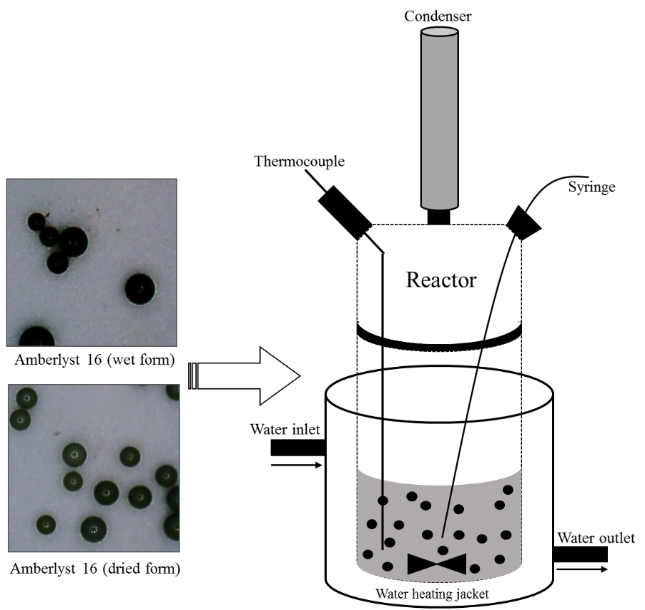
Initially, measured amounts of acetic acid and ethanol were added to the reactor and heated to the desired temperature. Once the system temperature reached the set point, sample aliquot (approximately 1 mL) was withdrawn. Then, an appropriate weight of catalyst was introduced and stirring of the reaction was instantaneously started; this was considered as the starting time of the ethanolysis reaction. The aliquots of reaction mixture withdrawn at specified time intervals (0, 15, 30, 90, 120, 180, 240, 360, 480, 600, 720, 840, 960, 1140, 1320, 1500 and 1680 min) to study the progress of the reaction. The reaction volume is 400 ml; therefore, removing around 17 ml aliquots (4.25 %) of total reaction mixture is assumed to not significantly affect the reaction balance as the aliquots removed would contain fraction of all reactants, intermediates, formed product and by-product. The stirring of the reaction mixture was stopped approximately 10 seconds prior to aliquot extraction to avoid the ejection of catalytic materials, and started immediately after the extraction. All experiments were replicated twice to obtain the reproducibility, and an average of the experimental values were presented in the graphical representations.
Figure 1: Experimental scheme for Amberlyst 16 catalyzed acetic acid esterification.
2.4. Reusability of catalyst
The degree of catalyst decay was tested through the recyclability tests. After the first run of esterification reaction, Amberlyst 16 resins were separated from the post-reaction mixture through filtration using the Whatmann filter paper. The catalysts were then washed with 5 mL of ethanol four times to remove the attached reaction mixture from previous runs. The catalyst, which is in the wet form, was then immediately used for the next cycle of esterification reaction. The aliquots of reaction mixture withdrawn at specified time intervals (0, 15, 60, 120, 240, 480, 920, 1500 and 1680 min). The procedure for the extraction of reaction aliquots was as previously mentioned. The design of experiments showing reaction temperature, catalyst dose and initial acetic acid concentration is presented in Table 2.
Table 2: Design of experiments for Amberlyst 16 catalyzed esterification of acetic acid.
Run | Catalyst form (cycle) | Temperature (ºC) | Ethanol-to-acid molar ratio | Catalyst dose (wt.%) | Acid inital  conc. (mol dm³)
1 | Dried | 60 | 6:1 | 5 | 2.38
2 | Wet | 60 | 6:1 | 10 | 2.38
3 | Wet | 40 | 6:1 | 5 | 2.38
4 | Wet | 50 | 6:1 | 5 | 2.38
5 | Wet | 70 | 6:1 | 5 | 2.38
6 | Wet | 60 | 3:1 | 5 | 4.09
7 | Wet | 60 | 9:1 | 5 | 1.68
8 | Wet | 60 | 6:1 | 15 | 2.38
9 | Wet | 60 | 6:1 | 5 | 2.38
10 | Wet, recycle-1 | 60 | 6:1 | 5 | 2.38
11 | Wet, recycle-2 | 60 | 6:1 | 5 | 2.38
12 | Wet, recycle-3 | 60 | 6:1 | 5 | 2.38
13 | Wet, recycle-4 | 60 | 6:1 | 5 | 2.38

2.5. Analysis
The acid value of withdrawn reaction samples were determined in accordance to the EN 14104 official method [27].
The acid value (AV) is expressed as:
$AV=\frac{V_{KOH} x C_{KOH} x M_{KOH}}{W_{R}}$ (1)
V_{KOH} is the volume of KOH (mL), C_{KOH} is the concentration of KOH in moles per liter, M_{KOH} is the molar mass, W_{R} is the weight of sample added to the titration in grams.
The acetic acid conversion (A_{x}) is expressed as:
$A_{x}=\frac{Initial moles of acid-Final moles of acid}{Initial moles of acid} x 100 \%$ (2)
The titration method determining the concentration of sulfonic acid species is employed to investigate the leaching phenomenon of Amberlyst 16 resins in the reactants.
2.6. Kinetic modelling: theoretical background
In a stoichiometric esterification reaction, a molecule of carboxylic acid reacts with a single molecule of ethanol to produce a single molecule of both fatty acid ethyl esters (FAEEs) and water. The overall esterification of acetic acid with ethanol is represented as:
For the kinetic modeling purpose, following commonly applied assumptions were taken into consideration [16, 28]:
- The reaction mixture was perfectly mixed, and its composition, catalyst distribution and temperature were uniform throughout the process because the reaction was performed in a batch reactor under continuous vigorous stirring.
- The contribution of homogeneous (leaching of solid catalyst in the reaction mixture) and thermal catalysis (reaction without catalyst) is insignificant because ion-exchange resins are poorly soluble in the reaction mixture and acts as heterogeneous catalyst.
The curve fitting procedure was performed using the Aspen custom modeler software (version 8.4, Aspen Technology, Inc., USA). The selection of an appropriate mathematical model for the described ethanolysis process was based on the statistical parameters, such as the sum of weighted errors and the model selection criteria (MSC). The mathematical expression for the MSC is presented as:
$MSC=\ln\left[\frac{\sum{{(β_{exp, i-}β_{exp, a})}^{2}}}{\sum{{(β_{exp, i-}β_{pre, i})}^{2}}}\right]-\frac{2p}{n}$ (3)

where, β_{exp,i} is the experimental data at i^{th} reaction time; β_{exp,a} is an average of the experimental data; β_{pre,i} is the predicted values at i^{th} reaction time; p is the number of the parameter involved in the model; n is the number of the experimental data.

- Results and discussion
  - Pretreatment effects
The pretreatment of ion-exchange resins has been proven to significantly affect their performance as catalysts. Pretreatment experiments were performed to investigate not only the leaching of ion-exchange resins in reactants but also on their performance as catalyst. Previous studies reported that different wet Amberlyst resins were dried before testing its catalytic performance [29-31]. Therefore, this study started with testing and comparing the efficacy of Amberlyst 16 as received wet and laboratory-dried form to assist the esterification of acetic acid with ethanol. For the drying pretreatment, Amberlyst 16 were kept in an oven, set at 65 ºC, for 24h. The catalyst dose applied for the esterification reaction is based on the number of resins beads and the mass balance was carried out. Therefore, catalyst dose of 5 and 10 wt. % (with respect to acetic acid) for dried and wet Amberlyst 16 resins, respectively, was used to catalyze the ethanolysis reaction. This is because the drying pretreatment resulted in around 50 % weight loss of the wet resins. The application of such method enables the access of reactant molecules to an equal number of catalytic sites. The esterification reaction was performed at 60 ºC using 6:1 ethanol-to-acid molar ratio, 200 rpm stirring intensity and 1680 min reaction time. The graphical representation indicating a drop in the concentration of acetic acid with time is shown in Figure 2. The rate of the reaction in the case of dried catalyst was better than that of weight catalyst during the initial 30 minutes of the reaction, after which the resins catalyst in wet form displayed slightly better reaction rate but no significant impact on the final acid conversion was observed. The acetic acid conversion after 1680 min of esterification reaction performed using wet and dried Amberlyst 16 was 93.3 and 90.7 %, respectively. Furthermore, the dried Amberlyst 16 slightly leached in ethanol solution, while, its wet form displayed no lixiviation phenomenon. Furthermore, Amberlyst 16 was stable in absolute ethanol, rectified ethanol and water. Therefore, Amberlyst 16 resins in its wet form was further used in all experiments.
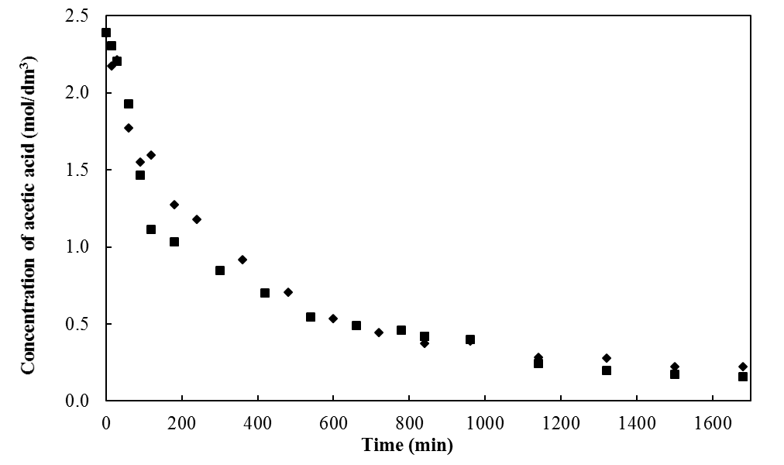
Figure 2: Catalytic performance of wet and dried Amberlyst 16 ion-exchange resins for the esterification process. ■- wet form, ♦- dried form. Reaction temperature-60 ºC, ethanol-to-acetic acid molar ratio- 6:1, stirring intensity- 200 rpm.

  - Temperature effects
The effects of different reaction temperatures on Amberlyst 16 resins catalyzed esterification reaction between acetic acid and ethanol was studied because the rise in temperature is anticipated to accelerate the reaction rate. The increase in temperature is said to improve the miscibility as well as reactivity between reactants [28]. The effects of four reaction temperatures (40, 50, 60 and 70 ºC) on the above-mentioned ethanolysis process was studied keeping constant ethanol-to-acid molar ratio of 6:1, catalyst dose of 5 wt. %, stirring intensity of 200 rpm and 1680 reaction time. Further higher temperatures were not applied to eliminate the possibility of ethanol evaporation. The experimental results for the effect of temperature on the variation in acetic concentration are presented as symbols in Figure 3. The experimental findings indicated that an increase in temperature had a positive impact on the rate of the described esterification reaction. To achieve approximately 50 % acid conversion, the reaction time reduced from 1500 to 360 min when temperature was raised from 40 to 70 ºC. The acid conversion after 1680 reaction time augmented from 50.2 to 87.8 % when temperature was raised from 40 to 70 ºC. The obtained experimental findings were in close agreement with the previously reported Amberlyst 16 resins catalyzed esterification processes [29, 30]. The final acid conversion increased by 18 and 14 % when temperature was raised from 40 ºC to 50 and 60 ºC, respectively; however, further increasing reaction to 70 ºC resulted only in rise of 5 % acid conversion. Therefore, reaction temperature of 60 ºC was used for further experiments.
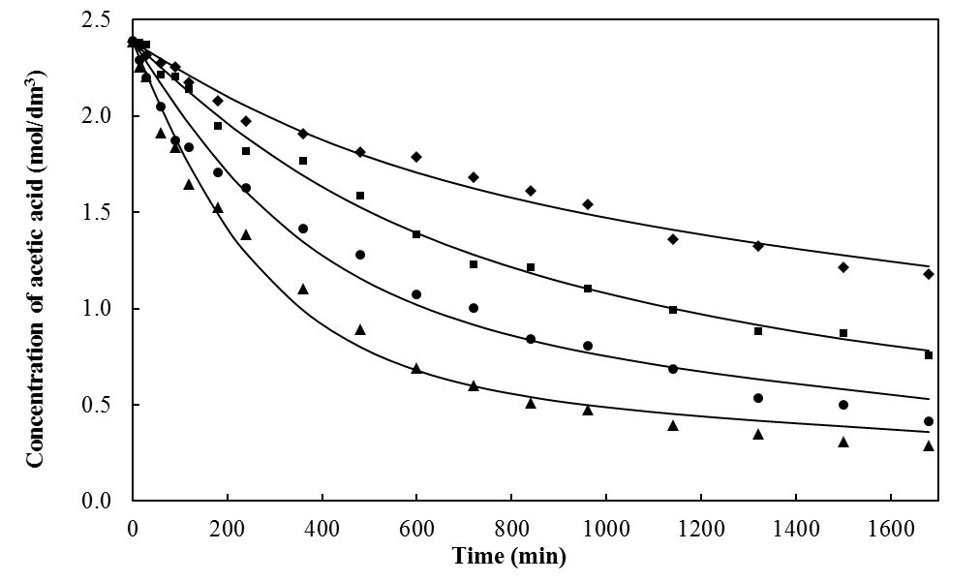
Figure 3: Comparison between experimental and predicted values for the variation in acetic acid concentration with time due to the impact of reaction temperatures. ♦- 40, ■- 50, ●- 60, ▲- 70 ºC. Experimental data: symbols, kinetic model: lines. Ethanol-to-acetic acid molar ratio- 6:1, catalyst dose- 5 wt. %, stirring intensity- 200 rpm.

  - Ethanol-to-acid molar ratio effects
The other important variable affecting the esterification reaction is the alcohol-to-acid molar ratio. Since the esterification is an equilibrium reaction, use of an excess alcohol would be beneficial to shift the reaction towards the product formation. The effects of different ethanol-to-acid molar ratio (3, 6 and 9:1) on the Amberlyst 16 resins catalyzed esterification reaction of acetic acid with ethanol was investigated keeping fixed temperature of 60 ºC, catalyst dose of 5 wt. %, stirring intensity of 200 rpm and 1680 reaction time. The experimental findings for the effect of ethanol-to-acid molar ratio on the variation in acetic concentration are presented as symbols in Figure 4. The obtained results suggested that increasing alcohol-to-acid molar ratio had a negative impact on the rate of the esterification reaction. Use of higher ethanol concentration slightly lowered the reaction rate. The acquired trend of results could be due to dilution of reaction mixture that minimized the acetic acid-catalyst interaction. The usage of very high amount of ethanol could also direct the dissociation of acetic acid and the reacting species, thus minimizing the rate of formation of the product. The achieved results were in close agreement with the previously reported esterification process, where in increasing methanol-to-acid molar ratio from 1 to 3:1 positively affected the esterification process; however, further increase in mole ratio of methanol-to-acid reduced oleic acid conversion from around 85 to 72 % [16]. Hykkerud and Marchetti reported similar pattern of results and explained that such behavior is because the reaction was in its initial stage and the equilibrium state was not applicable [27]. In the present study, highest acetic acid conversion of 82.6 % was obtained using 6:1 ethanol-acid molar ratio.
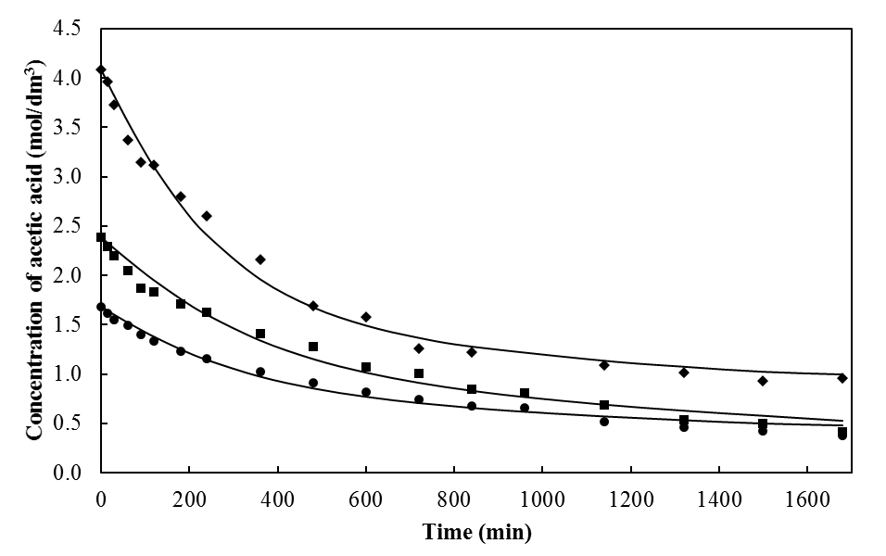
Figure 4: Comparison between experimental and predicted values for the variation in acetic acid concentration with time due to the impact of ethanol-to-acid molar ratio. ♦- 3, ■- 6, ●- 9:1. Experimental data: symbols, kinetic model: lines. Reaction temperature-60 ºC, catalyst dose- 5 wt. %, stirring intensity- 200 rpm.

  - Catalyst dose effects
The dependence of acetic acid conversion on the catalyst dose was further investigated. The effects of three catalysts amounts (5, 10 and 15 wt. %) on the change in the acetic acid concentration was studied setting the constant reaction temperature of 60 ºC, ethanol-to-acid molar ratio of 6:1, stirring intensity of 200 rpm and 1680 reaction time. The experimental results for the study evaluating the effects of catalyst dose on the variation in the concentration of acetic acid are shown as symbols in Figure 5. A faster drop in the acid concentration was observed with increasing catalyst dose. Increasing catalyst dose from 5 to 15 wt. % resulted in reducing reaction time from 600 to 90 min, respectively, to achieve around 55 % acetic acid conversion. This is attributed to an increase in the availability of active catalytic centers. Though increase in the catalyst amount accelerated the rate of the esterification reaction, no significant difference in the final acid conversion was observed. The highest acetic conversion of 93.3 % was recorded using 10 wt. % catalyst dose.
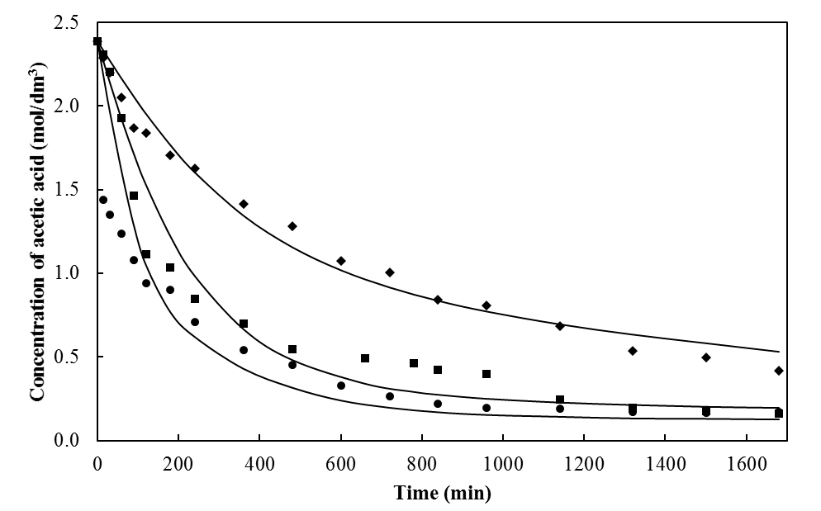
Figure 5: Comparison between experimental and predicted values for the variation in acetic acid concentration with time due to the impact of catalyst dose. ♦- 5, ■- 10, ●- 15 wt. %. Experimental data: symbols, kinetic model: lines. Reaction temperature-60 ºC, ethanol-to-acid molar ratio- 6:1, stirring intensity- 200 rpm.

  - Catalyst recyclability
From a chemical engineering perspective, reutilization of heterogeneous catalysts is an important aspect for the large-scale production of valuable chemicals. In this study, the recyclability of wet Amberlyst 16 cation-exchange resins to catalyze the esterification reactions of acetic acid with ethanol was investigated keeping constant reaction temperature of 60 ºC, ethanol-to-acid molar ratio of 6:1, catalyst dose of 5 wt. %, stirring intensity and 1680 min reaction time. The change in both reaction rate and final acetic acid conversion with time was monitored. The experimental findings for the catalyst recycle tests are presented in Figure 6. Reusing the catalyst slightly lowered the rate of reaction, but showed insignificant variation in the final acetic acid conversion. After four catalyst recycle tests, the final acetic acid conversion dropped only by 3.2 % indicating that commercial wet Amberlyst 16 is a suitable heterogeneous catalyst that could be reutilized at least four times for the ethyl acetate production under the studied range of experimental conditions.
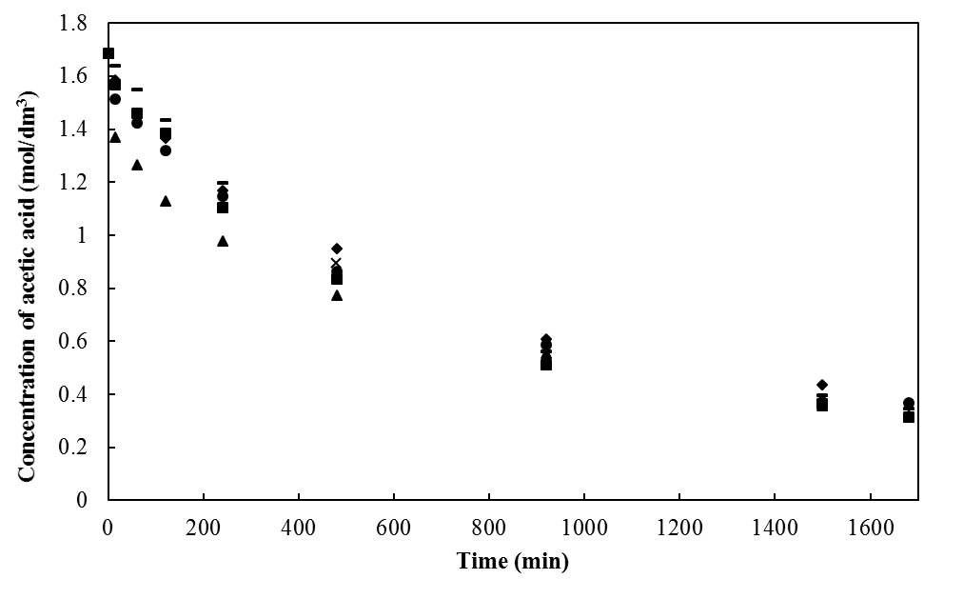
Figure 6: Recyclability tests of the wet Amberlyst 16 resins for the acetic acid esterification with ethanol. ▲- fresh, ●- reuse 1, ■- reuse 2, ♦- reuse 3, x- reuse 4. Reaction temperature-60 ºC, ethanol-to-acid molar ratio- 6:1, catalyst dose- 5 wt. %, stirring intensity- 200 rpm.

  - Kinetic modeling of esterification process
To develop a mathematical model that appropriately describes the chemical kinetics of Amberlyst 16 catalyzed esterification of acetic acid with ethanol, the adsorption of reactant molecules on the catalytic sites, surface chemical reaction and product desorption steps were taken into consideration. The rate-controlling step for this reversible reaction was determined, and rate constants for the overall reaction were evaluated. A total of 12 different kinetic models were tested, and the selection of the best mathematical model was based on the parameters such as MSC and sum of weighed errors. By fitting the model with the experimental data, the appropriate kinetic model for the current esterification reaction included following features:
- Both ethanol and acetic acid molecules are absorbed on the solid catalytic surface due to their polar nature.
- The esterification reaction occurred between ethanol and acetic acid molecule chemisorbed on the neighboring sites of the catalyst surface.
- The overall process rate is controlled by the surface reaction between chemisorbed ethoxide and acetic acid molecules.
- The overall Amberlyst 16 assisted esterification of acetic acid with ethanol follows Langmuir-Hinshelwood reaction mechanism.
The esterification reaction steps involved in the reaction pathway could be presented as:
$E+s \frac{\underset{→}{k_{1}}}{\underset{←}{k_{2}}} Es$ (4)
$A+s \frac{\underset{→}{k_{3}}}{\underset{←}{k_{4}}} As$ (5)
$Es+As \frac{\underset{→}{k_{5}}}{\underset{←}{k_{6}}} EA+Ws+s$ (6)
$Ws \frac{\underset{→}{k_{7}}}{\underset{←}{k_{8}}} W+s$ (7)
where, E is ethanol, A is acetic acid, s is the catalytic active sites, EA is ethyl acetate and W is water.
When the surface reaction was proposed to be the rate-limiting step, the fractional conversion of acetic acid can be expressed as:
$\frac{{dX}_{A}}{dt}={m }^{2}\left[\left[\frac{k_{1}k_{3}k_{5}C_{E}C_{A}}{k_{2}k_{4}}\right]-\left[\frac{k_{6}k_{8}C_{EA}C_{W}}{k_{7}}\right]\right]$ (9)
${k=Ae}^{{{-E}_{a}}/{RT}}$ (10)
The equation for the mass balance of the catalyst is presented as:
$m=\frac{m_{0}}{\left[1+\left[\frac{k_{1}C_{E}}{k_{2}}\right]+\left[\frac{k_{3}C_{A}}{k_{4}}\right]+\left[\frac{k_{8}C_{W}}{k_{7}}\right]\right]}$ (11)
while,
$C_{A}=C_{A0} \left[1-X_{A}\right]$ (12)
$C_{E}=C_{E0}-C_{A0}* X_{A}$ (13)
$C_{EA}=C_{W}=C_{A0}* X_{A}$ (14)
where, k₁, k₃, k₅ and k₇ are the specific rate constants for reaction in the forward direction; k₂, k₄, k₆ and k₈ are the specific rate constants for reaction in the reverse direction; (k₁, k₃, k₅, k₈ = ltr mol⁻¹t⁻¹; k₂, k₄, k₇=1 t⁻¹; k₆=ltr²(mol²)⁻¹t⁻¹); C_{E0} is the ethanol initial concentration (mol L⁻¹); C_{E} is the ethanol concentration at time t (mol L⁻¹); C_{A0} is the acetic acid initial concentration (mol L⁻¹); C_{A} is the acetic acid concentration at time t (mol L⁻¹); C_{W} is the concentration of water (mol L⁻¹); C_{EA} is the concentration of ethyl acetate (mol L⁻¹); m₀ is the initial mass of the catalyst (g); m is the mass of the catalytic sites involved in the reaction (g); A is the pre-exponential factor of the Arrhenius equation (min⁻¹); E_{a} is the activation energy (cal mol⁻¹); R is the universal gas constant (1.98 cal K⁻¹ mol⁻¹); T is the absolute temperature (K).
The discussed kinetic model provided a good correlation between the experimental findings and predicted values, with sum of weighed square error and MSC for the change in acetic acid concentration of 6.72 E-2 and 3.79, respectively. The achieved low value of sum of weighed square error and high value of MSC validated the proposed kinetic model based on the Langmuir-Hinshelwood reaction mechanism to be appropriate to predict the wet Amberlyst 16 assisted esterification of acetic acid with ethanol under the studied range of experimental conditions. The kinetic parameters for the acetic acid esterification process with ethanol in the presence of wet Amberlyst 16 cation-exchange resins are presented in Table 3. The achieved results were in agreement with previously reports, which concluded that the acetic acid esterification process follows the Langmuir-Hinshelwood type reaction mechanism [17, 19]. The activation energy values obtained for the current process were compared with those catalyzed using different Amberlyst resins, and were found to be in reasonable agreement with the previously reported studies [17, 23, 25]. The simulation curves for the experimental change in the acetic acid concentration at different temperature, ethanol-to-acid molar ratio and catalyst dose are presented as solid lines in Figure 3, 4 and 5, respectively.

Table 3: Kinetic parameters for the acetic acid esterification process with ethanol in the presence of wet Amberlyst 16 cation-exchange resins.
Parameters | Value | Unit
A₁ | 7133.17 | min⁻¹
E_{a1} | 2215.14 | cal mol⁻¹
A₂ | 126.74 | min⁻¹
E_{a2} | 3619.35 | cal mol⁻¹
A₃ | 5008.52 | min⁻¹
E_{a3} | 1506.69 | cal mol⁻¹
A₄ | 11.99 | min⁻¹
E_{a4} | 1953.84 | cal mol⁻¹
A₅ | 219.35 | min⁻¹
E_{a5} | 6438.3 | cal mol⁻¹
A₆ | 4005.27 | min⁻¹
E_{a6} | 4877.57 | cal mol⁻¹
A₇ | 972.99 | min⁻¹
E_{a7} | 9800.75 | cal mol⁻¹
A₈ | 597.74 | min⁻¹
E_{a8} | 4177.3 | cal mol⁻¹

- Conclusion
The current research article presents the experimental as well as simulation investigations for the esterification reaction of acetic acid with ethanol in the presence of the strongly acidic Amberlyst 16 ion-exchange resins. The obtained experimental findings suggested that the drying of Amberlyst 16 before its application for the esterification reaction displayed slight leaching as well as insignificant impact on the final acetic acid conversion, when compared with those using wet resins. Therefore, Amberlyst 16 could be applied directly in its available wet form to catalyze the acetic acid esterification reaction with ethanol. Increase in both reaction temperature and catalyst dose resulted in the acceleration in the rate of ethyl acetate generation. However, increasing ethanol-to-acid molar ratio slightly lowered the rate of reaction. The application of reaction temperature of 60 ºC, ethanol-to-acid molar ratio of 6:1, catalyst dose of 10 wt. % and 200 rpm stirring intensity resulted in 93.3 % acetic acid conversion after 1680 min of esterification reaction catalyzed by Amberlyst 16 cation-exchange resins. The catalyst was found to be active and stable under mentioned experimental conditions, and can be reutilized at least for four reaction cycles without any pretreatment. The proposed kinetic model suggested that the reaction followed Langmuir-Hinshelwood mechanism. The esterification reaction occurred between ethoxide and acetic acid molecules both chemisorbed on the neighboring catalytic active surface, the rate of which was controlled by the surface reaction step. The proposed kinetic model presented a good agreement between the predicted values and the experimental data under the studied range of experimental conditions. Based on the experimental as well as simulation investigations, it could be concluded that Amberlyst 16 cation-exchange resins is active, stable and reusable heterogeneous catalyst for the ethyl acetate production through the esterification route.

References
[1] Gaspar AB, Esteves AML, Mendes FMT, Barbosa FG, Appel LG (2009) Chemicals from ethanol-The ethyl acetate one-pot synthesis. Applied Catalysis A: General 1-2: 109
[2] Nielsen M, Junge H, Kammer A, Beller M (2012) Towards a green process for bulk-scale synthesis of ethyl acetate: Efficient acceptorless dehydrogenation of ethanol. Angewandte Chemie International Edition 23: 5711
[3] PRWEB. Global ETAC Production to Exceed 3.5 Mln Tonnes in 2015. http://www.prweb.com/releases/2014/02/prweb11619424.htm (Accessed 21.08.18)
[4] Merchant Research & Consulting Ltd. Ethyl Acetate (ETAC): 2016 World Market Outlook and Forecast up to 2020. https://mcgroup.co.uk/researches/ethyl-acetate-etac (Accessed 21.08.18)
[5] Inui K, Kurabayashi T, Sato S (2002) Direct synthesis of ethyl acetate from ethanol over Cu-Zn-Zr-Al-O catalyst. Applied Catalysis A: General 1-2: 53
[6] Inui K, Kurabayashi T, Sato S (2002) Direct synthesis of ethyl acetate from ethanol carried out under pressure. Journal of Catalysis 212(2): 207
[7] Manayil JC, Inocencio CVM, Lee AF, Wilson K (2016) Mesoporous sulfonic acid silicas for pyrolysis bio-oil upgrading via acetic acid esterification. Green Chemistry 18: 1387
[8] Bennett JA, Parlett CMA, Isaacs MA, Durndell LJ, Olivi L, Lee AF, Wilson K (2017) Acetic acid ketonization over Fe₃O₄/SiO₂ for pyrolysis bio-oil upgrading. ChemCatChem 9(9): 1648
[9] Rönnback R, Salmi T, Vuori A, Haario H, Lehtonen J, Sundqvist A, Tirronen E (1997) Development of a kinetic model for the esterification of acetic acid with methanol in the presence of a homogeneous acid catalyst. Chemical Engineering Science 52(19): 3369
[10] Mäki-Arvela P, Salmi T, Sundell M, Ekman K, Peltonen R, Lehtonen J (1999) Comparison of polyvinylbenzene and polyolefin supported sulphonic acid catalysts in the esterification of acetic acid. Applied Catalysis A: General 184(1): 25
[11] Jafar JJ, Budd PM, Hughes R (2002) Enhancement of esterification reaction yield using zeolite A vapour permeation membrane. Journal of Membrane Science 199(1-2): 117
[12] Marchetti JM, Errazu AF (2008) Esterification of free fatty acids using sulfuric acid as catalyst in the presence of triglycerides. Biomass and Bioenergy 32(9): 892
[13] Marchetti JM, Pedernera MN, Schbib NS (2011) Production of biodiesel from acid oil using sulfuric acid as catalyst: kinetics study. International Journal of Low-Carbon Technologies 6(1): 38
[14] Avhad MR, Marchetti JM (2016) Innovation in solid heterogeneous catalysis for the generation of economically viable and ecofriendly biodiesel: A review. Catalysis Reviews: Science and Engineering 58(2): 157
[15] Marchetti JM, Errazu AF (2008) Comparison of different heterogeneous catalysts and different alcohols for the esterification reaction of oleic acid. Fuel 87(15-16): 3477
[16] Ilgen O (2014) Investigation of reaction parameters, kinetics and mechanism of oleic acid esterification with methanol by using Amberlyst 46 as a catalyst. Fuel Processing Technology 124: 134
[17] Tsai Y-T, Lin H-m, Lee M-J (2011) Kinetics behavior of esterification of acetic acid with methanol over Amberlyst 36. Chemical Engineering Journal 171(3): 1367
[18] Jermy BR, Pandurangan A (2005) A highly efficient catalyst for the esterification of acetic acid using n-butyl alcohol. Journal of Molecular Catalysis A: Chemical 237(1-2): 146
[19] Miao S, Shanks BH (2011) Mechanism of acetic acid esterification over sulfonic acid-functionalized mesoporous silica. Journal of Catalysis 279(1): 136
[20] Peters TA, Benes NE, Holmen A, Keurentjes JTF (2006) Comparison of commercial solid acid catalysts for the esterification of acetic acid with butanol. Applied Catalysis A: General 297(2): 182
[21] Corma A, Garcia H, Iborra S, Primo J (1989) Modified faujasite zeolites as catalysts in organic reactions: Esterification of carboxylic acids in the presence of HY zeolites. Journal of Catalysis 120(1): 78
[22] Verhoef MJ, Kooyman PJ, Peters JA, van Bekkum H (1999) A study on the stability of MCM-41-supported heteropoly acids under liquid- and gas-phase esterification conditions. Microporous and Mesoporous Materials 27(2-3): 365
[23] Izci A, Bodur F (2007) Liquid-phase esterification of acetic acid with isobutanol catalyzed by ion-exchange resins. Reactive and Functional Polymers 67(12): 1458
[24] de la Iglesia Ó, Mallada R, Menéndez M, Coronas J (2007) Continuous zeolite membrane reactor for esterification of ethanol and acetic acid. Chemical Engineering Journal 131(1-3): 35
[25] Pöpken T, Götze L, Gmehling J (2000) Reaction kinetics and chemical equilibrium of homogeneously and heterogeneously catalyzed acetic acid esterification with methanol and methyl acetate hydrolysis. Industrial & Engineering Chemistry Research 39(7): 2601
[26] Gangadwala J, Mankar S, Mahajani S, Kienle A, Stein E (2003) Esterification of acetic acid with butanol in the presence of ion-exchange resins as catalysts. Industrial & Engineering Chemistry Research 42(10): 2146
[27] Hykkerud A, Marchetti JM (2016) Esterification of oleic acid with ethanol in the presence of Amberlyst 15. Biomass and Bioenergy 95: 40
[28] Avhad MR, Sánchez M, Peña E, Bouaid A, Martínez M, Aracil J, Marchetti JM (2016) Renewable production of value-added jojobyl alcohols and biodiesel using a naturally-derived heterogeneous green catalyst. Fuel 179: 332
[29] Tesser R, Casale L, Verde D, Di Serio M, Santacesaria E (2010) Kinetics and modeling of fatty acids esterification on acid exchange resins. Chemical Engineering Journal 157(2-3): 539
[30] Özbay N, Oktar N, Tapan NA (2008) Esterification of free fatty acids in waste cooking oils (WCO): Role of ion-exchange resins. Fuel 87(10-11): 1789
[31] Leveneur S, Murzin DY, Salmi T, Mikkola J-P, Kumar N, Eränen K, Estel L (2009) Synthesis of peroxypropionic acid and hydrogen peroxide over heterogeneous catalysts. Chemical Engineering Journal 147: 323

Acknowledgement
The authors would like to express their gratitude to the Norwegian University of Life Sciences (Project no. 1301051406) for the financial support.

Competing financial interests
The authors declare no competing financial interests.

