Urban Nature for land use planning: the City of Helsinki

Mina Di Marino*, Jari Niemelä and Kimmo Lapintie

Abstract

This paper explores urban nature within the built-up environment. Urban nature contributes to enhancing health and well-being, regulating climate change as well as reducing air pollution. However, due to urban densification and population growth, several cities have lost their spaces for urban nature, including local natural resources and opportunities to interact with nature. The aim of this paper is to discuss the emerging concepts of Urban Ecosystem Services (UES) and Urban Ecosystem Disservices (UED), Nature-Based Solutions (NBS) and Bio-Cultural Diversity (BCD), and the ways they are applied in the urban context. Contemporary planning and policies in the City of Helsinki are used as case studies. There is a growing interest among academics, policy makers and city planners in the ways in which nature can support sustainable urbanization. In addition to a comprehensive literature review, selected planning documents and reports were examined. The results show that although studies on the Ecosystem Services (ES) have already been conducted on the regional and local scale, it has clearly been difficult to operationalize the concepts in planning practices. The same is true of the new concepts of Nature-Based Solutions and Bio-Cultural Diversity. New ways of implementing these concepts in the planning processes need to be explored.

Keywords: green infrastructure, ecosystem service, knowledge gap, planning process, sustainability, urban densification.

Acknowledgments

The project was conducted at Aalto University and supported by the Academy of Finland, SRC on Urbanizing Society. Beyond MALPE-coordination: Integrative Envisioning –BeMInE- (under Grant number 13303549 STN), and afterwards at the Norwegian University of Life Sciences.

*Corresponding Author: Mina Di Marino Department of Urban and Regional Planning, Faculty of Landscape and Society, Norwegian University of Life Sciences, P.O. Box 5003 No-1432 Ås, Norway, mina.dimarino@nmbu.no

1 Introduction

Nature provides many benefits, contemporarily named ES, to the residents of cities (Niemelä et al., 2010). For instance, urban nature is purported to improve health and well-being, regulate climate change and decrease air pollution. However, over the last decade, the ways of supplying ES have been changed. The human societies can transform ecosystems to obtain a wider provision of a specific ES producing an evident decline of others (Rodriguez et al., 2006). For instance, the forests that are mainly managed for tree production can supply a provisioning service. However, the forest management can provide the decrease of cultural services, such as the decline of the recreational value of the land (Rodriguez et al., 2006). The phenomenon is called trade-offs. Therefore, in each urban region, it would be important to calculate the trade-offs between particular services (Schägner et al., 2013).

Nonetheless the advanced knowledge, thus far, nature has not effectively been used to guide the urban growth. Even though nature is considered relevant to balanced urban development, several cities have lost their spaces for urban nature, including local resources and opportunities to interact with nature (Standish et al., 2013). To counteract these negative changes, scholars have investigated the ways Green Infrastructure (GI) can be planned and developed to guide urban development (Tzoulas et al., 2007). Furthermore, within the European policy framework, GI has been defined as a “strategically planned network of natural and semi-natural areas with other environmental features designed and managed to deliver a wide range of ES” (European Commission (2013, p. 3). More recently, the European Environment Agency (2014, p. 10) has extended the definition saying that GI is an “ecological and spatial concept for promoting ecosystem health and resilience, contributing to biodiversity conservation, and benefiting humans by promoting the delivery of ES”. In addition to this, research has focused on the means to manage the urban nature in cities as well as the ways to incorporate ecological knowledge into urban design and planning (Ahern et al., 2014; Yli-Pelkonen and Niemelä, 2006).

Cities are highly dependent on ES, such as clean air, water, nutrient flows, and concurrently, there is a dualism between nature and culture (Karvonen, 2011). However, traditional urban planning has used preservation strategies to reduce human impacts on nature “by zoning society out of nature via urban growth boundaries and preservation of natural areas” (Karvonen, 2011, p. 24). In addition, urban residents are not fully aware of the benefits that urban nature can provide. They tend to measure urban nature through recreational aesthetic values. Some urban areas can be aesthetically unattractive, but biologically rich, while orderly landscapes, such as historic gardens and parks are culturally and aesthetically pleasing, but not necessarily biologically rich (Harrison and Davies, 2002). Thus, it is still difficult to combine socio-cultural issues with the ecological and functional aspects of nature. However, studies on the relationships between cultural ES and ecological characteristics of urban green areas have been already conducted. As Gomez et al. (2013) stated, the ecological infrastructures such as water and vegetation deliver ES within urban and peri-urban areas through parks, gardens, urban allotments, urban forests, single trees, green roofs, rivers and lakes. For instance, the psychological well-being in urban parks (such as the spiritual reflection, and the scenic view) is strongly correlated to the habitat diversity and built infrastructures (Gomez et al., 2013).

By adopting the notion of urban nature, we embrace two other concepts: new urban landscape and UES, including the UED. The new urban landscapes provide new urban ecosystems and, thereby, UES. The urban landscapes adapt to the conditions of cities, in which spatial and functional, ecological and economic issues are increasingly becoming ‘socio-cultural’ tasks (Gerstberger, 2016). UES are important in providing services which have direct impacts on well-being, health and safety, such as air purification, noise reduction, urban cooling and runoff mitigation (Gomez et al., 2013;). UED, on the other hand, includes displacement of endemic species, perception of unsafety and unattractive green areas (Ahern, 2016).

In addition to this, two emerging approaches are explored: Nature-based solutions (NBS) and bio-cultural diversity (BCD). NBS is an emerging approach “which builds on and supports other closely related concepts, such as the ecosystem approach, ES, ecosystem-based adaptation/mitigation, and green and blue infrastructure” (European Commission, 2016, p.24). The NBS approach to urban planning and design can be used to respond to societal challenges and to enhance human health and well-being in the densest cities (…) (European Commission, 2016, p.14). In addition, the BCD concept emphasises the dynamic interaction between humans and nature, cities included (Buizer et al., 2016). The intricate relations between biodiversity and culture are illustrated best by the BCD concept (Posey, 1999; Pilgrim and Pretty, 2010).

European cities, such as Stockholm and Vienna are losing green spaces, which has resulted in a reduction or loss of UES (Xiu et al., 2016; Czachs et al., 2016). To counteract this change, Vienna provides, for instance, developers and urban planners with guidelines to develop GI in the city. However, incentives are still lacking for the implementation of GI. The socio-cultural aspects are rarely combined with ecological and economic aspects (Czachs et al., 2016). The concept of BCD could be of assistance here (Buizer et al., 2016). Furthermore, urban planners and administrations should consider a wider range of the so-called ‘eco-spatial factors’ that consist of not only size, space consumption and ecological aspects, but also physical, psychological, social, and economic benefits (Czachs et al., 2016). Yet, European cities, such as London and Amsterdam, have already faced the process of renaturing that mostly consists of transforming brownfields and harbours into new residential areas, parks, and other green areas, as well as restoring degraded ecosystems. Urban nature needs to be integrated with economic and social concerns that have traditionally guided the development in London (Harrison and Davies, 2002).

The Finnish cities have not yet faced the phase of re-greening or renaturing degraded ecosystems to any large extent. On the contrary, even the latest decisions have been taken to convert arable lands into residential and infrastructure uses, thus reducing urban forests and other green areas.

We argue that a new way is needed to approach urban planning, one which links humans and nature/ecology. In fact, this is not new, but rather derived from the old and traditional way of considering the unity of ‘man and nature’ that was so prevalent in the minds and lives of our agrarian ancestors, who were entirely dependent on nature and the services it produced. Therefore, the issue does not seem to be the existence or amount of knowledge, but the way that urban reality is conceptualised through this knowledge, whether it is scientific or professional. Furthermore, if valid, dealing with the complex and dynamic urban reality at hand requires re-conceptualisation, and this is precisely the task we are interested in.
This paper addresses the following research question: How can the concepts of Nature-Based Solutions (NBS), Urban Ecosystem Services (UES) and Urban Ecosystem Disservices (UED), and Bio-Cultural Diversity (BCD) be used in land use planning? In order to address this question, we first focus on the European approach to NBS; secondly, on the recent studies on UES and UED; and thirdly, on the concept of BCD. Furthermore, the study explores the City of Helsinki, in which there is a growing interest between academics, practitioners and policy makers in recognizing urban nature and ES. The discussion of the paper moves to the role of urban nature within land use planning, embracing the concept of urban ecosystems and services provided by ecosystems.

2 Emerging concepts of urban nature

2.1 Nature-based Solutions

The nature-based solutions (NBS) approach can address several societal challenges such as 1) Restoring degraded ecosystems in order to improve the resilience of ecosystems and deliver vital ES, as well as to meet other societal challenges and 2) Developing climate change adaptation and mitigation (European Commission, 2015).

Developers and local authorities should consider NBS from the early stage of urban projects or strategies. Changes in land use, neglected land and abandoned areas are challenges for many cities. Urban regeneration through these solutions offers a context for innovative interventions for green growth. This approach of re-naturing can be part of the urban renewal of cities, but it also requires adequate legislative and institutional structures that support the investments on ecosystem restoration (European Commission, 2015, p. 2014).

Cities can be seen as innovation hubs for nature-based solutions that are used to regenerate derelict areas and historic districts, improve recreation facilities and human well-being. “Nature-based solutions also appear to resonate with the urban publics, and citizen empowerment (….). New forms of stakeholder engagement and citizen participation in urban design and planning must be explored in order to harvest these innovative capabilities, resources and cooperation” (European Commission, 2015, p.15). In summary, the advantage of the concept is that it shows the ways in which nature and society can be linked through benefits and solutions that nature/ecology can provide for humans. This brings nature close to people and encourages them to take care of nature because nature takes care of them.

2.2 Urban Ecosystem Services and Disservices

ES are defined as four major categories: provisioning, regulating, supporting, as well as cultural and recreational services (TEEB, 2011). Urban ecosystems are especially important in providing services that have a direct impact on well-being, health and safety, such as air purification, noise reduction, urban cooling and runoff mitigation (Niemelä et al., 2010). UES are services provided by gardens, urban allotments, urban forests, single trees, green roofs, streams, rivers and wetlands. (Gomez et al. 2013). Scholars stated that the economic evaluation of ES, are frequently requested by policy makers and practitioners as supporting information to guide decisions in urban planning and governance (Gomez et al., 2013).

As Gomez et al. (2013) argued, social structures, such as the built environment and institutions can mediate the links between ES source areas and end-users. Haase et al. (2014) stated that ES must be clearly communicated to planners, policy makers and practitioners and without any room for misinterpretation. However, communication may be a challenge as the concept is rather abstract and vague (Niemelä et al., 2010). Therefore, a long-term dialogue is needed between ES researchers and end-users of the knowledge.

Furthermore, the UED approach consists of the displacement of invasive species, respiratory allergies, perception of unsafety and unattractive green areas (Ahern, 2016). The ED are often associated with the Abandoned/Ruderal areas and Horticultural/Formal urban ecosystems. For example, the abandoned ecosystems can provide a “memory of the pre-urban ecosystem, and may serve as reference ecosystems (…) to serve as models for ecological restoration.” (Ahern, 2016, p. 536). Further studies are needed to better understand both services and disservices within urban ecosystems. (Standish et al., 2013).

2.3 Bio-Cultural Diversity

There is another novel concept being applied to the urban setting–namely ‘Bio-Cultural Diversity’ (BCD). There is an increasing awareness that biological diversity and cultural diversity interact with each other (Buizer et al., 2016). Thus, biodiversity is perceived and valued through and influenced by people and cultures (Posey, 1999; Pilgrim and Pretty, 2010). Furthermore, this concept is defined as the diversity of life in all its manifestations (biological, cultural and linguistic), which are all interrelated within a complex socio-ecological adaptive system (UNESCO, 2008). The concept of BCD has been originally established in a developing country context (Pilgrim and Pretty, 2010). However, the concept is increasingly expanded to refer to non-indigenous communities and western societies. Its application in western societies stresses the significance of hybrid landscapes which are well represented in urban environments as urban green spaces range from semi-natural biotopes to entirely human-modified ones. Examples of such human-created biotopes reflecting cultural values are, amongst others, allotment gardens, community gardens and forests, and public parks. These biotopes demonstrate the ways in which the diversity of cultural values has resulted in rich and specific forms of biodiversity at the level of landscapes, habitats/biotopes and species. For example, allotment gardens do not just demonstrate high levels of biodiversity and human dependencies on this biodiversity (edible plants) for consumption, but are also esteemed for their traditional crop varieties as well as enjoyment of biodiversity aesthetics. This link between the natural and social system can be studied and understood by the concept of BCD.

3 Research methods and materials

As a case study, the City of Helsinki is analysed from the point of view of the new conceptual framework. More than 1.6 million inhabitants live within the Helsinki Uusimaa Region, which presents the highest population density in Finland (Uusimaa Regional Council, 2014). The Helsinki Uusimaa Region includes the Helsinki Metropolitan Area (Helsinki, Vantaa, Espoo and Kauniainen). The reasons for selecting this case study is that literature is available from the operationalizing of concepts, such as ES in land use planning. Furthermore, there is a growing interest between academics, practitioners and policy makers in recognising urban nature and ES.

In particular, the authors have been involved in the process in different roles (consultancy, independent external expert, stakeholder) by conducting studies for official reports commissioned by the City of Helsinki, by developing research projects funded by the Academy of Finland (Finnish Agency for research funding) and by disseminating the results amongst local communities. Therefore, there is also first-hand knowledge of these concepts (NBS, ES and BCD).

A content analysis has been conducted to understand whether and in what ways the concepts of Nature-Based Solutions (NBS), Urban Ecosystem Services (UES) and Bio-Cultural Diversity (BCD) have been embedded within the urban planning documents (e.g. the way the concepts have been stated and in what context). The content analysis focused on the following reports: 1) Vision 2050 (Helsinki City Planning Department, 2013) and 2) the Comprehensive City Plan (City of Helsinki, 2016 b)

4 Results

4.1 The City of Helsinki

The City of Helsinki is expected to grow from the current 625,000 inhabitants to 860,000 inhabitants by 2050 (City of Helsinki, 2013). As a result of this projection, the city council has just approved a new comprehensive plan, where it is suggested that one third of the required new development be built by densifying the existing built areas, one third by transforming the existing motorways leading to the city centre into boulevards, and another third by adopting some of the existing urban forests into residential use. Thus, the city is losing green spaces both along the existing motorways and from the existing recreational and natural areas.

The so-called ‘boulevardisation’ aims to create a network of public rail transport as well as a gradual transformation of motorway-like entry routes in the outer suburbs into ‘city boulevards’ with the hope of reaching a modal shift from private to public transport (City of Helsinki, 2015a). The boulevards are represented as streets that provide smooth crossings and bicycle and pedestrian paths (Fig. 1).

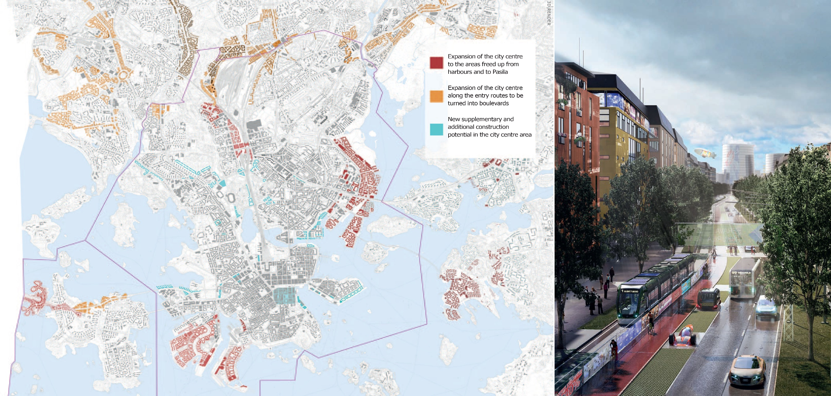

Figure 1. The city boulevards. Source of the left side image: Helsinki city plan draft, City Planning Department (City of Helsinki, 2015a, p. 6). Source of the right side image City Boulevards in Helsinki, City of Helsinki, 2015b, p. 3.
Currently, there are more than 110 m² of green areas per capita in Helsinki, while 2,100 kilometres of pedestrian and cycle paths are provided in total. The City of Helsinki owns 63.3% of the whole municipal area, while the state owns 8% of the land within the administrative borders (City of Helsinki, 2016a). One can clearly see the green fingers, which are both recreational and ecological corridors, running from the City Centre to the northern and eastern parts of the Metropolitan Areas such as the Central Park (Keskuspuisto) and the green finger along the Vantaanjoki River. (Fig. 2). The green fingers are also meant as an important part of the regional structure, since they are connected to the national parks of Nuuksio in the West and Sipoonkorpi in the East (Fig. 2).

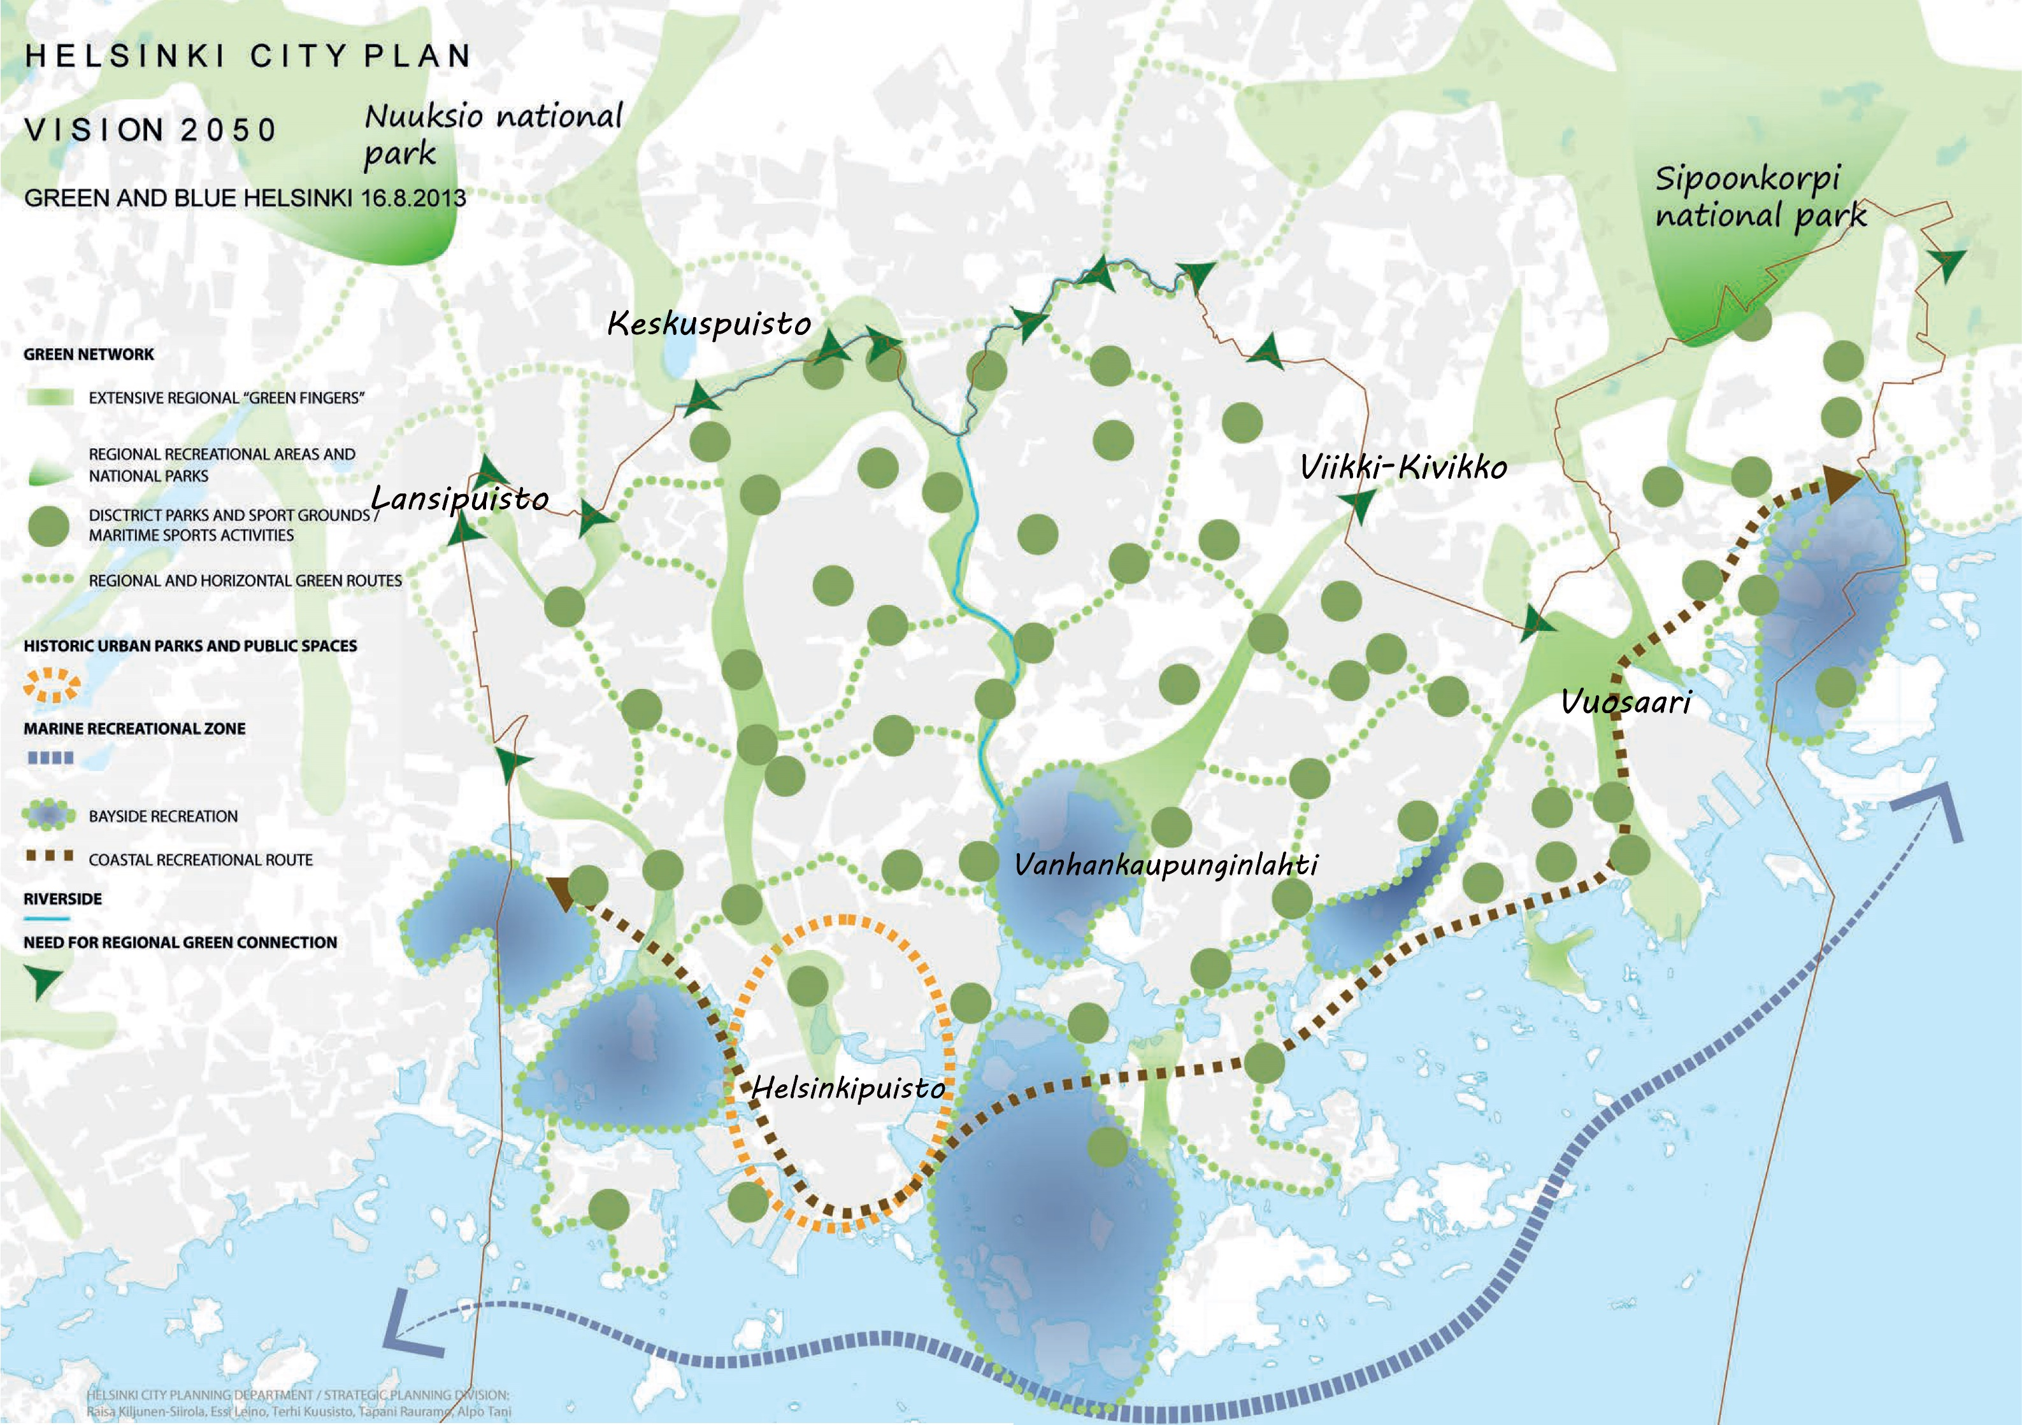

Figure 2. Green and blue Helsinki. Source image: Helsinki City Plan, Vision 2050, City of Helsinki, 2013.

The green structure in Figure 2, which has been recently included in the new comprehensive plan of Helsinki, is idealized. In reality, the green fingers are ‘broken’ in many places due to large roads cutting through them. Naturally, this hampers the movement of animals, but also makes it more difficult (and less pleasant) for people to use them as recreational routes (Fig. 2). In addition, the suggested new boulevards would further affect the green fingers. For instance, the boulevard of Hämeenlinnanväylä will take several green areas from the green finger of Keskuspuisto.

4.2 Understanding the concepts of nature and the new master plan of Helsinki

Green spaces, sea and recreational services are considered relevant to the citizens. Urban parks are seen as active environments for activities, culture and nature, while the landlocked bays and the archipelago are the only areas that still offer “enough space for genuine nature”. (Vision 2050, p. 11). The sea and nature are important to the citizens, but they also serve as competitiveness factors, distinguishing Helsinki from other European capitals

In the actual plan (the only one that will have a legal status), the green structure is divided into two abstract categories, ‘recreational and green areas’ and ‘the areas for recreation by the sea, as well as tourism’ The former areas are to be developed as important recreational, outdoor activities, sports, nature and cultural areas, connected to the regional green structure and the recreational zone by the sea (City of Helsinki, 2016b). The latter, on the other hand, should be developed as “important recreational, outdoor activities, sports, nature and cultural areas, connected to the continental recreational and green areas.” The category also includes areas for vacation building and tourism. Thus, even if there are only two categories of green areas, they are described similarly, particularly in recreational terms. Both descriptions in the legend contain the word “nature”, but it possesses no specific meaning. In addition, there is a general guideline (yleiskaavamääräys), according to which “recreational services and ES will be developed” (City of Helsinki, 2016b).

Thus, a clear gap exists between the conceptual framework developed in research, including the knowledge gathered during the preparation of the plan, and the conceptual framework used in the final version. One can clearly see that the two traditional concepts in planning, recreation and nature conservation, are overwhelmingly dominant. The concept of ES is mentioned once, but it is distinguished from recreation which is, in fact, one of the ES. There is no information of the kinds of services the existing green areas produce or the ways they are changed as a result of the new plan. If one third of new construction is placed on the existing (non-recreational) green corridors along the motorways, and another third on the green fields and urban forests, one would expect major changes in the ES provided by the existing green-blue structure (Di Marino and Lapintie, 2017). Thus, it is not clear in what way more detailed plans would be able to safeguard, manage and develop ES and green structures.

5 Discussion and conclusions

Within the current land use strategies, there are not explicit references to the NBS and CBD. Nonetheless, the understanding of urban nature is already revealed in the vision that the recreational areas of the city provide ecological, social and economic sustainability, as well as benefits of nature to people. In fact, several benefits that urban nature can provide to society derive from green spaces, recreational areas, gardens and green roofs. Therefore, there is some knowledge of the recreational services within the land use planning while the other ES have received little attention.

In addition to this, the results show that the City of Helsinki is already aware of the existing urban ecosystems and the kinds of habitats they provide, such as natural, anthropogenic habitats and constructed parks. Therefore, there is a need to further develop land use strategies for those places in which biodiversity has to deal with interactions with human beings. The study suggests that the NBS and BCD concepts can support these particular aspects of the land use. For instance, when discussing the urban functions of public spaces (such as urban and forests and gardens), the master plan should embed both recreational ES and ecological functions. The ES could form the backbone of a new approach to the public services.

However, this study reveals how limited the understanding of the urban green still is, despite decades of research on GI, ES, health effects, micro-climates, and storm water management dealt with by urban ecology. The two functions of recreation and preservation still dominate the field (Di Marino and Lapintie, 2017; Niemelä et al, 2010). The planning debate is still about the amount of green that can be sacrificed for urban development, which areas should be preserved, and what form the green network should take. The main points seem to be too complex to handle: the avoiding of the juxtaposition of urban development and urban green, the understanding of urban ecology in systemic terms (and not as end-states that can be represented in two-dimensional maps), and addressing the different qualities of the urban green and the respective ES. An urban forest and a golf course are both green, but they provide very different services, both ecologically and socially. The emerging concepts of UES and UED, NBS and BCD would be useful in dealing with this complex and dynamic urban reality.

List of references

Ahern J. (2016) Novel Urban Ecosystems: new nature(s) for the Century of the City. In Jombach, S., Valanszki, I. Filep-Kovacs K., Fabos, J. Gy., Ryan R.L., Lindhult M.S. & Kollanyi L. (Eds.) Landscapes and Greenways of Resilience Proceedings of 5th Fabos Conference on Landscape and Greenway Planning (Budapest, 01 July), pp. 533-541.

Ahern J., Cilliers S. & Niemelä J. (2014) The concept of ecosystem services in adaptive urban
planning and design: a framework for supportive innovation. Landscape and Urban Planning, 125, pp. 254-259.

Buizer M., Elands B. & Vierikko K. (2016) Governing cities reflexively—the biocultural diversity concept as an alternative to ecosystem services. Environmental Science & Policy 62: 7-13.

City of Helsinki (2016a) Helsinki Statistical Yearbook (Helsingin tilastollinen vuosikirja) http://www.hel.fi/hel2/tietokeskus/julkaisut/pdf/17_01_02_Tilastollinen_vuosikirja_2016_Askelo.pdf
City of Helsinki (2016b) Helsingin yleiskaava (Comprehensive City Plan) http://www.hel.fi/hel2/ksv/julkaisut/yos_2016-2.pdf
City of Helsinki (2015a) Urban Plan, Helsinki city plan draft.
http://www.hel.fi/hel2/ksv/julkaisut/esitteet/esite_2015-1_en.pdf

City of Helsinki (2015b) City Boulevards in Helsinki.
http://www.hel.fi/hel2/ksv/julkaisut/esitteet/esite_2015-4_en.pdf

City of Helsinki (2013) Helsinki City Plan, Vision 2050, Urban plan - the new Helsinki city plan
http://www.hel.fi/hel2/ksv/julkaisut/yos_2013-23_en.pdf

Di Marino M. & and Lapintie K. (2017) Exploring the concept of green infrastructure in urban
landscape. Experiences from Italy, Canada and Finland. Landscape Research
http://doi.org/10.1080/01426397.2017.1300640

European Environment Agency (2014). Spatial analysis of green infrastructure in Europe, EEA Technical Report No 2/2014. http://www.eea.europa.eu/publications/spatialanalysis-of-green-infrastructure

European Commission (2015). Towards an EU Research and Innovation policy agenda for Nature-Based Solutions & Re-Naturing Cities. Final Report of the Horizon 2020 (full version). http://bookshop.europa.eu/en/towards-an-eu-research-and-innovation-policy-agenda-for-nature-based-solutions-re-naturing-cities pbKI0215162/;pgid=GSPefJMEtXBSR0dT6jbGakZD0000krbuNIho;sid=m7IXPly59aUX3ATRTeSJmT6cOXFrbv565-I=?CatalogCategoryID=Gj0KABst5F4AAAEjsZAY4e5L

European Commission (2013) Green Infrastructure (GI) — Enhancing Europe’s Natural Capital {COM(2013) 249 final.
http://ec.europa.eu/environment/nature/ecosystems/docs/green_infrastructures/1_EN_ACT_part1_v5.pdf

Gerstberger S. (2016). Lp (R)evolution: A City on the Way to the Future. Las Palmas: ParkCity. In Jombach, S., Valanszki, I. Filep-Kovacs K., Fabos, J. Gy., Ryan R.L., Lindhult M.S. & Kollanyi L. (Eds.) Greenways and Landscape in Change. Proceedings of 5th Fabos Conference on Landscape and Greenway Planning (Budapest, 30 June), pp. 351-358.

Haase D., Larondelle N., Andersson E., Artmann M., Borgström S., Breuste J., Gomez-Baggethun E., Gren AX., Hamstead Z., Hansen R., Kabisch N., Kremer P., Langemeyer J., Rall E.L., McPhearson T., Pauleit S., Qureshi S., Schwarz N., Voigt A., Wurster D. & Elmqvist T. (2014) A Quantitative Review of Urban Ecosystem Service Assessments: Concepts, Models, and Implementation. AMBIO, 43, pp. 413–433.

Harrison C. & Davies G. (2012) Conserving biodiversity that matters: practitioners' perspectives on brownfield development and urban nature conservation in London. Journal of Environmental Management 65 (1): 95-108.

Karvonen A. (2011) Politics of Urban Runoff: Nature, Technology, and the Sustainable City. MIT Press: Cambridge, Massachusetts.

Niemelä J., Saarela S.R., Söderman T., Kopperoinen L., Yli-Pelkonen V., Väre S., & Kotze D.J.
(2010) Using the ecosystem services approach for better planning and conservation of urban
greenspaces. A Finland case study. Biodiversity Conservation, 19, pp. 3225–3243.

Pilgrim S. & Pretty J. (2010) Nature and Culture Rebuilding lost connections. Earthscan: Oxford.

Posey D.A. (1999) Cultural and spiritual values of biodiversity. A complementary contribution to the global biodiversity assessment. In: Posey, D.A. (ed.), Cultural and spiritual values of biodiversity. UNEP and Intermediate Technology Publications, London, pp. 1–19.

Rodríguez, J. P., T. D. Beard, Jr., E. M. Bennett, G. S. Cumming, S. Cork, J. Agard, A. P. Dobson, & Peterson G. D. (2006) Trade-offs across space, time, and ecosystem services. Ecology and Society 11(1): 28. [online] URL: http://www.ecologyandsociety.org/vol11/iss1/art28/

Schägner J.P., Brander L., Maes J. & Hartje V. (2013) Mapping ecosystem services' values: Current practice and future prospects. Ecosystem Services, 4: 33-46.

Standish R.J., Hobbs RJ & Miller JR (2013) Improving city life: options for ecological restoration in urban landscapes and how these might influence interactions between people and nature. Landscape Ecology, 28:1213–1221.

TEEB (2011) Manual for cities: Ecosystem services in urban management
http://www.teebweb.org/wpcontent/uploads/Study%20and%20Reports/Additional%20Reports/Manual%20for%20Cities/TEEB%20Manual%20for%20Cities_English.pdf

Tzoulas K., Korpela K., Venn S., Yli-Pelkonen V., Kazmierczak A., Niemelä J. & James P. (2007) Promoting ecosystem and human health in urban areas using green infrastructure: a literature review. Landscape and Urban Planning, 81:167–178.

UNESCO (2008) Links between biological and cultural diversity-concepts, methods and experiences. Report of an International Workshop. UNESCO, Paris.

Uusimaa Regional Council (2014) The Helsinki-Uusimaa Regional Programme Vision and strategy 2040 strategic Priorities 2014–2017.
http://www.uudenmaanliitto.fi/files/13281/Helsinki-Uusimaa_Regional_Programme_A31-2014.pdf

Yli-Pelkonen V. & Niemelä J. (2006) Use of ecological information in urban planning: experiences from the Helsinki metropolitan area, Finland. Urban Ecosystems, 9:211–226.

