Kevin Kaushal and Knut Einar Rosendahl

Taxing consumption to mitigate carbon leakage
Abstract:
Unilateral actions to reduce CO₂ emissions could lead to carbon leakage such as relocation of emission-intensive and trade-exposed industries (EITE). To mitigate such leakage, countries often supplement an emissions trading system (ETS) with free allocation of allowances to exposed industries, e.g. in the form of output-based allocation (OBA). This paper examines the welfare effects of supplementing OBA with a consumption tax on EITE goods. In particular, we investigate the case when only a subset of countries involved in a joint ETS introduces such a tax. The analytical results suggest that the consumption tax would have unambiguously global welfare improving effects, and have welfare improving effects for the tax introducing country as well unless there are strong unfavorable terms-of-trade effects. Numerical simulations in the context of the EU ETS support the analytical findings, including that the consumption tax is welfare improving for the single country that implements the tax.

Key words: Carbon leakage; Consumption tax; Emission trading system; Output-based allocation; Unilateral policy
JEL classification: D61, F18, H23, Q54

1. Introduction
In the Paris climate agreement from 2015, almost all countries in the world committed to reduce emissions of greenhouse gases (GHGs). The countries’ nationally determined contributions (NDCs) vary substantially, however, both when it comes to ambitions and indicated measures. Moreover, the NDCs are not legally binding, and it remains to be seen to what degree they will be followed up. Further, the second biggest emitter, the United States, has already signaled withdrawal from the Paris agreement. Thus, it is fair to conclude that the world will still rely on unilateral initiatives to reduce GHG emissions. Unilateral action however leads to carbon leakage, such as relocation of emission-intensive and trade-exposed industries (EITE). The affected industries claim that unilateral emission constraints would raise their production costs, and hence reduces their competitiveness in the world market. This induces more production and emissions in unregulated regions. As a result, the policymaker achieves lower emission level locally, but she risks losing job and industry to other regions, as well as higher GHG emissions abroad.
Although the economic literature suggests that overall carbon leakage is moderate (typically in the range of 5-30%, cf. Zhang, 2012, and Böhringer et al., 2012a – somewhat higher for the EITE industry), it is an important issue in the public debate and in policy decisions. Hence, policymakers have typically either exempted EITE industries from their climate regulation or implemented anti-leakage measures. For instance, sectors that are regulated by the EU Emission Trading System (EU ETS) and “exposed to a significant risk of carbon leakage”, are given a large number of free allowances(Böhringer et al. 2010; EC 2016). The allocation is based on product-specific benchmarks to maintain incentives to reduce emissions per unit of output. In order to reduce leakage exposure and limit surplus allowance, the allocation is linked to requirements such as activity level and production volumes (Neuhoff et al. 2016b). Free allowance allocation conditional on output is often referred to as output-based allocation (OBA) (Böhringer and Lange, 2005). A big share of industry sectors in the EU ETS are qualified as significantly exposed to leakage. Similar allocation rules can be found in other carbon markets such as in New Zealand, California and the Chinese regional pilot schemes (World Bank, 2014; Xiong et al., 2017).
While a large amount of free allowances could mitigate carbon leakage, this implicit output subsidy ends up stimulating domestic production and thereby resulting in too much use of these products globally. The incentives to substitute from carbon-intensive to carbon-free products are weakened. As there is uncertainty about leakage exposure for individual sectors, policymakers may be persuaded to allocate too many permits to too many industries. Sato et al. (2015) finds for instance in the EU ETS that “vulnerable sectors account for small shares of emission”, and Martin et al. (2014) concludes for the same market that the current allocation substantially overcompensates for a given carbon leakage risk. Another possible second-best policy instrument for anti-leakage is Border Carbon Adjustments (BCAs), with put charges on embedded carbon imports and refunds on export of EITE goods. Studies have shown that carbon leakage mitigation with BCAs would outperform OBA (Monjon and Quirion, 2011; Böhringer et al. 2012; Fischer & Fox 2012). BCAs may however not be politically feasible, and experts do not agree on whether or not it is compatible with WTO rules (Ismer and Haussner, 2016; Horn and Mavroidis, 2011; Tamiotti, 2011).
Recently a third approach, combining OBA with a consumption tax, has been proposed. Particularly, Böhringer et al. (2017c) shows that it is welfare improving for a country, which has already implemented a carbon tax along with output-based rebating (OBR) to EITE goods, to impose a consumption tax on top of the same EITE goods. They also show that a certain combination of OBR and a consumption tax would be equivalent to BCA. Further, whereas BCA may be politically contentious to introduce under current WTO rules, a consumption tax does not face the same challenge as it treats domestic and foreign goods symmetrically (Neuhoff et al., 2016a). There are other papers as well that examine a consumption tax related to environmental regulations, both alone or combined with other instruments (Roth et al. 2016; Eichner & Pethig 2015; Holland 2012). Moreover, policymakers in for example California, China, Japan, and Korea are currently operating with a price on carbon that also regulates the embodied carbon from consumption of carbon-intensive products, especially electricity (Munnings et al. 2018;). The extra administrative costs of a consumption tax are probably limited once an OBA scheme is already in place, cf. e.g. Neuhoff (2016b).
Our paper builds on the basic model and findings in Böhringer et al. (2017c). However, whereas the latter paper considers one regulating and one unregulating region, this paper examines the case where there is one unregulating region but two regulating regions that have a joint emission trading system with OBA to the EITE-goods. Further, only one of the two regions is considering to impose a consumption tax. The motivation for this is the current situation in Europe, where the EU/EEA countries have set quite ambitious climate targets for 2030 and especially 2050, and where EU institutions have responded enthusiastically to the Paris Climate Agreement outcome (Andresen et al., 2016). At the same time, there is significant political tension and different interests among the member states in the EU when it comes to climate policies. A prime example is the group of European countries depended on domestically produced coal, that have been critical towards EU’s long-term climate goals. Other countries, especially in the north and west of Europe, are in favor of increasing the ambitions in line with the Paris agreement’s requirement of gradually more ambitious targets. In the absence of cooperation to strengthen the climate policies, such as tightening the ETS further, the question is if unilateral action by a single country (or a group of countries) in the EU/EEA such as implementing a consumption tax on EITE goods would be welfare-improving or not.
We show analytically that under certain conditions it is welfare improving for a single region to introduce a consumption tax when the OBA is already implemented jointly in the two abating regions, unless there are strong unfavorable terms-of-trade effects. We also find that the consumption tax has an unambiguously global welfare improving effect. Based on the analytical findings, we complement with results from a stylized numerical simulation model calibrated to data for the world economy, with three regions and three goods. As already indicated, we are particularly interested in the European context and the EU ETS, where a variant of output-based allocation is already in place for emission-intensive goods. The numerical results support our analytical findings, irrespective of which EU/EEA country we consider as the single region imposing a consumption tax. That is, the policy is welfare improving, both for the single country and globally.
As mentioned, the analytical model in our paper builds on the model framework in Böhringer et al. (2017c). However, there are several differences between the two papers. First, we examine the case with three instead of two regions. Second, we consider a broader range of policies. While Böhringer et al. consider a carbon tax in their analytical part, and a fixed global emission reduction in the numerical part, we consider the case where two of the three countries are involved in a joint emission trading system and one the two considers imposing a consumption tax. Further, our paper focuses on specific regions, including two regulating regions in Europe, whereas Böhringer et al. divide the world into two equally sized economies. A common assumption in the two papers is that producers can reduce emissions independently of output reductions. This is an important assumption, as the purpose of the policymaker typically is to reduce emissions in EITE industries without reducing the production of the same good. The latter assumption differs from other papers such as Eichner and Pethig (2015). They show that combining production and consumption-based taxes outperform only production-based taxation, but assumes a one to-one relationship between emissions and production of the emission-intensive good.
In section 2 we introduce our theoretical model, and analyze the welfare effect of a consumption tax, when a joint emission trading system combined with OBA is already in place for a subset of regions. In section 3, we transfer our analysis to a stylized multi-region multi-sector numerical model. The numerical model is based on the theoretical model in section 2 and calibrated to data for the world economy. Finally, section 4 concludes.

2. Theoretical model
We build on the model framework in Böhringer et al. (2017c), but extend it to one more region and examine a broader range of policies. Consider a model with 3 regions, $j=\left\{1,2,3\right\}$, and three goods $x$, $y$, and $z$. Good $x$ is emission-free and tradable, $y$ is emission-intensive and tradable (EITE) goods such as metal and other minerals), while $z$ is emission-intensive and non-tradable (e.g. electricity and transport). Same types of goods, produced in different regions, are assumed homogenous. Carbon leakage may take place through relocating production of the $y$ good, and thus OBA is considered for this sector. The market price for the goods $x$, $y$, and $z$ in region $j$ are denoted $p^{xj}$, $p^{yj}$ and $p^{zj}$.
The utility for the representative consumer in region $j$ is given by $u^{j}\left({\overline{x}}^{j},{\overline{y}}^{j},{\overline{z}}^{j}\right)$, where the bar denotes consumption of the three goods. The utility function follows the normal assumptions; twice differentiable, increasing and strictly concave, i.e., the Hessian matrix is negative definite and we have a local maximum.
Production of good $y$ in region $j$ is $y^{j}=y^{1j}+y^{2j}+y^{3j}$, where $y^{ij}$ denotes produced goods in region $j$ and sold in region $i$ (and similarly for the x good). The cost of producing the goods in region $j$ is given by $c^{xj}\left(x^{j}\right)$, $c^{yj}\left(y^{j},e^{yj}\right)$ and $c^{zj}\left(z^{j},e^{zj}\right)$, where $e^{yj}$ and $e^{zj}$ denote emission from good $y$ and z in the region $j$. We assume that the cost is increasing in production for all goods, and that the cost of producing good $y$ and $z$ is decreasing in emissions, i.e., $c_{x}^{xj}$, $c_{y}^{yj}$, $c_{z}^{zj}>0$ (where $\frac{∂c^{xj}}{∂x^{j}}≡c_{x}^{xj}$ etc.). Further, $c_{e}^{yj}$, $c_{e}^{zj}≤0$ with strict inequality when emission is regulated, cost is twice differentiable and strictly convex. All derivatives are assumed to be finite.
Supply and demand give us the following market equilibrium conditions:
$${\overline{x}}^{1}+{\overline{x}}^{2}+{\overline{x}}^{3}=x^{1}+x^{2}+x^{3}$$
${\overline{y}}^{1}+{\overline{y}}^{2}+{\overline{y}}^{3}=y^{1}+y^{2}+y^{3}$ (1)
$${\overline{z}}^{j}=z^{j}$$

2.1. Climate policies
We assume that regions 1 and 2 have already implemented a cap-and-trade system, regulating emissions from production of the goods y and z in the two regions:
$$\overline{E}=e^{y1}+e^{y2}+e^{z1}+e^{z2}$$
where $\overline{E}$ is the binding cap on total emission. The emission trading market is balanced through the emission price t. We further assume that the two regions have implemented output-based allocation (OBA) to producers of the EITE good y, in order to mitigate carbon leakage to region 3, where we assume there is no climate policy imposed. OBA means that producers of good y receive free allowances in proportion to their output, which is an implicit subsidy s to production of good y in regions 1 and 2. The subsidy is proportional to the (endogenous) emission price t and the number of allowances received per unit produced. In the special case where the total number of free allowances to producers of the y good equals the total emissions from this sector, we have that $s=t(e^{y1}+e^{y2})/(y^{1}+y^{2})$. As the good z is not trade-exposed, there is no OBA to producers of this good.
Next, we assume that region 1 considers to implement a consumption tax $v^{1}$ on consumption of the y good, ${\overline{y}}^{1}$. The motivation for this tax is, as explained in the introduction, to counteract the negative impacts of OBA, which stimulates too much use of the y good.
The competitive producers in region $j$=1,2,3 maximize profits $π^{j}$such that:
$${Max}_{x^{ij}} π_{j}^{x}=\sum_{i=1}^{3}{\left[p^{xi}x^{ij}\right]}-c^{xj}(x^{j})$$
$${Max}_{y^{ij},e^{yj}} π_{j}^{y}=\sum_{i=1}^{3}{\left[\left(p^{yi}+s^{j}\right)y^{ij}\right]}-c^{yj}\left(y^{j},e^{yj}\right)-t^{j}e^{yj}$$
${Max}_{z^{j},e^{zj}} π_{j}^{z}=\left[p^{zj}z^{j}-c^{zj}\left(z^{j},e^{zj}\right)-t^{j}e^{zj}\right]$.
Since region 3 does not undertake any environmental policy, $t^{3}=s^{3}=0$, whereas we have $t^{1}=t^{2}=t$ and $s^{1}=s^{2}=s$ (see above). The first order conditions are straightforward to derive, and give the following relationships (assuming interior solution):
$$p^{x1}=p^{x2}=p^{x3}=c_{x}^{x1}=c_{x}^{x2}=c_{x}^{x3}$$
$$p^{y1}+s=p^{y2}+s=p^{y3}+s=c_{y}^{y1}=c_{y}^{y2}$$
$$p^{y3}=c_{y}^{y3}$$
$p^{zj}=c_{z}^{zj}$ (2)
$c_{e}^{y1}=c_{e}^{z1}=c_{e}^{y2}=c_{e}^{z2}=-t$ ; $c_{e}^{y3}=c_{e}^{z3}=0$
We notice that interior solution requires that the prices of the two tradable goods x and y are equalized across regions, as both are homogenous with no cost of trade, i.e., we may define:
$${p^{x}≡p^{xj}, p}^{y}≡p^{yj}$$

The representative consumer in region $j$ maximizes utility given consumption prices and an exogenous budget restriction $M^{j}$:
$$L^{j}=u^{j}\left({\overline{x}}^{j},{\overline{y}}^{j},{\overline{z}}^{j}\right)- λ^{j}\left(p^{x}{\overline{x}}^{j}+\left(p^{y}+v^{j}\right){\overline{y}}^{j}+p^{z}{\overline{z}}^{j}-M^{j}\right)$$
Differentiating the Lagrangian function w.r.t the goods, we get the following first-order conditions:
$\frac{∂L}{∂{\overline{x}}^{j}}=u_{\overline{x}}^{j}-p^{x}=0, \frac{∂L}{∂{\overline{y}}^{j}}=u_{\overline{y}}^{j}-\left(p^{y}+v^{j}\right)=0, \frac{∂L}{∂{\overline{z}}^{j}}=u_{\overline{z}}^{j}-p^{zj}=0$ (3)
where we have assumed interior solution, and normalized the utility functions so that $λ^{j}=1$.
Further, we assume that the regions have a balance-of-payment constraint. The net export from a region is equal to domestic production minus domestic consumption. Given the assumption of one global price for each of the tradable goods, we have from (2) that
$p^{y}\left(y^{j}-{\overline{y}}^{j}\right)+p^{x}\left(x^{j}-{\overline{x}}^{j}\right)=0$ (4)

2.2. The optimal consumption tax in region 1 under OBA

2.2.1. Welfare maximization in region 1
In order to evaluate the different climate policies, we need to specify the regional welfare functions. The welfare in region j can be expressed as:
$W^{j}=u^{j}\left({\overline{x}}^{j},{\overline{y}}^{j},{\overline{z}}^{j}\right)-c^{xj}\left(x^{j}\right)-c^{yj}\left(y^{j},e^{yj}\right)-c^{zj}\left(z^{j},e^{zj}\right)-τ^{j}(e^{y1}+e^{y2}+e^{y3}+e^{z1}+e^{z2}+e^{z3})$ (5)
where $τ^{j}$ is region j’s valuation of reduced global GHG emissions. We will refer to this as the Pigouvian tax. The welfare consists of three elements: i) utility of consumption, ii) costs of production, and iii) costs of emissions. Note that the permit price t might vary from the Pigouvian tax.
Next, we want to derive the optimal consumption tax $v^{1}$of good $y$in region 1, given that an emission trading system with OBA for sector y has already been implemented for regions 1 and 2.
By differentiating (5) with respect to $v^{1}$, subject to (4), we arrive at the following result for the optimal level of consumption tax $v^{1*}$ in region 1:
$v^{1*}={\left(\frac{∂{\overline{y}}^{1}}{∂v^{1}}\right)}^{-1}\left[s\frac{∂y^{1}}{∂v^{1}}-\frac{∂p^{y}}{∂v^{1}}\left(y^{1}-{\overline{y}}^{1}\right)-\frac{∂p^{x}}{∂v^{1}}\left(x^{1}-{\overline{x}}^{1}\right)+\left(-t\right)\left(\frac{∂e^{y1}}{∂y^{1}}\frac{∂y^{1}}{∂v^{1}}+\frac{∂e^{z1}}{∂z^{1}}\frac{∂z^{1}}{∂v^{1}}\right)+τ^{1}\left(\frac{∂e^{y3}}{∂y^{3}}\frac{∂y^{3}}{∂v^{1}}+\frac{∂e^{z3}}{∂z^{3}}\frac{∂z^{3}}{∂v^{1}}\right)\right]$(6)
e
d
c
a
b
The first factor (a) is negative since an increase in consumption tax will lead to a decrease in consumption of good $y$ in region 1. Thus, negative (positive) terms inside the bracket tends to increase (decrease) the optimal consumption tax.
An imposed consumption tax in region 1 leads to less total demand of $y$, and thus the global market price falls. Hence, the production of $y$ decreases in all the three regions and the second term (b) in the equation is negative. The term reflects the distortive side effects of the implicit OBA subsidy that causes too much consumption of this good.
Since the consumption of $y$ falls, $p^{y}$ decreases, i.e., $\frac{∂p^{y}}{∂v^{1}}<0$. The consumer will now buy more of the relatively cheaper good $x$, and hence $\frac{∂p^{x}}{∂v^{1}}>0$. Whether part (c) is negative or positive will then depend on $\left(y^{1}-{\overline{y}}^{1}\right)$ and $\left(x^{1}-{\overline{x}}^{1}\right)$, i.e., whether region 1 is a net exporter or importer of the two goods. For instance, if region 1 is a net exporter of good $x$ and net importer of good y, the term becomes negative. This term therefore captures the terms-of-trade effects for the region.
The fourth part (d) consists of two terms, where the first term inside the parenthesis is negative as explained above. The second term is likely positive, due to interactions in the quota market. Remember that the sum of emissions from sector y and z in regions 1 and 2 must be unchanged and equal to the emission cap. Thus, emissions from production of the good z must increase as long as emissions from producing good y in regions 1 and 2 decline, and this is realized due to a lower quota price when production (and hence emissions) of y decreases. Whether joint emissions from sector y and z in region 1 increases or decreases is thus ambiguous. However, if the consumption tax in region 1 affects producers of good y in region 1 stronger (weaker) than producers in region 2, the sign of part (d) is likely positive (negative). Finally, we notice that the higher (lower) the permit price, the more (less) important this part becomes compared to the next part (e).
The last part (e) captures the emission effect in region 3. When global demand and the market price of good $y$ drop, emissions related to producing this good in region 3 also decrease, $\frac{∂e^{y3}}{∂y^{3}}\frac{∂y^{3}}{∂v^{1}}<0$. The effects on consumption of the non-tradable good z, and hence production and emissions, in region 3 are ambiguous. However, with the emission effect from production of good y as a first order effect, while impacts in sector z is a second order effect, it seems very likely that the former effect is stronger than the latter effect. Thus, the sum of the two terms in part (e) is negative, i.e., emissions in region 3 decline when the consumption tax is imposed on good y in region 1:
$\left(\frac{∂e^{y3}}{∂y^{3}}\frac{∂y^{3}}{∂v^{1}}+\frac{∂e^{z3}}{∂z^{3}}\frac{∂z^{3}}{∂v^{1}}\right)<0$ (7)
Recall that the first term (a) is negative. Then there are two negative and two ambiguous terms inside the bracket. Hence, the sign of the optimal consumption tax is in general ambiguous. However, if region 1 is not a net exporter of the y good, and if producers in regions 1 and 2 react symmetrically to the consumption tax (i.e., for the y good and the z good), then the optimal consumption tax in region 1 is unambiguously positive. Hence, we have the following proposition:
Proposition 1. Consider a region i that has a joint emission trading system with another region j, where output-based allocation is implemented for production of EITE-goods. Then it is optimal for region i to also impose a consumption tax on EITE-goods if it is not a net exporter of EITE-goods and producers in regions i and j react symmetrically to the consumption tax.
Proof: As explained in the text, the sign of factor (a) in equation (6) is strictly negative, while the signs of the terms inside the bracket of (6) are all negative (some strictly negative) if region i is not a net exporter of good y and producers in regions i and j react symmetrically to the consumption tax. Hence, the sign of $v^{1*}$ is strictly positive, and thus the proposition is proved.
To understand the intuition behind Proposition 1, recall that there is one intended and one unintended effect of imposing OBA. The intended effect is to mitigate leakage, i.e., reduce emissions in the unregulating region. The unintended effect is that the implicit production subsidy causes too much use of the EITE good. That is, OBA hampers the switch from emission-intensive goods to less emission-intensive goods. The purpose of the consumption tax is to mitigate the unintended effect (i.e., re-establishing the switch towards less emission-intensive goods) without compromising with the intended effect of OBA. The proposition above shows that the consumption tax is welfare-improving, also for a country that is part of an emission trading system with OBA.
If the consumption tax is imposed in both region 1 and region 2 (v¹ = v² = v), and we consider the joint welfare in these two regions (assuming a common valuation of global emission reduction equal to τ), the optimal consumption tax becomes:
$v^{*}={\left(\frac{∂({\overline{y}}^{1}+{\overline{y}}^{2})}{∂v}\right)}^{-1}\left[s\frac{∂(y^{1}+y^{2})}{∂v}+\frac{∂p^{y}}{∂v}\left(y^{3}-{\overline{y}}^{3}\right)+\frac{∂p^{x}}{∂v}\left(x^{3}-{\overline{x}}^{3}\right)+τ\left(\frac{∂e^{y3}}{∂y^{3}}\frac{∂y^{3}}{∂v}+\frac{∂e^{z3}}{∂z^{3}}\frac{∂z^{3}}{∂v}\right)\right]$ (8)
In this case, we see that part (d) in equation (6) has disappeared, and the optimal consumption tax (for regions 1 and 2 jointly) is positive if region 3 is not a net importer of the good y.

2.2.2. The global welfare maximization
Let us now assume that the planer in region 1 is concerned about the global welfare when imposing a unilateral climate policy in region 1, including the cost of emissions as before. Global welfare can then be expressed as followed:
$W^{G}=\sum_{j=1,2,3}{\left[u^{j}\left({\overline{x}}^{j},{\overline{y}}^{j},{\overline{z}}^{j}\right)-c^{xj}\left(x^{j}\right)-c^{yj}\left(y^{j},e^{yj}\right)-c^{zj}\left(z^{j},e^{zj}\right)-τ^{1}(e^{yj}+e^{zj})\right]}$ (9)
where $τ^{1}$ is still region 1’s valuation of global emissions, referred to as the Pigouvian tax above.
By differentiating w.r.t. to the consumption tax in region 1 (given a joint quota market with OBA in regions 1 and 2), we find that:

$v^{1G*}={\left(\frac{∂{\overline{y}}^{1}}{∂v^{1}}\right)}^{-1}\left[s\left(\frac{∂y^{1}}{∂v^{1}}+\frac{∂y^{2}}{∂v^{1}}\right)+τ^{1}\left(\frac{∂e^{y3}}{∂y^{3}}\frac{∂y^{3}}{∂v^{1}}+\frac{∂e^{z3}}{∂z^{3}}\frac{∂z^{3}}{∂v^{1}}\right)\right]$ (10)
g
h
f
From previously, we know that (f) is negative, $\frac{∂{\overline{y}}^{1}}{∂v^{1}}<0$, as a consumption tax causes less demand in region 1.
Furthermore, the global market price for good $y$ falls because of less demand and the price reduction makes it less profitable for the producers in the international market, hence (g) must be negative as well, $\frac{∂y^{1}}{∂v^{1}},\frac{∂y^{2}}{∂v^{1}}<0$. This is similar to part (b) in equation (6).
The last terms is identical to the last term in (6), which we argued is negative, cf. equation (7).
The social planner in region 1 was earlier concerned about the terms-of-trade effects when maximizing welfare in region 1, while this is not the case when it takes a global welfare perspective. Moreover, part (d) in equation (6) is also no longer present in equation (9) as the planner takes into account effects on production costs in region 2 as well.
Thus, we see that from a global welfare perspective, the optimal consumption tax in region 1 is unambiguously positive. We state this as a proposition:
Proposition 2. Consider a region i that has a joint emission trading system with another region j, where output-based allocation is implemented for production of EITE-goods. Then it is optimal from a global welfare perspective that region i impose a consumption tax on EITE-goods.
Proof: As explained in the text, the sign of factor (f) in equation (10) is strictly negative, while the signs of the terms inside the bracket of (10) are both strictly negative. Hence, the sign of $v^{1G*}$ is strictly positive, and thus the proposition is proved.
Last, consider the case if region 3 is unaffected by the consumption tax in region 1. Equation (9) then becomes:
$$v^{1G*}=\frac{s\left(\frac{∂y^{1}}{∂v^{1}}+\frac{∂y^{2}}{∂v^{1}}\right)}{\left(\frac{∂{\overline{y}}^{1}}{∂v^{1}}\right)}$$
Since consumption of y in region 2 is likely to increase as a result of the consumption tax in region 1 (via lower price of the y good), the numerator is likely smaller than the denominator. Thus, we have $v^{1G*}< s^{1}$. However, the less consumption in region 2 responds to the reduced consumption in region 1, the higher is $v^{1G*}$. Moreover, if we return to the case with two regions (or implement the consumption tax in both regions 1 and 2), the optimal consumption tax becomes equal to the OBA subsidy: $v^{1G*}= s^{1}$. The latter supports the findings from Böhringer et al. (2017c) when a consumption tax is implemented on top of the OBR, in a two regions case.

3. Numerical analysis
Based on the theoretical model, we now transfer our analysis to numerical simulations with a stylized computable general equilibrium (CGE) model based on Böhringer et al. (2017c). Numerical simulations are useful to examine the ambiguous outcomes from our theoretical analysis, while also give more in-depth insights into the proportion of economic effects based on empirical data. We are particularly interested in the case of Norway, which has a joint emission trading system with the European Union (EU ETS), where a variant of output-based allocation is already in place for emission-intensive goods. Our main question here is whether it is welfare-improving for Norway to implement a consumption tax on such goods, when the effects on global emissions are also taken into account.

3.1 Model summary
We assume three regions calibrated according to Norway (NOR), the European Union (EU) and rest of the world (ROW). The three regions have four production sectors: non-carbon and tradable production x, carbon-intensive and tradable production y, carbon-intensive and non-tradable production z, and fossil energy production f. In line with the theoretical analysis, x, y and z can only be used in final consumption. Like in Böhringer et al. (2017c), f can only be used in production (of y and z) and cannot be traded between regions. Hence, we focus on the carbon leakage related to the competitive channel, in accordance with the theoretical analysis. As in the theoretical model, the tradable goods are assumed homogenous with a global price and no transportation cost.
The input factors in production are capital, labor, fossil energy and natural resources. Capital, labor and fossil energy are mobile between sectors but immobile between regions. The resource is only used in fossil energy production, and is also immobile. The input factors are combined by the producers at minimum cost subject to technological constraints. Production of x, y, z is expressed by two level CES cost functions, describing the demand responsiveness for capital, labor and fossil energy input. For f production, the two level CES cost function consists of capital, labor and resource. At the top level, we have the CES function with substitution between energy/resource and the value-added (capital and labor) composite. At the second level, the CES value-added composite consists of substitution between capital and labor. Further, emission is proportional to the use of fossil energy as input for production. Thus, the emission reduction takes place by reducing energy use through either; i) substitution of energy by the value-added composite, or ii) reducing the production output.
Each region’s final consumption is determined by a representative agent who maximizes utility subject to a budget constraint. The representative agent’s budget constraint is the monetary value of regional endowment of capital, labor and resource. The agent’s utility is given as a constant-elasticity-of-substitution (CES) combination of final consumption goods.

3.2 Data and calibration
We use the standard calibration procedure in general equilibrium analysis, where base-year data information defines some of the exogenous parameter values. For other parameters, we either use estimates from other studies, calibrate them based on simulations of a well-established large-scale CGE-model (Böhringer et al., 2017c), or use educated guesses (see below for details).
The calibration of the model is based on World input Output Database (WIOD) data (base-year 2009). We restructure the empirical data to fit the model described in Section 3.1. The WIOD-dataset of the world is based on 43 regions with 56 sectors, linked with corresponding data of CO₂ emission from each sector. We map all the WIOD sectors into four merged sectors x, y, z and f. Further, we stick to the presumption in the theoretical analysis that there are no carbon related emissions in sector $x$, and thus set emissions in this sector equal to zero. Production, consumption and CO₂ emissions per sector and region are shown in Table 1.
We observe and quantify net exports in sector $x$ and $y$ in the base-year based on the difference between a region’s production and consumption. This balance of payment constraint is incorporated in the numerical simulation model. As mentioned before, we assume no trade for the $z$ sector. The calibrated z sector, however, is a composite of some sectors with limited trade. Thus, we simply assume that produced quantity in a region is the same as consumed quantity in the same region.
The representative agent is assumed to have a CES utility function, which is calibrated on share form with share parameters of consumption set to base-year shares. We mainly consider the effects of assuming heterogeneous goods in the numerical simulations. That is, we follow the heterogeneous goods approach by Armington (1969) and distinguish between domestic and foreign produced goods (“Armington goods”). Like Böhringer et al. (2017c), we use a substitution elasticity of 0.5 between the three goods at the top level in the utility function. At the second level, we incorporate substitution elasticity of 8 between domestic and imported goods x and y, and at the third level we distinguish between the origin of the foreign produced goods with a substitution elasticity of 16. We also present the results with the assumption of homogenous goods, which reflects the theoretical model, while we consider heterogeneous goods to be more realistic. With infinite Armington elasticities, the heterogeneous goods case transforms into the case of homogenous goods.

 | Production  (billion $) | Consumption  (billion $) | CO₂  (billion ton)
x^{NOR} | 422 | 448 | -
y^{NOR} | 179 | 111 | 2.39x10⁻²
z^{NOR} | 46 | 46 | 2.26x10⁻²
x^{EU} | 24 645 | 24 162 | -
y^{EU} | 4 846 | 5 000 | 8.76x10⁻¹
z^{EU} | 1 952 | 1 952 | 1.76
x^{ROW} | 60 160 | 60 166 | -
y^{ROW} | 19 301 | 19 214 | 6.32
z^{ROW} | 5 820 | 5 820 | 11.84
Table 1: Base-year values from WIOD data and calibrated parameters in the numerical model

3.3 Policy scenarios
We consider the calibrated equilibrium in 2009 as a business-as-usual scenario, even though the EU ETS was already in place with an average ETS price of 13 Euro per ton CO₂ in 2009. Norway joined the EU ETS in 2008. Our reference (REF) policy scenario is when Norway and the EU together implement a joint emission reduction target for the whole economy, using an economy-wide ETS with either auctioning or unconditional grandfathering. The reduction target is set to 20 percent in the main scenarios. Next, we consider the scenario where producers of the y good receive allowances in proportion to their output, i.e., output-based allocation (OBA). We assume that the number of free allowances to y producers is chosen so that the net purchase of allowances for y producers is zero, i.e., $s(y^{1}+y^{2})=t(e^{y1}+e^{y2})$. Then we consider scenarios where Norway implements a carbon consumption tax on the y good (OBA+Tax). As a comparison, we also consider scenarios where Norway and the EU implement such a consumption tax jointly. Whereas both OBA and the consumption tax are directed towards the emission-intensive and trade-exposed sector y, sector z will still be competing for the available permits after the additional policies are adopted. In the OBA+Tax scenarios we consider different levels of the consumption tax, ranging from 0% to 200% as a fraction of the OBA rate s.
Neither the OBA nor the consumption tax will affect emissions within the EU + Norway (due to the fixed emission cap), but emissions in other countries may change via changes in the leakage rate. Since global emissions are different across the policy scenarios, we need to put a price on global emission reductions (as in Section 2). For the most part, we will assume that the permit price in the REF scenario reflects Norway’s valuation of global emission reductions.
To examine the sensitivity of our findings, we present a number of sensitivity analysis in Section 3.5.

3.4 Results
We investigate the effects on key indicators such as leakage rate, welfare, permit price and production. The leakage rate is defined as percentage changes in the non-abating region’s (ROW) emission, over emissions reduction in the abating regions (NOR+EU). The welfare change measure is the ratio between BAU and the different policy scenarios, where regional welfare is defined as the money-metric utility of consumption minus the valuation of changes in global emissions.
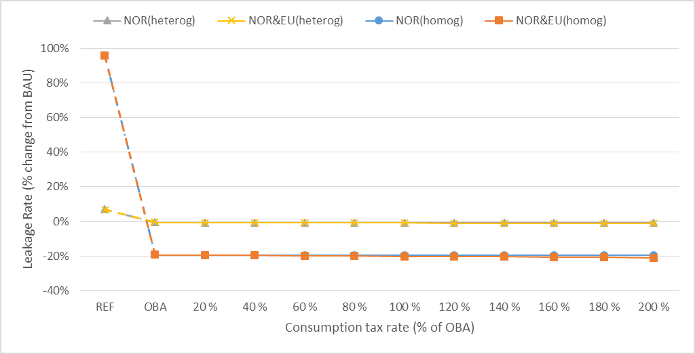
Figure 1: Leakage rate from Norway and EU under different combination of policies, and assumptions of heterogonous (heterog) and homogenous (homog) goods. “NOR” denotes consumption tax only in Norway, while “NOR&EU” denotes joint consumption tax in the two regions. The numbers on the horizontal axis indicate consumption tax rate as a share of the OBA rate.
Figure 1 shows the effects on leakage in the different scenarios. In the REF scenario, with only emission pricing, the leakage rate is close to 95% in the homogenous goods case, while merely 8% in the heterogeneous goods case. Since goods are less trade exposed with a lower Armington elasticity, the leakage rate is consequently lower as well. Given no energy trade in our model, leakage only happens through the market for EITE-goods (y) in our analysis. Next, the figure shows that introducing OBA has significant impact on leakage, which is fully eliminated. That is, OBA provides a perfect leakage mitigation tool in our model. With consumption tax gradually introduced in Norway, the leakage rate continues to decrease, but only slightly as Norway constitutes a small part of the abating regions. However, the consumption tax has a slightly bigger impact on the leakage rate when it is introduced in both regions.
The permit price is $179 or $70 in REF, when we assume heterogonous or homogenous goods, respectively. As stated earlier, the OBA tends to simulate local production of the y good, while the consumption tax reduces the demand for the same good. This has implications for the permit market in EU and Norway, and hence for the permit price. The permit price increases under OBA, as expected: With more output of the y good produced domestically, the permit price must increase in order to clear the permit market. With gradually increasing consumption tax, the permit price decreases due to less production of the y good.
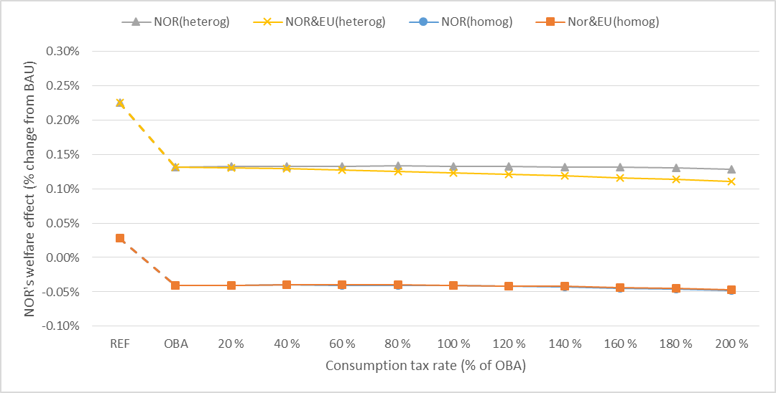
Figure 2: Norway’s welfare effect under different combination of policies, and assumptions of heterogonous (heterog) and homogenous (homog) goods. “NOR” denotes consumption tax only in Norway, while “NOR&EU” denotes joint consumption tax in the two regions. The numbers on the horizontal axis indicate consumption tax rate as a share of the OBA rate.
Figure 2 shows the welfare change in Norway under the different policies. The change is displayed as a percentage change compared to the BAU scenario, also taking into account the change in global emissions, where we use the emission price from REF to value these changes. We attribute the welfare change related to emission to the region(s) that imposes the policy. Thus, if only Norway implements a consumption tax, the whole emission reduction (vis-à-vis OBA) is regarded as a welfare gain for Norway. If both Norway and the EU introduce a joint consumption tax, only a share of the emission benefits is assigned Norway, where the share is determined by Norway’s initial emissions relative to that of Norway and the EU in total. As discussed in Section 2, the marginal cost of emissions τ could be different from the permit price t. Thus, a sensitivity analysis is carried out with different marginal cost of emission τ in the following section.
The OBA reallocates production from ROW back to the abating regions. Further, global emissions decline under the OBA scenario compared to REF, meaning less climate damages. However, with OBA leading to higher permit price and lower price for good y, the demand for all other goods fall in Norway. The overall results indicate a welfare declining effect of OBA in Norway, which is a net exporter of EITE goods. The theoretical analysis in Section 2 suggested ambiguous effects on welfare for a region that implements a consumption tax, if the region is a net exporter of the leakage-exposed good. Our numerical simulation however suggests that the consumption tax is welfare improving in Norway, with an optimal consumption tax in the range of about 80% (40%) of the OBA-rate when assuming heterogeneous (homogenous). The welfare impacts are generally small, however. The main drivers for the welfare improvement in Norway seem to be both lower global emissions and correction of the distortive OBA effects (as the terms of trade effects are negative for Norway). When disregarding the welfare effects of lower global emissions, the optimal consumption tax (for Norway) is still positive but somewhat lower (40% vs. 80%). If both abating regions introduce the consumption tax, Norway’s welfare is practically unchanged up to a tax level of 20% of the OBA-rate when assuming heterogeneous goods, while the optimal tax for Norway is 60% of the OBA-rate when assuming homogenous goods.
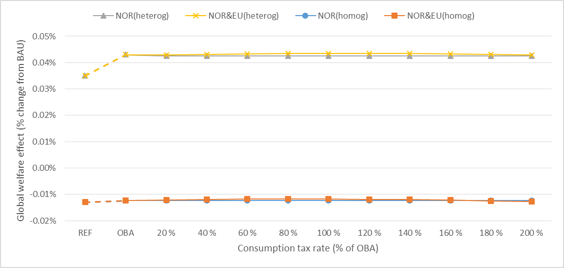
Figure 3: Global welfare effects under different combination of policies, and assumptions of heterogonous (heterog) and homogenous (homog) goods. “NOR” denotes consumption tax only in Norway, while “NOR&EU” denotes joint consumption tax in the two regions. The numbers on the horizontal axis indicate consumption tax rate as a share of the OBA rate.
According to our proposition 2, a consumption tax on top of the OBA in Norway, has an unambiguously positive effect from a global welfare perspective. Results illustrated in Figure 4 support this finding, and suggest an optimal consumption tax is in the range of around 120% of the OBA-rate when assuming heterogeneous goods. Naturally, the global welfare improvement is much stronger if both abating regions introduce the tax, and again the welfare effects are lower when assuming homogenous goods.
Figure 4 shows the welfare gains for EU and ROW when assuming Armington goods. EU_ in the legends corresponds to EU’s welfare effect, while ROW_ corresponds to ROW’s welfare effect. Contrary to Norway, the OBA results in a welfare improving effect for EU. This supports previous findings in e.g. Böhringer et al. (2017a), when assuming homogenous tradable goods. In the case where the consumption tax is imposed in both the EU and Norway, we notice that the EU benefits from this. In this case, we further see that ROW slightly loses. Hence, the global welfare improvement shown in Figure 3 is partly due to the fact that Norway and the EU gains from terms of trade effects at the expenses of ROW (in addition to the gains from lower emissions). The welfare effect in ROW is also (slightly) negative when a consumption tax is introduced only in Norway. This result supports similar findings in Böhringer et al. (2017c). It is however important to emphasize that overall global welfare effects from the consumption tax are unambiguously positive, and thus in principle at least all regions could be better off if ROW were to be compensated through a monetary transfer.
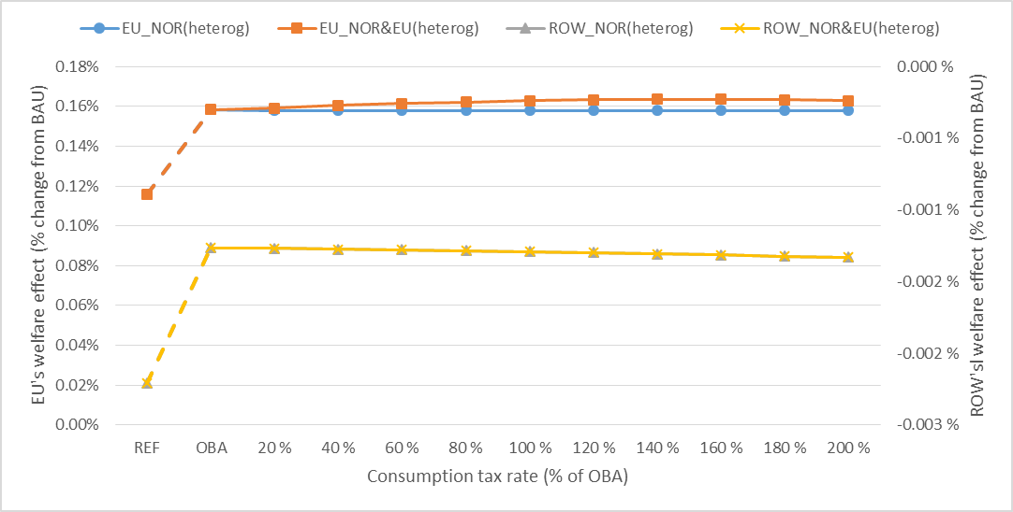
Figure 4: EU’s and ROW’s welfare effects under different combination of policies and assumption of heterogonous (heterog) goods. “NOR” denotes consumption tax only in Norway, while “NOR&EU” denotes joint consumption tax in the two regions. The numbers on the horizontal axis indicate consumption tax rate as a share of the OBA rate.
The effects on consumption in Norway is shown in Figure 5, under different combinations of policies where the consumption tax is only introduced in Norway. Here we consider the heterogonous goods approach. A carbon price (REF) increases the costs for the producers of carbon intensive goods y and z in Europe, and hence the price of these goods, which further reduces the demand for y and z in Norway (and the EU). The consumption of the carbon-free good x, which is now relatively cheaper, increases. When OBA is introduced for the good y, we have the opposite effect for this good as OBA works as an implicit production subsidy to y. Consumption of y and x is higher than the BAU-level under OBA. When the consumption tax is introduced on good y, we see that the consumption of y decreases significantly, while consumption of x and z increases. Consumption of z is always below the BAU scenario, however, in our results. The increased consumption of x and z is due to the relative price changes, as well as declining permit price, and improved terms-of-trade effects. More of the y good is now exported from Norway and more is imported of x.
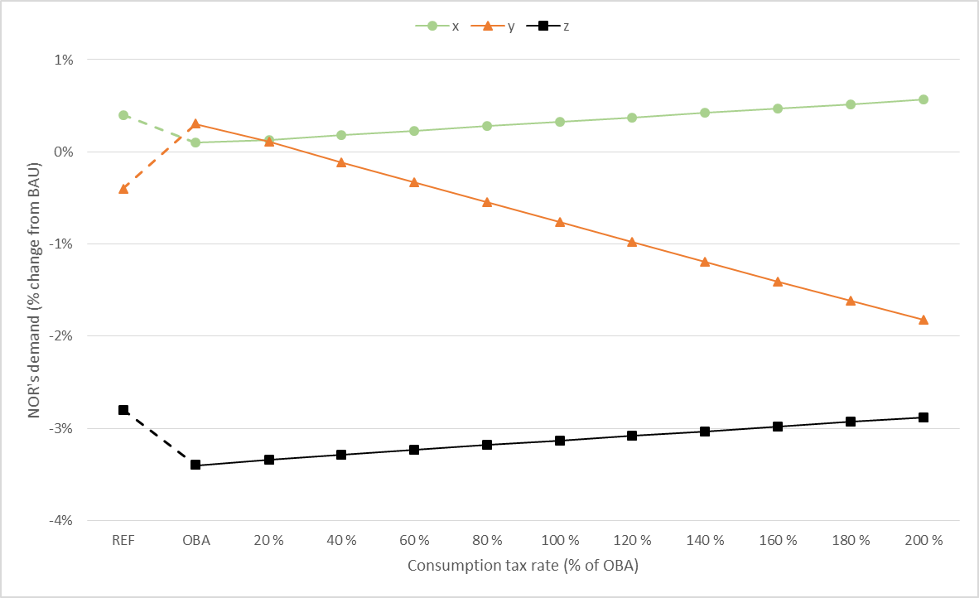Figure 5: Consumption of the three goods in Norway under different combination of policies, and assumption of heterogonous goods. Consumption tax only imposed in Norway. The numbers on the horizontal axis indicate consumption tax rate as a share of the OBA rate.

3.5 Sensitivity analysis
How robust are our numerical results with respect to changes in our model assumptions? For instance, the theoretical analysis showed that regional welfare effects for the tax-implementing region are ambiguous, while the numerical simulations showed a positive effect for Norway. Furthermore, the simulations confirmed the unambiguous theoretical result that global welfare improves. To check the robustness of the results, we now examine the effects of changing some of our main assumptions: i) the EU tightens its emission cap in line with imposing the consumption tax, ii) the mobility of capital, iii) the optimal Pigouvian tax being higher than the emission price in REF, iv) different Armington and substitution elasticity, v) and a consumption tax introduced in other European countries than Norway.
In the base assumption the overall emission in EU is unchanged after introducing the consumption tax, resulting in a reallocation of emission between EU member states. However, it could be the case that the EU decides to tighten its emission cap in order to avoid the so-called waterbed effect. EU’s tightening of the emission cap has been strengthened from 1.7% to 2.2% per year in response to low emission prices. In addition, the Market Stability Reserve has been implemented, probably leading to cancellation of allowances (Perino, 2018). Thus, implementing a consumption tax could possibly lead to similar tightening of the system. One way to address this situation, where the EU does additional emission reductions in line with imposing the consumption tax, is to fix the price of emission (equal to price under OBA). By examining this case, where the consumption tax is introduced in Norway, or Norway and the EU, the results show somewhat higher welfare effect from the consumption tax in both regions compared to the baseline situation. The leakage rate is slightly higher with additional emission reduction in the EU because of unchanged emission price, while global emissions are lower. However, the differences compared to the baseline simulations are only marginal for both welfare and leakage.
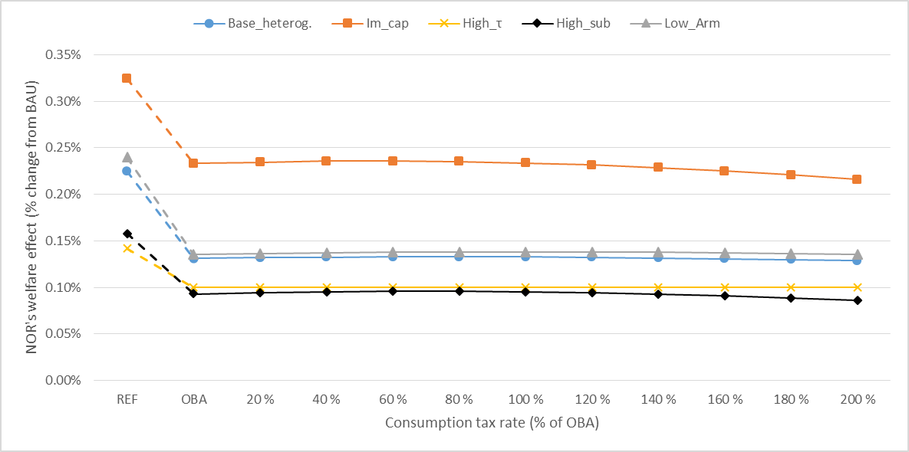Figure 6: Sensitivity analysis of Norway’s welfare effects of consumption tax: Baseline simulations (Base_heterog.), immobile capital (Im_cap), higher Pigouvian tax (High_τ), higher substitution elasticity (High_sub), and lower Armington elasticity (Low_Arm).
In most sectors, capital is likely immobile in the short term. Figure 6 shows the welfare effect globally and for Norway with the assumption of immobile capital between sectors but still domestically mobile labor force. With immobile capital, the leakage is less of a concern and hence the welfare changes are more beneficial under all scenarios compared with the benchmark assumption, both for Norway and globally. Further, the optimal consumption tax is around 60% of the OBA rate while the optimal consumption tax for global welfare is in the range of about 20% of the OBA rate.
In our theoretical analysis, we discussed the possibility of the Pigouvian tax being different from the carbon price observed in the REF scenario (in the benchmark simulations, we have assumed that the two are equal). In particular, given the low prices in the EU Emission Trading System over the last years, one could argue that the Pigouvian tax is higher than the current CO₂ price. In our baseline simulations, the permit price is rather high, as the emission reduction target is quite ambitious (20%). Figure 6 shows the case if EU’s reduction target is set to 10% and the Pigouvian tax is at the same level as in the baseline simulation, the benefits of the climate policy would naturally be bigger as global emission reductions would have a greater impact on welfare. Hence for Norway, the optimal consumption tax is somewhat higher than with our benchmark assumption, now in the range of around 100% of the OBA rate. For the global welfare effect, the optimal consumption tax is around 120% of the OBA rate. The additional welfare gains from the consumption tax in Norway and globally are however about the same as in the benchmark simulations.
With a lower Armington elasticity, we now assume less trade-exposure for producer 𝑥 and 𝑦. In Figure 6 we show how this assumption affects the global and Norway’s welfare. The welfare effects under all the different policy scenarios are higher with a lower Armington elasticity. This is mainly a result of leakage now being more limited, and therefore the global benefits of emission reductions are bigger. The numerical simulations still suggest that the consumption tax is welfare improving for Norway. Moreover, the optimal consumption tax is now higher (100% of the OBA rate) than in our benchmark simulations with the Armington goods assumption (80% of the OBA rate). The global welfare effects are also positive, but still limited with only Norway introducing the consumption tax. The optimal consumption tax for the global welfare is still in the range of 120% of the OBA rate. The global welfare effects are in general higher with lower Armington elasticity, and that moving from REF to OBA has higher global welfare gains.
In our baseline simulations, we assumed a substitution elasticity value of 0.5. With a higher value (of 2) the consumption tends to shift more towards the carbon-free good $x$ in REF, and to $x$ and $z$ with a consumption tax. Hence, Norway’s welfare gains of a consumption tax are in general lower compared to our baseline simulations. However, a consumption tax combined with OBA still has a welfare improving effect for Norway and globally. With heterogeneous goods, the optimal consumption tax is in the range of 60% of the OBA rate for Norway (vs. 80% in the baseline simulation), and 100% (vs. 120%) when considering global welfare.
How would a consumption tax introduced in another EU/EEA country than Norway affect both their regional and global welfare? In Figure 7 we list the result under various combination of policies in different EU countries. In the model, we replace the region Norway with an EU country, and include Norway in the EU region. The parameters in the model are calibrated in the same way as described in section 3.2, i.e., according to the specific country’s characteristics. In line with section 3.4, we use the permit price in the REF scenario to reflect the EU/EEA country’s valuation of global emission. Hence, the valuation of global emission for each of the EU/EEA countries is the same as Norway’s in section 3.4. The Armington elasticity for the representative agent is set to the same values as in our baseline simulation in section 3.4, and the percent values in the figure is the optimal consumption tax rate for the different countries. The figure shows the same qualitative result as for Norway, when different EU countries introduce the consumption tax. That is, a consumption tax on top of OBA increases regional welfare for all countries. The optimal consumption tax is in the range of 80%-200%, with Bulgaria, Estonia and Lithuania having the highest rate. Because of their small economic size and the countries being net exporter of the carbon free good $x$, their welfare gain is substantial compared to BAU. Global welfare increases too in all these cases when a regional consumption tax is implemented. The magnitude differs depending on the policy introducing country’s specific characteristics, such as the size of the economy and of the sectors. In line with our finding from section 3.4, the positive effect on welfare from the consumption tax is mainly due to its effects on emissions and terms of trade, and correction of the distortive OBA effects.
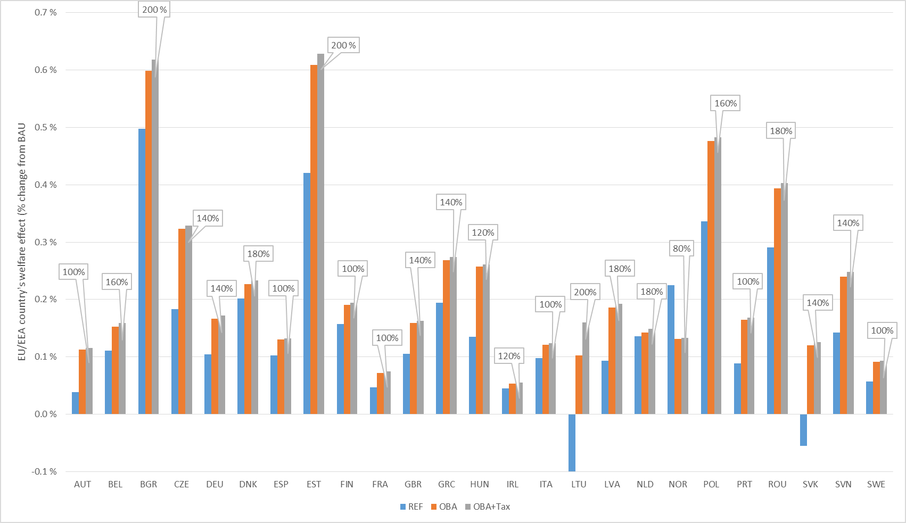
Figure 7: Regional welfare effects under different combination of policies in EU/EEA countries. Percentage changes vis-à-vis BAU. The numbers indicate optimal consumption tax rate for each country (as a share of the OBA rate).

4. Concluding remarks
As the world will still rely on unilateral action after the Paris climate agreement, many countries are considering or have introduced climate policies such as emission trading systems. Greenhouse gases however are global pollutants and unilateral action leads to carbon leakage when there is no global cap on emissions. In this paper we have focused on leakage associated with the relocation of emission-intensive and trade-exposed (EITE) industries. The economics literature have suggested different approaches to mitigate this type of carbon leakage, where border carbon adjustment in addition to emission pricing has been regarded as a second-best instrument to improve cost-effectiveness of unilateral climate policy. This instrument may not however be politically feasible, so countries and regions have either excluded such industries from their regulations or found other anti-leakage solutions, such as output-based allocation (OBA) to EITE-industries, which has been implemented e.g. in the EU ETS.
However, as OBA acts as an implicit production subsidy to domestic production, this results in too high consumption and production worldwide. Hence, an approach where OBA is combined with a consumption tax on all use of the EITE goods has been proposed by e.g. Böhringer et al. (2017c). In the current paper we have examined whether a single country, being part of a bigger ETS involving many countries where OBA to EITE-industries is already in place, should unilaterally implement such a consumption tax.
We first showed analytically that it is welfare improving for the single country to introduce the consumption tax when we account for the benefits of reduced global emissions, unless there are strong unfavorable terms-of-trade effects. Moreover, the consumption tax has an unambiguous global welfare improving effect. Next, we confirmed these results with a stylized numerical model calibrated to real world data, where we considered the context of the EU ETS. Individual EU/EEA members were consistently better off in welfare terms if implementing such a consumption tax.
If the tax is set equal to the output-based allocation factors (“benchmarks”), the administrative cost of adding such a consumption tax will likely be limited (Neuhoff et al., 2016a; Ismer and Haussner, 2016). Böhringer et al. (2017c) shows that the outcome of this combined policy will be equivalent to a certain variant of border carbon adjustments. However, a more differentiated variant of carbon tariffs could still be more targeted than a consumption tax, especially if the tariff is able to differentiate between firms according to their emission intensity (Böhringer et al. 2017b). First of all, it would redirect imports (and consumption) towards the least emission-intensive countries or producers, as these are less hit by the tariff. In addition, if the tariffs are firm-specific they might give these firms incentives to reduce their emission intensity. Still, the question remains about the compatibility with WTO rules. Thus, in the meantime combining output-based allocation with a consumption tax seems like a powerful and acceptable policy strategy to mitigate carbon leakage, also for individual countries involved in a more extensive emission trading system.
Appendix A, Derivations

A1: Region welfare maximization

By differentiating the regional welfare (5) with respect to consumptions tax, we get
$$\frac{{∂W}^{1}}{∂v^{1}}=u_{x}^{1}\frac{∂{\overline{x}}^{1}}{∂v^{1}}+u_{y}^{1}\frac{∂{\overline{y}}^{1}}{∂v^{1}}+u_{z}^{1}\frac{∂{\overline{z}}^{1}}{∂v^{1}}-c_{x}^{x1}\frac{∂x^{1}}{∂v^{1}}-c_{y}^{y1}\frac{∂y^{1}}{∂v^{1}}-c_{z}^{z1}\frac{∂z^{1}}{∂v^{1}}-c_{e}^{y1}\frac{∂e^{y1}}{∂v^{1}}-c_{e}^{z1}\frac{∂e^{z1}}{∂v^{1}}-τ\left[\frac{∂e^{y1}}{∂v^{1}}+\frac{∂e^{y2}}{∂v^{1}}+\frac{∂e^{y3}}{∂v^{1}}+\frac{∂e^{z1}}{∂v^{1}}+\frac{∂e^{z2}}{∂v^{1}}+\frac{∂e^{z3}}{∂v^{1}}\right]$$
Recall the conditions and assumptions from (2) and (3), and we then get
$$=p^{x}\frac{∂{\overline{x}}^{1}}{∂v^{1}}+\left(p^{y}+v^{1}\right)\frac{∂{\overline{y}}^{1}}{∂v^{1}}+p^{z1}\frac{∂{\overline{z}}^{1}}{∂v^{1}}-p^{x}\frac{∂x^{1}}{∂v^{1}}-\left(p^{y}+s^{1}\right)\frac{∂y^{1}}{∂v^{1}}-p^{z1}\frac{∂z^{1}}{∂v^{1}}+t^{1}\frac{∂e^{y1}}{∂v^{1}}+t^{1}\frac{∂e^{z1}}{∂v^{1}}-τ\left[\frac{∂e^{y1}}{∂v^{1}}+\frac{∂e^{y2}}{∂v^{1}}+\frac{∂e^{y3}}{∂v^{1}}+\frac{∂e^{z1}}{∂v^{1}}+\frac{∂e^{z2}}{∂v^{1}}+\frac{∂e^{z3}}{∂v^{1}}\right]$$

We further simplify the equation
$$=p^{x}\frac{∂{\overline{x}}^{1}}{∂v^{1}}-p^{x}\frac{∂x^{1}}{∂v^{1}}+\left(p^{y}+v^{1}\right)\frac{∂{\overline{y}}^{1}}{∂v^{1}}+p^{z1}\frac{∂{\overline{z}}^{1}}{∂v^{1}}-p^{z1}\frac{∂z^{1}}{∂v^{1}}-\left(p^{y}+s^{1}\right)\frac{∂y^{1}}{∂v^{1}}+t^{1}\left(\frac{∂e^{y1}}{∂v^{1}}+\frac{∂e^{z1}}{∂v^{1}}\right)-τ\left[\frac{∂e^{y1}}{∂v^{1}}+\frac{∂e^{y2}}{∂v^{1}}+\frac{∂e^{y3}}{∂v^{1}}+\frac{∂e^{z1}}{∂v^{1}}+\frac{∂e^{z2}}{∂v^{1}}+\frac{∂e^{z3}}{∂v^{1}}\right]$$

$$=p^{x}\left(\frac{∂{\overline{x}}^{1}}{∂v^{1}}-\frac{∂x^{1}}{∂v^{1}}\right)+\left(p^{y}+v^{1}\right)\frac{∂{\overline{y}}^{1}}{∂v^{1}}+p^{z1}\left(\frac{∂{\overline{z}}^{1}}{∂v^{1}}-\frac{∂z^{1}}{∂v^{1}}\right)-\left(p^{y}+s^{1}\right)\frac{∂y^{1}}{∂v^{1}}+t^{1}\left(\frac{∂e^{y1}}{∂v^{1}}+\frac{∂e^{z1}}{∂v^{1}}\right)-τ\left[\frac{∂e^{y1}}{∂v^{1}}+\frac{∂e^{y2}}{∂v^{1}}+\frac{∂e^{y3}}{∂v^{1}}+\frac{∂e^{z1}}{∂v^{1}}+\frac{∂e^{z2}}{∂v^{1}}+\frac{∂e^{z3}}{∂v^{1}}\right]$$

Since there is no trade of the good $z$, i.e. $\left(\frac{∂{\overline{z}}^{1}}{∂v^{1}}=\frac{∂z^{1}}{∂v^{1}}\right)$:
$$=p^{x}\left(\frac{∂{\overline{x}}^{1}}{∂v^{1}}-\frac{∂x^{1}}{∂v^{1}}\right)+\left(p^{y}+v^{1}\right)\frac{∂{\overline{y}}^{1}}{∂v^{1}}-\left(p^{y}+s^{1}\right)\frac{∂y^{1}}{∂v^{1}}+t^{1}\left(\frac{∂e^{y1}}{∂v^{1}}+\frac{∂e^{z1}}{∂v^{1}}\right)-τ\left[\frac{∂e^{y1}}{∂v^{1}}+\frac{∂e^{y2}}{∂v^{1}}+\frac{∂e^{y3}}{∂v^{1}}+\frac{∂e^{z1}}{∂v^{1}}+\frac{∂e^{z2}}{∂v^{1}}+\frac{∂e^{z3}}{∂v^{1}}\right]$$
Recall (4), further we differentiate (4) w.r.t. consumption tax, remembering the product rule:
$$\frac{∂p^{y}}{∂v^{1}}\left(y^{1}-{\overline{y}}^{1}\right)+p^{y}\left(\frac{∂y^{1}}{∂v^{1}}-\frac{∂{\overline{y}}^{1}}{∂v^{1}}\right)+\frac{∂p^{x}}{∂v^{1}}\left(x^{1}-{\overline{x}}^{1}\right)+p^{x}\left(\frac{∂x^{1}}{∂v^{1}}-\frac{∂{\overline{x}}^{1}}{∂v^{1}}\right)=0$$

solving this for $p^{x}$
$$p^{x}=\frac{\left(p^{y}\left(\frac{∂y^{1}}{∂v^{1}}-\frac{∂{\overline{y}}^{1}}{∂v^{1}}\right)+\frac{∂p^{y}}{∂v^{1}}\left(y^{1}-{\overline{y}}^{1}\right)+\frac{∂p^{x}}{∂v^{1}}\left(x^{1}-{\overline{x}}^{1}\right)\right)}{-\left(\frac{∂x^{1}}{∂v^{1}}-\frac{∂{\overline{x}}^{1}}{∂v^{1}}\right)}$$
we insert this into our equation for $p^{x}$
$$\frac{{∂W}^{1}}{∂v^{1}}=\left[\frac{\left(p^{y}\left(\frac{∂y^{1}}{∂v^{1}}-\frac{∂{\overline{y}}^{1}}{∂v^{1}}\right)+\frac{∂p^{y}}{∂v^{1}}\left(y^{1}-{\overline{y}}^{1}\right)+\frac{∂p^{x}}{∂v^{1}}\left(x^{1}-{\overline{x}}^{1}\right)\right)}{-\left(\frac{∂x^{1}}{∂v^{1}}-\frac{∂{\overline{x}}^{1}}{∂v^{1}}\right)}\right]\left(\frac{∂{\overline{x}}^{1}}{∂v^{1}}-\frac{∂x^{1}}{∂v^{1}}\right)+\left(p^{y}+v^{1}\right)\frac{∂{\overline{y}}^{1}}{∂v^{1}}-\left(p^{y}+s^{1}\right)\frac{∂y^{1}}{∂v^{1}}+t^{1}\left(\frac{∂e^{y1}}{∂v^{1}}+\frac{∂e^{z1}}{∂v^{1}}\right)-τ\left[\frac{∂e^{y1}}{∂v^{1}}+\frac{∂e^{y2}}{∂v^{1}}+\frac{∂e^{y3}}{∂v^{1}}+\frac{∂e^{z1}}{∂v^{1}}+\frac{∂e^{z2}}{∂v^{1}}+\frac{∂e^{z3}}{∂v^{1}}\right]$$

and since
$$-\frac{\left(\frac{∂{\overline{x}}^{1}}{∂v^{1}}-\frac{∂x^{1}}{∂v^{1}}\right)}{\left(\frac{∂x^{1}}{∂v^{1}}-\frac{∂{\overline{x}}^{1}}{∂v^{1}}\right)}=\frac{\left(\frac{∂{\overline{x}}^{1}}{∂v^{1}}-\frac{∂x^{1}}{∂v^{1}}\right)}{\left(\frac{∂{\overline{x}}^{1}}{∂v^{1}}-\frac{∂x^{1}}{∂v^{1}}\right)}=1$$
We can further simplify:
$$=p^{y}\left(\frac{∂y^{1}}{∂v^{1}}-\frac{∂{\overline{y}}^{1}}{∂v^{1}}\right)+\frac{∂p^{y}}{∂v^{1}}\left(y^{1}-{\overline{y}}^{1}\right)+\frac{∂p^{x}}{∂v^{1}}\left(x^{1}-{\overline{x}}^{1}\right)+\left(p^{y}+v^{1}\right)\frac{∂{\overline{y}}^{1}}{∂v^{1}}-\left(p^{y}+s^{1}\right)\frac{∂y^{1}}{∂v^{1}}+t^{1}\left(\frac{∂e^{y1}}{∂v^{1}}+\frac{∂e^{z1}}{∂v^{1}}\right)-τ\left[\frac{∂e^{y1}}{∂v^{1}}+\frac{∂e^{y2}}{∂v^{1}}+\frac{∂e^{y3}}{∂v^{1}}+\frac{∂e^{z1}}{∂v^{1}}+\frac{∂e^{z2}}{∂v^{1}}+\frac{∂e^{z3}}{∂v^{1}}\right]$$

$$=p^{y}\left(\frac{∂y^{1}}{∂v^{1}}-\frac{∂{\overline{y}}^{1}}{∂v^{1}}+\frac{∂{\overline{y}}^{1}}{∂v^{1}}-\frac{∂y^{1}}{∂v^{1}}\right)+\frac{∂p^{y}}{∂v^{1}}\left(y^{1}-{\overline{y}}^{1}\right)+\frac{∂p^{x}}{∂v^{1}}\left(x^{1}-{\overline{x}}^{1}\right)+v^{1}\frac{∂{\overline{y}}^{1}}{∂v^{1}}-s^{1}\frac{∂y^{1}}{∂v^{1}}+t^{1}\left(\frac{∂e^{y1}}{∂v^{1}}+\frac{∂e^{z1}}{∂v^{1}}\right)-τ\left[\frac{∂e^{y1}}{∂v^{1}}+\frac{∂e^{z1}}{∂v^{1}}+\frac{∂e^{y2}}{∂v^{1}}+\frac{∂e^{z2}}{∂v^{1}}+\frac{∂e^{y3}}{∂v^{1}}+\frac{∂e^{z3}}{∂v^{1}}\right]$$
Recall the constraint on emission in region 1 and 2, $\overline{E}=e^{y1}+e^{y2}+e^{z1}+e^{z2}$. By differentiating this w.r.t the consumption tax, we have that:
$$\frac{∂\overline{E}}{∂v^{1}}=\frac{∂e^{y1}}{∂v^{1}}+\frac{∂e^{y2}}{∂v^{1}}+\frac{∂e^{z1}}{∂v^{1}}+\frac{∂e^{z2}}{∂v^{1}}=0$$
By this assumption, our equation can now be expressed as:
$$=p^{y}\left(\frac{∂y^{1}}{∂v^{1}}-\frac{∂{\overline{y}}^{1}}{∂v^{1}}+\frac{∂{\overline{y}}^{1}}{∂v^{1}}-\frac{∂y^{1}}{∂v^{1}}\right)+\frac{∂p^{y}}{∂v^{1}}\left(y^{1}-{\overline{y}}^{1}\right)+\frac{∂p^{x}}{∂v^{1}}\left(x^{1}-{\overline{x}}^{1}\right)+v^{1}\frac{∂{\overline{y}}^{1}}{∂v^{1}}-s^{1}\frac{∂y^{1}}{∂v^{1}}+t^{1}\left(\frac{∂e^{y1}}{∂v^{1}}+\frac{∂e^{z1}}{∂v^{1}}\right)-τ\left[\frac{∂e^{y3}}{∂v^{1}}+\frac{∂e^{z3}}{∂v^{1}}\right]$$

and simplified to
$$=v^{1}\frac{∂{\overline{y}}^{1}}{∂v^{1}}-s^{1}\frac{∂y^{1}}{∂v^{1}}+\frac{∂p^{y}}{∂v^{1}}\left(y^{1}-{\overline{y}}^{1}\right)+\frac{∂p^{x}}{∂v^{1}}\left(x^{1}-{\overline{x}}^{1}\right)+t^{1}\left(\frac{∂e^{y1}}{∂v^{1}}+\frac{∂e^{z1}}{∂v^{1}}\right)-τ\left[\frac{∂e^{y3}}{∂v^{1}}+\frac{∂e^{z3}}{∂v^{1}}\right]$$
And we finally arrive at (6), by moving $v^{1}$ on the other side of the equal sign
$v^{1*}={\left(\frac{∂{\overline{y}}^{1}}{∂v^{1}}\right)}^{-1}\left[s^{1}\frac{∂y^{1}}{∂v^{1}}-\frac{∂p^{y}}{∂v^{1}}\left(y^{1}-{\overline{y}}^{1}\right)-\frac{∂p^{x}}{∂v^{1}}\left(x^{1}-{\overline{x}}^{1}\right)+\left(-t^{1}\right)\left(\frac{∂e^{y1}}{∂y^{1}}\frac{∂y^{1}}{∂v^{1}}+\frac{∂e^{z1}}{∂z^{1}}\frac{∂z^{1}}{∂v^{1}}\right)+τ\left(\frac{∂e^{y3}}{∂y^{3}}\frac{∂y^{3}}{∂v^{1}}+\frac{∂e^{z3}}{∂z^{3}}\frac{∂z^{3}}{∂v^{1}}\right)\right]$ (6)

A2: Global Welfare Maximization

By differentiating the global welfare w.r.t consumption tax in region 1, we get
$$\frac{{∂W}^{G}}{∂v^{1}}=\sum_{j=1,2,3}{\left[u_{x}^{j}\frac{∂{\overline{x}}^{j}}{∂v^{1}}+u_{y}^{j}\frac{∂{\overline{y}}^{j}}{∂v^{1}}+u_{z}^{j}\frac{∂{\overline{z}}^{j}}{∂v^{1}}-c_{x}^{xj}\frac{∂x^{j}}{∂v^{1}}-c_{y}^{yj}\frac{∂y^{j}}{∂v^{1}}-c_{z}^{zj}\frac{∂z^{j}}{∂v^{1}}-\left(τ+c_{e}^{yj}\right)\frac{∂e^{yj}}{∂v^{1}}-\left(τ+c_{e}^{zj}\right)\frac{∂e^{zj}}{∂v^{1}}\right]}$$

From our assumption in (2), (3), (5) and (6) we get
$$\frac{{∂W}^{G}}{∂v^{1}}=\sum_{j=1,2,3}{\left[p^{x}\frac{∂{\overline{x}}^{j}}{∂v^{1}}+\left(p^{y}+v^{j}\right)\frac{∂{\overline{y}}^{j}}{∂v^{1}}+p^{zj}\frac{∂{\overline{z}}^{j}}{∂v^{1}}-p^{x}\frac{∂x^{j}}{∂v^{1}}-\left(p^{y}+s^{j}\right)\frac{∂y^{j}}{∂v^{1}}-p^{zj}\frac{∂z^{j}}{∂v^{1}}\right]}-\left(τ+c_{e}^{y1}\right)\frac{∂e^{y1}}{∂v^{1}}-\left(τ+c_{e}^{z1}\right)\frac{∂e^{z1}}{∂v^{1}}-\left(τ+c_{e}^{y2}\right)\frac{∂e^{y2}}{∂v^{1}}-\left(τ+c_{e}^{z2}\right)\frac{∂e^{z2}}{∂v^{1}}-\left(τ+c_{e}^{y3}\right)\frac{∂e^{y3}}{∂v^{1}}-\left(τ+c_{e}^{z3}\right)\frac{∂e^{z3}}{∂v^{1}}$$

$$=\sum_{j=1,2,3}{\left[p^{x}\frac{∂{\overline{x}}^{j}}{∂v^{1}}-p^{x}\frac{∂x^{j}}{∂v^{1}}+\left(p^{y}+v^{j}\right)\frac{∂{\overline{y}}^{j}}{∂v^{1}}-\left(p^{y}+s^{j}\right)\frac{∂y^{j}}{∂v^{1}}+p^{zj}\frac{∂{\overline{z}}^{j}}{∂v^{1}}-p^{zj}\frac{∂z^{j}}{∂v^{1}}\right]}-\left(τ-t^{1}\right)\frac{∂e^{y1}}{∂v^{1}}-\left(τ-t^{1}\right)\frac{∂e^{z1}}{∂v^{1}}-\left(τ-t^{2}\right)\frac{∂e^{y2}}{∂v^{1}}-\left(τ-t^{2}\right)\frac{∂e^{z2}}{∂v^{1}}-\left(τ+c_{e}^{y3}\right)\frac{∂e^{y3}}{∂v^{1}}-\left(τ+c_{e}^{z3}\right)\frac{∂e^{z3}}{∂v^{1}}$$
Since good $z$ is non-tradable, the production in region $j$ is equal to consumption in the same region. Also recall that $c_{e}^{y3}=c_{e}^{z3}=0$ and $t^{1}=t^{2}$
$$=\sum_{j=1,2,3}{\left[p^{x}\left(\frac{∂{\overline{x}}^{j}}{∂v^{1}}-\frac{∂x^{j}}{∂v^{1}}\right)+\left(p^{y}+v^{j}\right)\frac{∂{\overline{y}}^{j}}{∂v^{1}}+p^{zj}\left(\frac{∂{\overline{z}}^{j}}{∂v^{1}}-\frac{∂z^{j}}{∂v^{1}}\right)-\left(p^{y}+s^{j}\right)\frac{∂y^{j}}{∂v^{1}}\right]}+\left(t^{1}-τ\right)\left(\frac{∂e^{y1}}{∂v^{1}}+\frac{∂e^{z1}}{∂v^{1}}\right)+\left(t^{1}-τ\right)\left(\frac{∂e^{y2}}{∂v^{1}}+\frac{∂e^{z2}}{∂v^{1}}\right)-τ\left(\frac{∂e^{y3}}{∂v^{1}}+\frac{∂e^{z3}}{∂v^{1}}\right)$$
Again, we use our assumptions from (4), differentiate w.r.t consumption tax and solve it for $p^{x}$(remembering the product rule):
$$\frac{∂p^{y}}{∂v^{1}}\left(y^{j}-{\overline{y}}^{j}\right)+p^{y}\left(\frac{∂y^{j}}{∂v^{1}}-\frac{∂{\overline{y}}^{j}}{∂v^{1}}\right)+\frac{∂p^{x}}{∂v^{1}}\left(x^{j}-{\overline{x}}^{j}\right)+p^{x}\left(\frac{∂x^{j}}{∂v^{1}}-\frac{∂{\overline{x}}^{j}}{∂v^{1}}\right)=0$$
$$p^{x}=\frac{\left(p^{y}\left(\frac{∂y^{j}}{∂v^{1}}-\frac{∂{\overline{y}}^{j}}{∂v^{1}}\right)+\frac{∂p^{y}}{∂v^{1}}\left(y^{j}-{\overline{y}}^{j}\right)+\frac{∂p^{x}}{∂v^{1}}\left(x^{j}-{\overline{x}}^{j}\right)\right)}{-\left(\frac{∂x^{j}}{∂v^{1}}-\frac{∂{\overline{x}}^{j}}{∂v^{1}}\right)}$$
Insert this for $p^{x}$ into our equation:
$$\sum_{j=1,2,3}{\left[\frac{\left(p^{y}\left(\frac{∂y^{j}}{∂v^{1}}-\frac{∂{\overline{y}}^{j}}{∂v^{1}}\right)+\frac{∂p^{y}}{∂v^{1}}\left(y^{j}-{\overline{y}}^{j}\right)+\frac{∂p^{x}}{∂v^{1}}\left(x^{j}-{\overline{x}}^{j}\right)\right)}{-\left(\frac{∂x^{j}}{∂v^{1}}-\frac{∂{\overline{x}}^{j}}{∂v^{1}}\right)}\left(\frac{∂{\overline{x}}^{j}}{∂v^{1}}-\frac{∂x^{j}}{∂v^{1}}\right)+\left(p^{y}+v^{j}\right)\frac{∂{\overline{y}}^{j}}{∂v^{1}}+p^{zj}\left(\frac{∂{\overline{z}}^{j}}{∂v^{1}}-\frac{∂z^{j}}{∂v^{1}}\right)-\left(p^{y}+s^{j}\right)\frac{∂y^{j}}{∂v^{1}}\right]}+\left(t^{1}-τ\right)\left(\frac{∂e^{y1}}{∂v^{1}}+\frac{∂e^{z1}}{∂v^{1}}\right)+\left(t^{1}-τ\right)\left(\frac{∂e^{y2}}{∂v^{1}}+\frac{∂e^{z2}}{∂v^{1}}\right)-τ\left(\frac{∂e^{y3}}{∂v^{1}}+\frac{∂e^{z3}}{∂v^{1}}\right)$$

Since
$$\frac{\left(\frac{∂{\overline{x}}^{j}}{∂v^{1}}-\frac{∂x^{j}}{∂v^{1}}\right)}{\left(\frac{∂{\overline{x}}^{j}}{∂v^{1}}-\frac{∂x^{j}}{∂v^{1}}\right)}=1$$
The equation can be simplified to
$$=\sum_{j=1,2,3}{\left[p^{y}\left(\frac{∂y^{j}}{∂v^{1}}-\frac{∂{\overline{y}}^{j}}{∂v^{1}}\right)+\frac{∂p^{y}}{∂v^{1}}\left(y^{j}-{\overline{y}}^{j}\right)+\frac{∂p^{x}}{∂v^{1}}\left(x^{j}-{\overline{x}}^{j}\right)+\left(p^{y}+v^{j}\right)\frac{∂{\overline{y}}^{j}}{∂v^{1}}-\left(p^{y}+s^{j}\right)\frac{∂y^{j}}{∂v^{1}}\right]}+\left(t^{1}-τ\right)\left(\frac{∂e^{y1}}{∂v^{1}}+\frac{∂e^{z1}}{∂v^{1}}\right)+\left(t^{1}-τ\right)\left(\frac{∂e^{y2}}{∂v^{1}}+\frac{∂e^{z2}}{∂v^{1}}\right)-τ\left(\frac{∂e^{y3}}{∂v^{1}}+\frac{∂e^{z3}}{∂v^{1}}\right)$$
$$=\sum_{j=1,2,3}{\left[p^{y}\left(\frac{∂y^{j}}{∂v^{1}}-\frac{∂{\overline{y}}^{j}}{∂v^{1}}+\frac{∂{\overline{y}}^{j}}{∂v^{1}}-\frac{∂y^{j}}{∂v^{1}}\right)+\frac{∂p^{y}}{∂v^{1}}\left(y^{j}-{\overline{y}}^{j}\right)+\frac{∂p^{x}}{∂v^{1}}\left(x^{j}-{\overline{x}}^{j}\right)+v^{j}\frac{∂{\overline{y}}^{j}}{∂v^{1}}-s^{j}\frac{∂y^{j}}{∂v^{1}}\right]}+\left(t^{1}-τ\right)\left(\frac{∂e^{y1}}{∂v^{1}}+\frac{∂e^{z1}}{∂v^{1}}\right)+\left(t^{1}-τ\right)\left(\frac{∂e^{y2}}{∂v^{1}}+\frac{∂e^{z2}}{∂v^{1}}\right)-τ\left(\frac{∂e^{y3}}{∂v^{1}}+\frac{∂e^{z3}}{∂v^{1}}\right)$$
$$=\sum_{j=1,2,3}{\left[v^{j}\frac{∂{\overline{y}}^{j}}{∂v^{1}}-s^{j}\frac{∂y^{j}}{∂v^{1}}+\frac{∂p^{y}}{∂v^{1}}\left(y^{j}-{\overline{y}}^{j}\right)+\frac{∂p^{x}}{∂v^{1}}\left(x^{j}-{\overline{x}}^{j}\right)\right]}+\left(t^{1}-τ\right)\left(\frac{∂e^{y1}}{∂v^{1}}+\frac{∂e^{z1}}{∂v^{1}}\right)+\left(t^{1}-τ\right)\left(\frac{∂e^{y2}}{∂v^{1}}+\frac{∂e^{z2}}{∂v^{1}}\right)-τ\left(\frac{∂e^{y3}}{∂v^{1}}+\frac{∂e^{z3}}{∂v^{1}}\right)$$

Recall our assumption from (1):
$${\overline{x}}^{1}+{\overline{x}}^{2}+{\overline{x}}^{3}=x^{1}+x^{2}+x^{3}$$
$${\overline{y}}^{1}+{\overline{y}}^{2}+{\overline{y}}^{3}=y^{1}+y^{2}+y^{3}$$

And we can rewrite our equation to
$$=\sum_{j=1,2,3}{\left[v^{j}\frac{∂{\overline{y}}^{j}}{∂v^{1}}-s^{j}\frac{∂y^{j}}{∂v^{1}}\right]}+\left(t^{1}-τ\right)\left(\frac{∂e^{y1}}{∂v^{1}}+\frac{∂e^{z1}}{∂v^{1}}\right)+\left(t^{2}-τ\right)\left(\frac{∂e^{y2}}{∂v^{1}}+\frac{∂e^{z2}}{∂v^{1}}\right)-τ\left(\frac{∂e^{y3}}{∂v^{1}}+\frac{∂e^{z3}}{∂v^{1}}\right)$$
Since the consumption tax is only introduced in region 1, and OBA in region 1 and 2, we can re-write to:
$$=\left(v^{1}\frac{∂{\overline{y}}^{1}}{∂v^{1}}-s^{1}\frac{∂y^{1}}{∂v^{1}}-s^{2}\frac{∂y^{2}}{∂v^{1}}\right)+\left(t^{1}-τ\right)\left(\frac{∂e^{y1}}{∂v^{1}}+\frac{∂e^{z1}}{∂v^{1}}\right)+\left(t^{1}-τ\right)\left(\frac{∂e^{y2}}{∂v^{1}}+\frac{∂e^{z2}}{∂v^{1}}\right)-τ\left(\frac{∂e^{y3}}{∂v^{1}}+\frac{∂e^{z3}}{∂v^{1}}\right)$$
From (2) $s^{1}=s^{2}$ and $t^{1}=t^{2}$
$$v^{1G*}={\left(\frac{∂{\overline{y}}^{1}}{∂v^{1}}\right)}^{-1}\left[s^{1}\left(\frac{∂y^{1}}{∂v^{1}}+\frac{∂y^{2}}{∂v^{1}}\right)+\left(τ-t^{1}\right)\left(\frac{∂e^{y1}}{∂v^{1}}+\frac{∂e^{z1}}{∂v^{1}}+\frac{∂e^{y2}}{∂v^{1}}+\frac{∂e^{z2}}{∂v^{1}}\right)+τ\left(\frac{∂e^{y3}}{∂v^{1}}+\frac{∂e^{z3}}{∂v^{1}}\right)\right]$$
Remembering our emission constraint$\frac{∂\overline{E}}{∂v^{1}}=\frac{∂e^{y1}}{∂v^{1}}+\frac{∂e^{y2}}{∂v^{1}}+\frac{∂e^{z1}}{∂v^{1}}+\frac{∂e^{z2}}{∂v^{1}}=0$, and we finally arrive at (9)
$v^{1G*}={\left(\frac{∂{\overline{y}}^{1}}{∂v^{1}}\right)}^{-1}\left[s^{1}\left(\frac{∂y^{1}}{∂v^{1}}+\frac{∂y^{2}}{∂v^{1}}\right)+τ\left(\frac{∂e^{y3}}{∂y^{3}}\frac{∂y^{3}}{∂v^{1}}+\frac{∂e^{z3}}{∂z^{3}}\frac{∂z^{3}}{∂v^{1}}\right)\right]$ (10)

Appendix B: Summary of the numerical CGE model
Indices and sets:
Set of regions R NOR, EU, ROW
Set of goods g x, y ,z
r (alias j) Index for regions

Variables:
$S^{gr}$ Production of good g in r
$S_{FE}^{r}$ Production of FE in r
$D^{gr}$ Aggregated consumer demand of good g in r
${KL}^{gr}$ Value-added composite for g in r
${KLF}^{r}$ Value-added composite for FE in r
$A^{gr}$ Armington aggregate of g in r
${IM}^{gr}$ Import aggregate of g in r
$W^{r}$ Consumption composite in r

$p^{g,r}$ Price of g in r
$p_{FE}^{r}$ Price of Primary fossil FE in r
$p_{KL}^{gr}$ Price of value added for g in r
$p_{KLF}^{r}$ Price of value added for FE in r
$p_{L}^{r}$ Price of labor (wage rate) in r
$p_{K}^{r}$ Price of capital (rental rate) in r
$p_{Q}^{r}$ Rent for primary energy resource in r
$p_{A}^{gr}$ Price of Armington aggregate of g in r
$p_{IM}^{gr}$ Price of aggregate imports of g in r
$p_{CO2}^{r}$ Price of CO2 emission in r
$p_{W}^{r}$ Price of consumption composite in r
$o^{gr}$ Output-Based Allocation on g in r
$v^{gr}$ Consumption tax on g in r

Parameters:
$σ_{KLE}^{r}$ Substitution between value-added and energy g in r
$σ_{KL}^{r}$ Substitution between value-added g in r
$σ_{Q}^{r}$ Substitution between value-added and natural resource in FE in r
$σ_{LN}^{r}$ Substitution between value-added in FE in r
$σ_{A}^{gr}$ Substitution between import and domestic g in r
$σ_{IM}^{gr}$ Substitution between imports from different g in r
$σ_{W}^{r}$ Substitution between goods to consumption

$θ_{FE}^{gr}$ Cost Share of FE in production of g in r
$θ_{KL}^{gr}$ Cost Share of labor in production of g in r
$θ_{Q}^{r}$ Cost Share of natural resource in production of FE in r
$θ_{LN}^{r}$ Cost Share of labor in production of FE in r
$θ_{A}^{gr}$ Cost Share of domestic goods g in consumption in r
$θ_{IM}^{gr}$ Cost Share of different imports goods g in consumption in r

$L_{0}^{gr}$ Labor endowment in sector g in region 𝑟
$L_{0,FE}^{r}$ Labor endowment in FE in region 𝑟
$K_{0}^{gr}$ Capital endowment in sector g in region 𝑟
$K_{0,FE}^{r}$ Capital endowment in FE in region 𝑟
$Q_{0}^{r}$ Resource endowment of primary fossil energy in region 𝑟
${CO2}_{MAX}^{r}$ CO₂ emission allowance in region 𝑟
$κ_{CO2}^{r}$ Coefficient for primary fossil energy of CO₂ emission in region 𝑟

Zero Profit Conditions
Production of goods except for fossil primary energy:
$$π_{S}^{gr}={\left(θ_{FE}^{gr}{\left(p_{FE}^{r}+κ_{CO2}^{r}p_{CO2}^{gr}\right)}^{\left(1-σ_{KLE}^{r}\right)}+\left(1-θ_{FE}^{gr}\right){p_{KL}^{gr}}^{\left(1-σ_{KLE}^{r}\right)}\right)}^{\left(\frac{1}{1-σ_{KLE}^{r}}\right)} ≥p^{gr}+o^{gr} ⊥S^{gr}$$

Sector specific value-added aggregate for x, y and z:
$$π_{KL}^{gr}={\left(θ_{KL}^{gr}{p_{L}^{r}}^{\left(1-σ_{KL}^{gr}\right)}+\left(1-θ_{KL}^{gr}\right){p_{K}^{r}}^{\left(1-σ_{KL}^{gr}\right)}\right) }^{\left(\frac{1}{1-σ_{KL}^{gr}}\right)} ≥p_{KL}^{gr} ⊥{KL}^{gr}$$

Production of fossil primary energy:
$$π_{FE}^{r}={\left(θ_{Q}^{r}{p_{Q}^{r}}^{\left(1-σ_{Q}^{r}\right)}+\left(1-θ_{Q}^{r}\right){p_{KLF}^{r}}^{\left(1-σ_{Q}^{r}\right)}\right)}^{\left(\frac{1}{1-σ_{Q}^{r}}\right)} ≥p_{FE}^{r} ⊥S_{FE}^{r}$$

Sector specific value-added aggregate for FE:
$$π_{KLF}^{r}={\left(θ_{LN}^{r}{p_{L}^{r}}^{\left(1-σ_{LN}^{r}\right)}+\left(1-θ_{LN}^{r}\right){p_{K}^{r}}^{\left(1-σ_{LN}^{r}\right)}\right) }^{\left(\frac{1}{1-σ_{LN}^{r}}\right)} ≥p_{KLF}^{r} ⊥{KLF}^{r}$$

Armington aggregate except for FE:
$$π_{A}^{gr}={\left(θ_{A}^{gr}{\left(p^{gr}+v^{gr}\right)}^{\left(1-σ_{A}^{gr}\right)}+\left(1-θ_{A}^{gr}\right){p_{IM}^{gr}}^{\left(1-σ_{A}^{gr}\right)}\right)}^{\left(\frac{1}{1-σ_{A}^{gr}}\right)} ≥p_{A}^{gr} ⊥A^{gr}$$

Import Composite except for FE:
$$π_{IM}^{gr}={\left(\sum_{j≠r}{θ_{IM}^{gjr}}{\left(p^{gj}+v^{gr}\right)}^{\left(1-σ_{IM}^{gr}\right)}\right)}^{\left(\frac{1}{1-σ_{IM}^{gr}}\right)} ≥p_{IM}^{gr} ⊥{IM}^{gr}$$

Consumption composite:
$$π_{W}^{r}={\left(θ_{W}^{xr}{p_{A}^{xr}}^{\left(1-σ_{W}^{r}\right)}+θ_{W}^{yr}{p_{A}^{yr}}^{\left(1-σ_{W}^{r}\right)}+θ_{W}^{zr}{p_{A}^{zr}}^{\left(1-σ_{W}^{r}\right)}\right)}^{\left(\frac{1}{1-σ_{w}^{r}}\right)} ≥p_{W}^{r} ⊥W^{r}$$

Market Clearing Conditions

Labor:
$$\sum_{g}{L_{0}^{gr}}+L_{0,FE}^{r}≥\sum_{g}{{KL}^{gr}\frac{∂π_{KL}^{gr}}{∂{p_{L}}^{r}}}+{KLF}^{r}\frac{∂π_{KLF}^{r}}{∂{p_{L}}^{r}} ⊥{p_{L}}^{r}$$

Capital:
$$\sum_{g}{K_{0}^{gr}}+K_{0,FE}^{r}≥\sum_{g}{{KL}^{gr}\frac{∂π_{KL}^{gr}}{∂{p_{K}}^{r}}}+{KLF}^{r}\frac{∂π_{KLF}^{r}}{∂{p_{K}}^{r}} ⊥{p_{K}}^{r}$$

Primary fossil energy resource:
$$Q_{0}^{r}≥S_{FE}^{r}\frac{∂π_{FE}^{r}}{∂p_{Q}^{r}} ⊥{p_{Q}}^{r}$$

Value-added except FE:
$${KL}^{gr}≥S^{gr}\frac{∂π_{S}^{gr}}{∂p_{KL}^{gr}} ⊥p_{KL}^{gr}$$

Value-added FE:
$${KLF}^{r}≥S_{FE}^{r}\frac{∂π_{FE}^{r}}{∂p_{KLF}^{r}} ⊥p_{KLF}^{r}$$

Armington Aggregate:
$$A^{gr}≥W^{r}\frac{∂π_{W}^{r}}{∂p_{A}^{gr}} ⊥p_{A}^{gr}$$

Import Aggregate:
$${IM}^{gr}≥A^{gr}\frac{∂π_{A}^{gr}}{∂p_{IM}^{gr}} ⊥p_{IM}^{gr}$$

Supply-demand balance of goods, except FE:
$$S^{gr}≥A^{gr}\frac{∂π_{A}^{gr}}{∂p^{gr}}+\sum_{j≠r}{{IM}^{gj}}\frac{∂π_{IM}^{gj}}{∂p^{gj}} ⊥p^{gr}$$

Supply-demand balance of FE:
$$S_{FE}^{r}≥\sum_{g}{S^{gr}}\frac{∂π_{S}^{gr}}{∂\left(p_{FE}^{r}+κ_{CO2}^{r}p_{CO2}^{gr}\right)} ⊥p_{FE}^{r}$$

Demand of goods:
$$D^{gr}≥A^{gr}\frac{∂π_{A}^{gr}}{∂p^{gr}}+{IM}^{gr}\frac{∂π_{IM}^{gr}}{∂p^{gr}} ⊥D^{gr}$$

CO₂ Emission in region:
$${CO2}_{MAX}^{r}≥κ_{CO2}^{r}S_{FE}^{r} ⊥p_{CO2}^{r}$$

Consumption by consumers
$$p_{W}^{r}W^{r}≥p_{L}^{r}\left(\sum_{g}{L_{0}^{gr}}+L_{0,FE}^{r}\right)+p_{K}^{r}\left(\sum_{g}{K_{0}^{gr}}+K_{0,FE}^{r}\right)+{p_{Q}}^{r}Q_{0}^{r}+p_{CO2}^{r}{CO2}_{MAX}^{r}-S^{gr}o^{gr}+D^{gr}v^{gr} ⊥p_{W}^{r}$$

Elasticities: $σ_{KLE}=0.5$ $σ_{KL}=1$
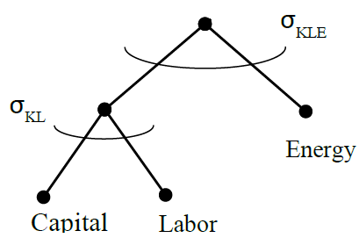
Figure B1: Nesting in production, except for fossil fuel energy

Elasticities: $σ_{Q}=0.9$ $σ_{KL}=1$

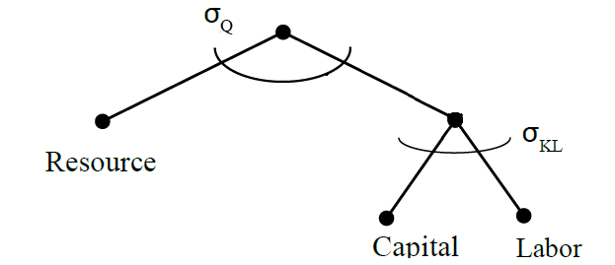
Figure B2: Nesting in production of fossil fuel energy

Elasticity: $σ_{W}=0.5$
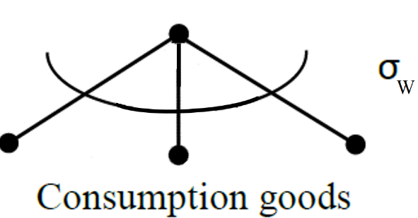

Appendix C: Mapping of WIOD sectors

Model Sectors | WIOD Sectors
y: emission-intensive and tradable goods | Oil, Mining and Quarrying; Chemicals and Chemical Products; Basic Metals and Fabricated Metal; Other Non-Metallic Mineral; Transport Equipment; Textiles and Textile Products; Food, Beverages and Tobacco; Pulp, Paper, Paper , Printing and Publishing
z: emission-intensive and non-tradable goods | Transport Sector (air, water, rail, road); Electricity
x: emission-free and tradable goods | All remaining goods and services
Table C1: Mapping of WIOD sectors to model sectors
Table C1 shows the mapping of the 56 WIOD sectors to three composite sectors in our model.

References
Armington, P.A. (1969). A Theory of Demand for Products Distinguished by Place of Production, IMF Staff Papers 16 (1): 159-178.
Andresen, S., Skjærseth, J., Jevnaker, T., Wettestad, J. (2016). The Paris Agreement: Consequences for the EU and Carbon Markets?. Politics and Governance, 4(3): 188-196
Böhringer, C., Balistreri, E., Rutherford, T.F. (2012a). The role of border carbon adjustment in unilateral climate policy: overview of an energy modeling forum study (EMF29). Energy Economics, 34 (Supplement 2): 97–110.
Böhringer, C., Rosendahl, K. E., Weiqi, T. (2018). ETS Design and Potential Effects in China: a comparison with the EU, in Wettestad, J., Gulbrandsen, L.H. (eds.): The Evolution of Carbon Markets: Design and Diffusion, Routledge: London and New York.
Böhringer, C., Bye, B., Fæhn, T., Rosendahl, K. E. (2017a). Output-based rebating of carbon taxes in the neighbor’s backyard: Competitiveness, leakage and welfare. Canadian Journal of Economics, 50: 426-455.
Böhringer, C., Bye, B., Fæhn, T., Rosendahl, K. E. (2017b). Targeted carbon tariffs: Export response, leakage and welfare. Resource and Energy Economics, 50: 51-73.
Böhringer, C., Lange, A., (2005). On the design of optimal grandfathering schemes for emission allowances. European Economic Review, 49: 2041-2055.
Böhringer, C., Rosendahl, K. E., Storrøsten, H. B. (2017c). Robust policies to mitigate carbon leakage, Journal of Public Economics 149: 35–46.
Copeland, B.R. (1996). Pollution content tariffs, environmental rent shifting, and the control of cross-border pollution. Journal of International Economics, 40: 459-476.
Eichner, T., Pethig, R.. (2015). Unilateral climate policy with production-based and consumption-based carbon emission taxes. Environ. Resour. Econ., 61: 141-163.
Fischer, C., Fox, A. K. (2012). Comparing policies to combat emissions leakage: Border carbon adjustments versus rebates. Journal of Environmental Economics and Management, 64 (2): 199-216.
Hoel, M. (1996). Should a carbon tax be differentiated across sectors? Journal of Public Economics, 59: 17-32.
Holland, S. P. (2012). Emissions taxes versus intensity standards: Second-best environmental policies with incomplete regulation. Journal of Environmental Economics and Management, 63 (3): 375-387.
Horn, H., Mavroidis, P.C. (2011). To B(TA) or not to B(TA)? On the legality and desirability of border tax adjustments from a trade perspective. World Economy, 34: 1911-1937.
Ismer, R., Haussner, M. (2016). Inclusion of Consumption into the EU ETS: The Legal Basis under European Union Law. Review of European Community & International Environmental Law, 25 (1): 69-80.
Ismer, R., Neuhoff, K. (2007). Border tax adjustment: a feasible way to support stringent emission trading. European Journal of Law and Economics, 24 (2): 137-164
Markussen, J.R. (1975). International externalities and optimal tax structures. Journal of International Economics, 5: 15-29.
Martin, R., Muûls, M., de Preux, L.B.,Wagner, U.J., (2014). Industry compensation under relocation risk: a firm-level analysis of the EU emissions trading scheme. American Economic Review, 104: 2482–2508.
Monjon, S., Quirion, P. (2011). Addressing leakage in the EU ETS: border adjustment or output-based allocation? Ecological Economics, 70: 1957-1971.
Munnings, C., Acworth, W., Sartor, O., Kim, Y., Neuhoff, K. (2018). Pricing Carbon Consumption: Synthesizing an emerging trend. Climate Policy.
Neuhoff, K., Ismer, R., Acworth, W., Ancygier, A., Fischer, C., Haussner, M., Kangas, H., Kim, Y., Munnings, C., Owen, A., Pauliuk, S., Sartor, O., Sato, M., Stede, J., Sterner, T., Tervooren, M., Tusveld, R., Wood, R., Xiliang, Z., Zetterberg, L., Zipperer, V. (2016a). Inclusion of Consumption of carbon intensive materials in emissions trading – An option for carbon pricing post-2020. Climate Strategies: report may 2016.
Neuhoff, K., Owen, A., Pauliuk, S., Wood, R. (2016b). Quantifying Impacts of Consumption Based Charge for Carbon Intensive Materials on Products. Discussion Papers: DIW Berlin, 1570
Perino, G. (2018): New EU ETS Phase 4 rules temporarily puncture waterbed, Nature Climate Change, 8: 260-271, April 2018.
Roth, S., Zetterberg, L., Acworth, W., Kangas H., Neuhoff, K., Zipperer, V. (2016). The pulp and paper overview paper: Sector analysis for the Climate Strategies Project on Inclusion of Consumption in Carbon Pricing. Climate Strategies: Overview Paper.
Sato, M., Neuhoff, K., Graichen, V., Schumacher, K., Matthes, F., (2015). Sectors under scrutiny: evaluation of indicators to assess the risk of carbon leakage in the UK and Germany. Environmental and Resource Economics, 60: 99-124.
Tamiotti, L., (2011). The legal interface between carbon border measures and trade rules. Climate Policy, 11: 1202-1211.
Taylor, S. M. (2005). Unbundling the Pollution Haven Hypothesis. The B.E. Journal of Economic Analysis & Policy, 4 (2).
World Bank (2014). State and Trends of Carbon Pricing 2014. Washington, DC: World Bank. http://documents.worldbank.org/curated/en/2014/05/19572833/state-trends-carbonpricing-2014
Xiong, L., Shen, B., Shaozhou, Q,.Price, L. & Ye, B. (2017). The allowance mechanism of China’s carbon trading pilots: A comparative analysis with schemes in EU and California. Applied Energy, 185 (2): 1849-1859.
Zhang, Z.X. (2012). Competitiveness and leakage concerns and border carbon adjustment. Int. Rev. Environ. Resour. Econ., 6: 225–287.

Cf. also the pollution haven literature, e.g. (Taylor 2005).
Leakage mainly occurs through two channels, i.e., i) fossil fuel markets; and ii) markets for EITE goods. This paper focuses on leakage in the latter case. The leakage rates for the EITE industries specifically are usually found to be somewhat higher than the overall leakage rates, see e.g. Fischer and Fox (2012). The theoretical literature on leakage goes back to Markussen (1975), and other important contributions are Hoel (1996) and Copeland (1996).
https://ec.europa.eu/clima/policies/ets/allowances/leakage_en
Ismer and Haussner (2016) discuss the correct legal basis under EU law: “inclusion of consumption may be based on Article 192.1 of the Treaty on the Functioning of the EU and thus be adopted without unanimity voting in the Council of the EU.”
Neuhoff et al. (2016b) looks at 4047 commodity groups and finds that a consumption tax combined with ETS will have some administrative burdens, but could be moderate if designed correctly. Further, they conclude that “administrative efforts for 77 to 83% of imports could be avoided while still 85% to 90% of import-related carbon liabilities are included”.
To simplify notation, we replace $\sum_{i=1}^{3}{x^{ij}}$ with $x^{j}$ in the equations.
The correct definition of the Pigouvian tax is the global marginal external costs of emissions. Whether $τ^{j}$reflects this, or only domestic costs of global emissions, does not matter for the analytical results.
See Appendix A1.
We have tested the signs of d) and e) in our numerical simulations. The numerical simulation in the context of EU ETS and Norway confirms that part d) is practically zero. As for part e), we see that emission in the EITE production sector in ROW falls, while emission in the non-tradable and emission intensive sector increases. The net emission effect in ROW is still negative (as we suggested), and the sum of d) and e) is negative.
See Appendix A2
This could be the case if there is no trade between regions 1-2 and region 3, or if region 3 is much smaller than regions 1-2, in which case production and consumption changes in regions 1-2 are much bigger than in region 3.
We also simulate the model with capital immobile between sectors, see Section 3.5.
See appendix B for CGE-summary and nesting in different sectors.
The model is implemented as a Mixed Complementarity Problem in GAMS, using the PATH-solver.
CO₂-data for Norway is collected from Statistics Norway (SSB).
See appendix C for mapping of WIOD sectors.
In our dataset, sector $x$accounted for 14-15% of the global CO₂ emissions in 2009.
Given the existence of the EU ETS in 2009, we can think of this as an additional emission reduction target of 20 percent relative to the base-year emission.
Although allocation in the EU ETS is based on the emission intensities of the best performing 10% of the installations (for a specific product), total allocation to industrial installations in phase 3 (since 2013) has been on average above 90% of total emissions to these industries (according to Refinitiv Carbon Research). For the most exposed industries, the share is likely even higher.
Compared to the welfare expression in (5), the cost functions are excluded and replaced with the endowment and technological constraints as explained above.
Recall that the leakage rate is measured as emission changes in ROW divided by emission reductions in EU+NOR.
Recall from table 2, that Norway is net exporter of the emission-intensive and trade-exposed good
We assume that $τ^{ROW}$= 0 in ROW’s welfare function, as there is no climate policy in this region (in our analysis).
Recall that the emission price falls with introduction of the consumption tax in the base case simulation, also resulting in lower leakage rate.

