New working spaces in the Helsinki Metropolitan Area: Understanding location factors and implications for planning

Mina Di Marino (corresponding author)
Arch., Ph.D. in Urban Regional and Environmental Planning
Associate Professor
Department of Urban and Regional Planning
Norwegian University of Life Sciences
Faculty of Landscape and Society
As, Norway, NO 1432
mina.di.marino@nmbu.no

Antti Rehunen
Researcher
Finnish Environment Institute, SYKE
Latokartanonkaari 11,
FI-00790 Helsinki,
Antti.Rehunen@ymparisto.fi

Maija Tiitu,
Researcher,
Finnish Environment Institute, SYKE
Latokartanonkaari 11,
FI-00790 Helsinki,
Maija.tiitu@ymparisto.fi

Kimmo Lapintie
Professor of Urban and Regional Planning
Head of Research at the Department of Architecture
School of Arts, Design and Architecture
Aalto University
Tel. 358 50 5842710
P.O. Box 31000
00076 AALTO, Kimmo.lapintie@aalto.fi

Abstract

In the last two decades, new working spaces (NWS), such as co-working spaces, libraries and cafeterias have been increasingly used as temporary or permanent locations for work. Studies on their proliferation, types, and location factors are rapidly appearing from multiple perspectives. However, several European cities still lack a clear overview of this phenomenon. In this context, a systematic spatial analysis of NWS within the urban structure should be carried out, considering the characteristics of the urban form, degree of accessibility and travel mode opportunities, as well as multi-functionality of the urban districts and location of jobs. Thus, the paper first presents a review of the current studies on location factors of NWS and then develops additional planning arguments on the multi-functionality, urban form. Next, the phenomenon is empirically analysed in Helsinki Metropolitan Area. The results show that the NWS are predominantly located in the most compact and/or multi-functional districts and pedestrian zones. Unlike in many other European cities, there are both free and paid NWS. This new knowledge is not yet embedded in the planning agendas, but it can support future strategies and practices for a more sustainable urban development including the location of workplaces.

Keywords new working spaces, location factors, urban form, multi-functionality, travel modes, and knowledge-intensive jobs.

Introduction

In the last decades, a variety of new working spaces (NWS) and new working practices have rapidly surfaced. The growing flexibility in work arrangements, particularly in the knowledge industries, and increasing use of information and communication technology have contributed to an extended concept of workplace. Different spatial settings have been used for working purposes, such as private homes, offices, cafeterias, public libraries, co-working spaces, hotel lobbies, restaurants and other public spaces (Merkel, 2019).

“Co-working-spaces provide individual or institutional users a flexible and highly autonomous use of both office and social space that eases the direct personal interaction among the co-working users for social, learning, cultural and business-related interests”(Bouncken and Reuschl, 2018, p. 322). In previous studies, significant emphasis has been laid on the degree of productivity and creativity in co-working spaces, social and professional interactions that might occur amongst users (Brown et al., 2017; Moriset, 2014), as well as the flexibility of these spaces and the freedom to choose them (Kojo and Nenonen, 2014).

In this context, several, European cities still lack a clear overview of the proliferation of NWS such as coworking spaces and public libraries that people might choose for working purposes, before and during the COVID-19 pandemic. Data on the location and attributes of NWS have not been gathered comprehensively. The understanding of the location factors of NWS can be further supported by analysing the characteristics of the urban form of the city, the degree of accessibility, and multi-functionality of the urban districts in which NWS are located. Indeed, the implications of this phenomenon for urban and regional planning are still unexplored. For example, the development of NWS has not yet been considered in mainstream planning (such as master plans and zoning). The concept of workplace itself is fast evolving, and the traditional commuting (from home to the office) can be extended to a wider network of urban spaces in metropolitan areas (Di Marino and Lapintie, 2017).

Moreover, several studies have analysed the location factors of these NWS bearing in mind the density of business activities, proximity to university and amenities, and good accessibility to public transport (Mariotti et al., 2017). However, in addition to this, a more systematic knowledge of the urban form of the city, travel modes and related urban fabrics can contribute to the understanding of location factors of NWS. This new knowledge can support a more sustainable urban development of our metropolitan areas that should consider the development of both traditional workplaces and NWS.

During the COVID-19 virus pandemic, the concept of workplace has become even more topical considering the sanitary restrictions and required social distancing in the work environment.
The number of remote workers has risen considerably under the conditions of COVID-19 due to new requirements and lockdowns around the world (Berg et al. 2020). For several groups of people, such as experts, researchers, artists and other highly specialized workers, home has become the only place to work. In various countries, traditional offices are still not available for several reasons (e.g. lack of private rooms, lack of social distancing in the open spaces, unsafe air ventilation, as well as small and narrow meeting rooms). In addition to this, there are difficulties in reaching the offices due to long commuting distances by public transport and crowded conditions within public transport vehicles when travelling during the peak hours. If we need to live with social distancing, in both the short and long-term future, this will impact the shape of our cities, as well as the ways of moving around, using urban spaces and arranging activities (Batty, 2021).

Within the uncertainties due to the pandemic, however, it is necessary first to analyse the proliferation of NWS and implications for planning prior to the pandemic. This will provide a basis for future research on NWS.

Thus, the aim of the paper is to elaborate on the current knowledge of NWS in terms of location factors and implications for planning. The Helsinki Metropolitan Area (HMA) is taken as case study considering a growing trend of working outside the office, which was more evident compared to other European cities prior to the COVID-19 pandemic (Eurofund, 2020); changes in working spaces locations; and good availability of monitoring data. By conducting the case study of the HMA, the paper provides a systematic analysis of NWS and traditional knowledge intensive workplaces in multifunctional centres, which are defined on the basis of the density of people and jobs and diversity of services. By examining the locations of NWS in travel-related zones, the study also contributes to extend the analysis of location factors to different travel mode opportunities, in addition to public transport.

Hence, the study addresses the following research questions: RQ1) What is the current understanding of the location factors of NWS and traditional knowledge intensive workplaces? RQ2) How are NWS spatially connected to multi-functional centre areas? RQ3) How is the accessibility by different modes of transport related to the location of NWS?

Te study first presents a review of NWS, and secondly, current studies on location factors of NWS. Then the case of HMA and quantitative research methods (consisting of statistics and spatial analyses) are presented in the study. The empirical analysis focuses on NWS and traditional knowledge intensive workplaces in the urban structure. Furthermore, the paper discusses the contribution of the empirical findings to current planning and future strategies.

New Working Spaces

Since the 2000s, scholars have aimed to understand the reasons for the increase of NWS, such as co-working spaces, libraries, cafeterias, maker spaces and fablabs in our cities. The variety of definitions of these NWS has been analysed in several studies (Bouncken and Reuschl, 2018, Di Marino and Lapintie, 2018; Kojo and Nenonen, 2016). For example, a co-working space is defined as a shared space amongst workers (Lange 2011; Gandini, 2015). In this space, individuals and groups develop some shared sets of norms, rules, and behaviour which build a co-working space culture or co-working community (Ricarda and Reuschl, 2018). Co-working spaces are mostly considered as informal workspaces available to the self-employed, specifically freelance workers in the culture and creative industries. The socio-spatial and technological features of NWS as well as the the design of the space can support the co-production of knowledge, collaborative work, and mutual learning (Capdevila, 2015).

Lately, scholars have claimed that NWS could potentially affect the traditional way of planning employment spaces and revitalize city centres (Brown et al., 2017; Babb et al., 2018). They have also questioned the location of workplaces that urban planners and policymakers have traditionally assigned through zoning (Babb et al., 2018). Recently, NWS have been found in existing business structures including art centres, coffee shops, and serviced offices (Fuzi, 2015; Di Marino and Lapintie, 2017).

Privately owned and managed NWS such as coworking spaces (fee-based business models) are largely discussed in the literature (Spinuzzi 2012). However, there are different business models of NWS (profit and non-profit) and level of user access (public, semi-public and private) that need further investigation (Kojo and Nenonen, 2016). More recently, there has been an increasing number of publicly owned NWS that are managed by universities, public libraries, and other public organizations. This phenomenon is increasingly occurring in Finland, Denmark, the Netherlands, Norway, Canada, UK and Australia (Wyatt et al., 2015). For instance, public libraries have been recently conceived as multifunctional hubs with both digital services and spaces for working purposes (Di Marino and Lapintie, 2015). In Finland, paid or limited access NWS are usually private, but some are owned by the public sector (such as research institutes and public administration) and accessible only to those employed in the social services and government (Di Marino et al., 2018). In fact, in the last few years, government employees have been progressively working outside the offices one or two days per week searching for more productivity and changes to work practices. Prior to the COVID-19, this phenomenon has been observed both in Finland and Australia (Houghton et al., 2018, Di Marino et al., 2018). In addition to paid (and limited access) NWS, this study analyses free NWS which are usually funded and provided by municipalities, universities, public libraries and other public institutions and open to all.

Current studies on the location factors of NWS

The findings from a review of the current literature show that several studies have focused on analysing the location factors of NWS (Table 1). Studies on location factors of NWS are developed according to the traditional location theory (Lloyd and Dicken, 1992; Hayter, 1997)that has mainly focused on the location choices of manufacturing firms, including location tendencies and decision processes (Louw et al., 2004). Recent theoretical and empirical studies stated that the same factors of the manufacturing industry may be relevant for the analyses of service firms in the creative sector (such as coworking spaces) (Mariotti et al., 2021). As Table 1 shows, agglomeration economies (localization and urbanization economies), accessibility to infrastructures, market size and potential, labour costs and skills, and transportation costs can be location determinants of coworking spaces (Mariotti et al., 2017).

By focusing on the city of Perth and Western Australia, Babb and his co-authors (2018) demonstrated that the location of several shared workspaces, such as co-working spaces, libraries and cafeterias, is based on the access to target markets and urban centres and the vitality of the surrounding area (Table 1, lf1). The findings also reveal that shared workspaces are associated with additional travel, both in trips taken and travel time, which conflict with policies on travel reduction to urban centres. Strategies and measures on NWS were absent or weakly defined in the planning and policy framework of the cases analysed by the authors.

Location factors (lf) mainly investigated in metropolitan areas | - The high concentration of businesses activities and services characterizing certain urban districts (Mariotti et al., 2017; Babb, et al., 2018, Moriset, 2014)
 | - The proximity to universities and research centres with a high concentration of knowledge and skills) (Mariotti et al., 2017, Di Marino and Lapintie, 2017, 2018)
 | - Accessibility by public transport (Mariotti et al., 2017, Di Marino and Lapintie, 2017)
 | - Premise cost (e.g. land and rent affordability) (e.g. Mariotti et al, 2017; Avdikos and Merkel, 2019)
Other location factors (lf) to further analyse | - Availability of public and semi-public NWS (e.g., Bilandzic and Forth, 2013; Kojo and Nenonen, 2016), that can extend the analysis of the premises cost (see lf 4), and business model of NWS (profit and non-profit)
 | - Size of NWS (Avdikos and Merkel, 2019)
 | - Other travel modes, such as walking and biking distances (Kojo, Nenonen, 2016; Stam and van de Vrande, 2017), and by car in the urban fabrics that can support the analysis of accessibility to public transport (see lf.3)
 | - Multifunctionality of the urban districts (see mix-land use, varied provision of public and private services, and locations of jobs) (Di Marino et al., 2018) that extend studies on the high concentration of businesses (see lf 1)
 | - Reputation of the districts (Babb et al., 2018)
 | - Availability of multifunctional spaces and other services in the same buildings (training centre, health care, café) (Koio and Nenonen, 2016, 2017) that can extend studies on cost premises and related services (see lf 4)
 | - Proximity to other industries not only creative sectors (Di Marino et al., 2018; Houghton et al., 2018) when a large variety of remote workers use NWS
 | - Proximity to both public and private organisations when a large variety of remote workers use NWS, and there are more flexible contracts

Table 1. Location factors of NWS. Except for no. 4, 6, 9, 10, 12, all location factors are investigated in this study. Table re-adapted from Di Marino and Mariotti (2020)

Similarly, Mariotti and her co-authors (2017) analysed the location patterns of co-working spaces in the City of Milan. The findings disclosed that co-working spaces are mainly located in the densest areas of business activities as well as in proximity to universities and research centres (lf1 and lf2). The co-working spaces are characterized by a high degree of accessibility, since they are close to the local and regional networks of public transport (lf3). This same study also revealed that larger co-working spaces are often in those areas in which the costs of premises are lower and there is a higher availability rate of office spaces (lf4). Despite the increasing bottom-up phenomenon, Mariotti and her co-authors, similarly to Babb and his co-authors, concluded that there is a need to increase public support and local management, which would in turn facilitate the development of local co-working spaces (lf5 and lf10). Similar analyses have been conducted in the UK and Germany (see Avdikos and Merkel, 2020), Finland (Kojo and Nenonen, 2016), and in the Netherlands (Stam and van de Vrande, 2017).

Moreover, studies on knowledge-intensive industries have emphasised the significance of density and availability of human capital for innovative growth (Kiuru and Inkinen, 2017). Both specialization and diversification have significance for regional innovativeness (van der Panne & van Beers, 2006). Knowledge intensive jobs are concentrated both in centres and specialized areas (Inkinen & Kaakinen, 2016). Specialization in creative industries and pleasant working environments attract new companies and workers to the area (Coll-Martinez & Arauzo-Carod 2017). A growing number of jobs in the knowledge sector will increase the demand for NWS particularly in city centre, but also in other more narrowly focused knowledge intensive clusters (lf2).
In addition, scholars have also focused on the size of co-working spaces and the real estate market in the cities (lf6 and lf4). By analysing the cases of London and Berlin, Avdikos and Merkel (2020) explained that large co-working companies (such as Regus and WeWork) locate their premises in inner city areas because workers seem to search for working spaces that are: i) centrally located; ii) surrounded by cultural and urban amenities, iii) accessible by good public transport and iv) close to a variety of businesses and the benefits from the function of localization economies (Avdikos and Merkel, 2020). On the other hand, smaller co-working spaces in Berlin and London still exist and continue to grow. However, they are increasingly pushed outside of inner-city areas towards peripheral neighbourhoods or in deprived inner-city areas characterized by lower and affordable rents (lf4). The peripheral area can provide marketable features, such as free parking, which was thought to attract suburban workers However, this model might require increased mobility of the workers both by public transport and private cars (when the peripheral areas are not very accessible) (Babb et al., 2018). Moreover, Ohnmacht et al. (2020) have compared urban and rural locations of co-working spaces and found out that co-working spaces have the potential to reduce car emission particularly in the cities, while in rural areas the commuting to co-working spaces is dominated by car travel.

Other location factors for a more comprehensive analysis

The number of factors influencing the location of NWS might be larger than indicated in previous studies. The multifunctionality of urban districts (which consider the mixed land use around the NWS, variety of services, and job locations) (see Table 1, lf8), and travel modes opportunities (lf7) can help to further understand the current tendency (where NWS are mainly located and why). These location factors can also contribute to the understanding of ‘neighbourhood oriented’ (and pedestrian-scale) NWS from the perspective of users (Stam and van de Vrande, 2017).

Referring to the multi-functionality of urban districts (lf 8), it is important to understand that the evolving concept of multifunctionality is widely discussed from the planning perspective (De Paris and Lopes, 2018; Louw and Bruisma, 2006). In the 1990s, in addition to the typical land uses (residential, office, retail, restaurants and entertainment), the components of mixed uses have embraced additional activities (live, work, play, learn) (Wardner, 2014), and only more recently NWS. Furthermore, the mixed-use concept has been extended to include the creation of compact city centres and walkable sub-centres (Foord, 2010). These centres also function as nodes in transport infrastructures and ICT-networks (Bertolini et al., 2016; Priemus and Hall, 2014). Mixed-use development can clearly contribute to the urban diversity, vitality, and attractiveness of urban areas. Indeed, the conceptual level of mixed-use can be applied to the different contexts of environment, society, design, and institutions. The mix of forms and tenures of housing can also affect the overall density of urban form, and commercial and office uses combined with residential functions and NWS. This can generate synergetic effects on the territory (Grant, 2002; Louw and Bruisma, 2006). The reputation of a district including elements, such as vitality and attractiveness of its urban areas, is an important element that managers consider when locating NWS (lf 9). However, when analysing the urban functions in our cities, there is no clear planning regulation which would distinguish NWS from traditional office use.

The most central areas are multifunctional (Rodenburg et al. 2011; Hamnett and Whitelegg, 2007), while suburban areas are still more mono-functional housing, office or other single-use districts. However, new suburban office spaces have emerged in various locations including multi-functional sub-centres, concentrations of business, retail and entertainment, as well as dispersed and still homogenous office districts (see the American cases analysed by Lang et al. 2009).

The multi-functionality of urban form also relates to accessibility by different travel modes (lf7). According to Bertolini and le Clercq (2003), sustainable urban mobility patterns can be achieved if households and firms can link the same or a greater number as well as the diversity of places of activity by modes other than car, namely by walking or cycling, or by transit. In addition to travel modes, Newman and his co-authors. (2016) argue that the respective transport systems have created three comprehensive systems, or “fabrics” in cities: walking, transit, and automobile urban fabrics. The theory of urban fabrics has evolved from the need to view the structure of cities beyond the modernist way of thinking with separated city functions, in order to promote healthy urban planning and reduce cities’ automobile dependency (Kosonen, 2015; Newman et al., 2016). Areas of walking and transit urban fabrics are characterised by a dense urban form, more diverse services, and mixed land use (Newman et al. 2016), setting good preconditions for multi-functionality. In contrast, the areas of automobile urban fabric more often represent a mono-functional structure, such as low-density housing or large retail units best accessible by car.

The location of jobs within the spatial urban structures is continuously developing because of changes in industries, market volumes, industrial clustering, transport connections, and land use planning. In this context, cities also present differences in the location patterns of jobs. Söderström and his co-authors (2015) have compared the location of jobs in the Helsinki and Stockholm city regions, while Tiitu and her co-authors (2020) analysed Helsinki and Oslo city regions. According to their results that cover all industries, jobs in the Helsinki region are less concentrated in the urban core area than they are in Stockholm and Oslo. In the Helsinki city region, the principal proportional growth in 2000-2010 has unfolded in the peri-urban area. In the Stockholm city region, large job clusters are located in the city centre and its fringe zone as well as in sub-centres and clusters that are tied together by intensive rail-oriented connections, whereas in Helsinki, this type of development is still not visible. In contrast, several office buildings close to the city centre in the Helsinki city region have been transformed into housing.

The development of the knowledge intensive sector seems to differ from the overall development of jobs in the Helsinki city region. Inkinen and Kaakinen (2016) have focused on knowledge-intensive clusters of jobs in the Helsinki Metropolitan Area and found out that they are predominantly located close to road- and rail-structures and terminals, and clusters become smaller as their distance from the centre of Helsinki increases.

The multifunctionality and accessibility of urban structures are also related to the polycentricity of urban form. Polycentric development implies the emergence of new multi-functional sub-centres of business, retail and entertainment. Sub-centres are typically located around transport hubs, but the share of sustainable transport modes in sub-centres usually remains lower than in main city centre (Wolday and Næss, 2019).
In this context, it is important to further develop the planning of workplaces by including the NWS and by further elaborating on the knowledge of location factors of NWS.

The Case study of the Metropolitan Area of Helsinki

The case study focuses on the HMA which consists of the capital city, Helsinki, and three adjoining municipalities, Espoo, Vantaa, and Kauniainen. The urban core area of the Helsinki region is located within these four cities. Together the municipalities have 1.17 million inhabitants (Official Statistics of Finland, 2019).

The Helsinki city region (which is not an administrative entity) consists of 14 municipalities (including the HMA), whereas the Helsinki-Uusimaa Region (the regional authority) consists of 26 municipalities (including the HMA). The HMA is the most urbanized area in Finland with the highest concentration of jobs in the country (27% of all jobs), representing a large variety of industries. Most of the governmental workplaces, favourable for teleworking, are situated in the HMA.

During the past 30 years, the urban structure of the HMA has developed from being predominantly monocentric to becoming more polycentric with many multifunctional sub-centres within 20 kilometres from the city centre. Most of the sub-centres have a rail link to the centre, and also traverse rail connections are planned and under construction. Mono-functional job agglomerations outside sub-centres have public transport services, but mobility patters are usually dominated by car. In the outer city region, local centres rely on car and bus connections or are located around railway stations. There are multiple and contradictory interpretations of polycentricity in the Helsinki city region (Granqvist et al. 2019). The City of Helsinki has favoured the development of multi-functional rail-based centre areas within its borders, while other municipalities out of the HMA have supported more balanced development taking into account also other centres and bus-based regional transport.

In this study, the provision of different kinds of NWS (such as co-working spaces and libraries) is analysed both in relation to the multifunctional sub-centres and more mono-functional job agglomerations. Cafeterias are excluded in the examined working spaces, because there was insufficient data on working opportunities and facilities in them.

The proliferation of NWS is connected to an increase in teleworking. Prior to the COVID-19, the extent of ICT and internet connectivity, as well as the work culture and economic structure have influenced the increasing adoption of telework in the Nordic countries (Eurofound, 2020). According to a barometer published by the Ministry of Economic Affairs and Employment of Finland, teleworking increased steadily between 2012 and 2017. Altogether 20% of Finnish workers regularly worked remotely in 2017, at least on a monthly basis. In addition, almost half of the workers were allowed, at least to some extent, to decide when they do their work (Lyly-Yrjänäinen, 2018). In the HMA, the opportunities for teleworking are better than in Finland on average, because of the high share of government jobs and other knowledge intensive industries.

According to pre-pandemic studies on Finnish teleworking, there were significant differences in teleworking between industries and socioeconomic groups. Among workers in different sectors in Finland, those in the government and private business sectors have been the most likely to telework, and municipality employees least likely. Among workers with a high socioeconomic status (senior officers), 29% worked remotely daily or weekly, and 68% at least occasionally. In contrast, only 8% of workers with a lower socioeconomic status teleworked. Results from an internet panel survey conducted by the telecommunications company DNA also implied that entrepreneurs and managers teleworked in more diverse places than other workers (Nepa, 2018). However, according to the same survey, the benefits of teleworking were similar irrespective of the socioeconomic status of the work.

The pandemic has forced a significant increase of remote work. According to a local panel survey, approximately half of Finnish employees worked remotely in April 2020 and were also willing to work remotely when possible, also after the pandemic (Taloustutkimus, 2020). Based on the Statistics Finland’s Labour Force Survey, the share of employees working from home had doubled in 2020 (Leskinen, 2020).

The pandemic has had different impacts on the use of NWS. Tight restrictions have limited the number of NWS users, and most remote work has been carried out at home. On the other hand, closures of traditional workplaces have created increasing interest in NWS within the Finnish debate (see e.g. Torppa, 2020). Because of uncertainties during and post COVID-19, it is necessary to apply pre-pandemic data in the analysis to produce a basic understanding of the locations of NWS, which have never been investigated before. The use of NWS can be expected to increase after the pandemic, as the remote work practices have become more common.

In the Finnish context, several scholars have focused on NWS (Kojo and Nenonen, 2016; Di Marino and Lapintie, 2017), and related concepts such as multi-local working (working in multiple places such as coworking, coffee shops, public libraries and home) (Koroma et al., 2014, Di Marino and Lapintie, 2018). Nevertheless, NWS have been partially acknowledged in current planning strategies. Among the strategic visions, the City of Helsinki has recognised the advantages of providig an urban structure that enables space for new creative thinking and new technologies (City of Helsinki, 2013). However, the master plan of 2016 shows little evidence of measures that could support the vision mentioned. On the one hand, the mixed-use and diverse city centre is mentioned in several parts of the document, on the other hand, the plan predominantly deals with working and workplaces in a place-based, traditional manner (City of Helsinki, 2016). Within the regional planning strategies, there is awareness that the massive advancement in information technology is affecting the spatial distribution of knowledge workers. In this context, the start-up activities of the universities as well as other start-ups and entrepreneurs are seen as fundamental key actors in the future urban and economic growth (Helsinki Uusimaa Region, 2016. However, there are no explicit references to emerging NWS.

Research methods and materials

The overall research design of the study is based on quantitative GIS-based analyses that aim to answer to the research questions. The examination is carried out as spatial overlay analysis of jobs, NWS, multifunctional centre areas and travel-related urban zones. Furthermore, concentrations of knowledge intensive jobs have been identified based on density and their dominant industries. The results of the GIS-based analyses are presented in tables. The spatial analyses aim to understand how NWS are spatially connected to the multifunctional areas and the possible different modes of transport to reach the NWS. These spatial analyses are supported by the graphics which show the number of NWS and traditional workplaces (and related percentage), as well as the location of traditional knowledge-intensive workplaces and NWS in the HMA.

The analysis of urban form in this study is carried out using data from the Monitoring System of Spatial Structure and Urban Form (YKR, 2020) that is maintained by the Finnish Environment institute. YKR includes data on the built environment, housing, jobs, and commuting in a 250 m statistical grid covering the whole of Finland. Data on jobs is available for the period 1990–2016, and jobs are classified into 21 main groups on the basis of the Standard Industrial Classification (TOL, 2008). Six groups are defined here as knowledge-intensive: arts, entertainment and recreation; professional, scientific and technical activities; public administration; education; information and communication; and financial and insurance activities. These industries typically involve work that is possible to carry out in places outside the official workplace. The definition of knowledge-intensive industries is not clear, and other industries also include jobs that display a knowledge-intensive character.

The YKR data has enabled the identification of different types of areas within spatial urban structures. Spatial divisions have included delineations of urban area, multifunctional centre areas, and travel-related urban zones. Multifunctional centre areas are defined for the city centre and subsidiary centres on the basis of the density of people and jobs, and diversity of services (Rehunen et al., 2014). Density criteria are based on the distribution of people and jobs in statistical cells and the identification of densest quantiles in the distribution. Diversity criteria require jobs from at least four different industries in a centre area cell.

The dataset “travel-related urban zones” describes the travel mode opportunities for different areas and has its theoretical background in the conceptualization of urban fabrics by Newman et al. (2016). The pedestrian zones are based on the “multifunctional centres” dataset using certain buffer distances suitable for walking for their spatial extent: 2 km for the city centre, and 1 km for the sub-centre pedestrian zones from the central point of each zone. City centre fringe zone reaches 3 km from the outer edge of the city centre pedestrian zone. Public transport zones are classified as intensive or ordinary according to the availability of public transport during the rush hour (Finnish Environment Institute SYKE, 2020). The criteria for the intensive zone are a 10-minute headway for rail and 5-minute headway for bus transport, and a maximum walking distance of 250 m for bus stop or 700 m for a railway station. The ordinary public transport zones require a headway of 15 minutes with the same walking distances as the intensive zone. All the remaining areas of the localities not meeting the criteria for pedestrian or public transport zones are considered as car zones.

Data on NWS is collected from web pages with listings of co-working spaces and other facilities for meetings and flexible work (which are offered, for instance, by public libraries and universities). The collected data includes 86 NWS that typically provide a workstation and related facilities as well as separate meeting rooms. The number of workstations and simultaneous users in most NWS is typically in the size range of 20-50 people. The largest working spaces are able to accommodate more than 100 people, offering a variety of working and meeting rooms. Two thirds of NWS are co-working spaces which are based on paid membership or accessible only to personnel of a certain employer. Most of paid or limited access NWS are private, but some are owned by the public sector and accessible only for public sector employees. One third of NWS are free and open access to all users. These NWS are usually maintained by an educational establishment, library or other public body. Some of the listed libraries provide maker spaces, devices and other equipment free of charge, such as the Iso Omena Library in Espoo, and the Urban Workshop in the New Central Library Oodi, in Helsinki.

Location of NWS in multifunctional centre-areas

The significance of knowledge-intensive jobs has grown in recent decades. In the HMA, the number and share of knowledge-intensive jobs has increased during 2007–2016, while the number of jobs in other industries has declined because of a long period of economic recession and slow growth. In 2016, 37% of workplaces in the HMA were found in industries classified here as knowledge-intensive, and their share has increased by a percentage point in a decade.

Knowledge-intensive workplaces are located differently than those other industries. Of knowledge-intensive workplaces, 69% were located in multifunctional centre areas in 2016, compared to 48% of other workplaces were. NWS that emerged on a large scale only in the 2010s have similar location patterns as traditional knowledge-intensive workplaces; 74% of paid NWS and 79% of free NWS are located in multifunctional centre areas (Fig. 1, Table 2).

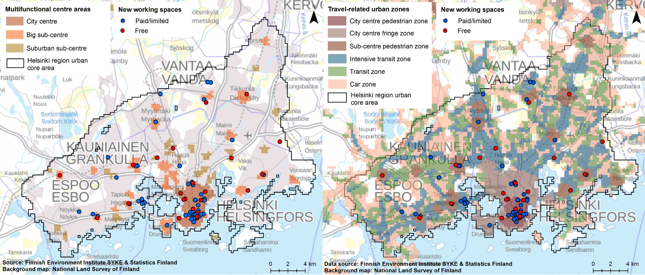

Fig. 1 Location of new working spaces in relation to multi-functional centre areas (left) and travel-related urban zones (right) in the HMA in 2019.

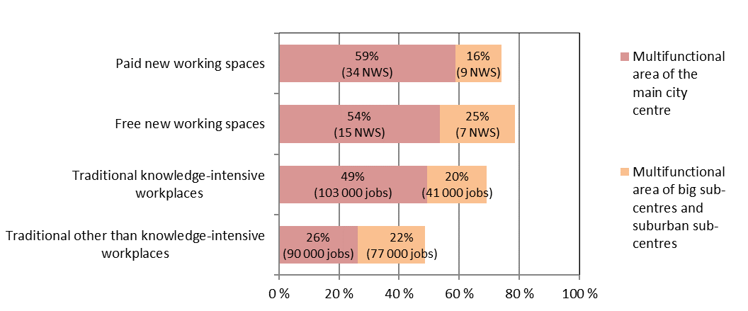

Table 2 Percentage of NWS and traditional workplaces in multifunctional centre areas of the HMA in 2019.

The main city centre has a dominant position in knowledge-intensive industries and particularly as a location for NWS. In the HMA, 49% of knowledge-intensive jobs and 57% of NWS were located in the multifunctional area of the city centre. Because the multifunctional area of the city centre extends continuously 4 km north from the centre point, the multifunctional centre area covers a considerable area, altogether 16 km². Among knowledge-intensive industries in the HMA, financial activities and public administration are most highly concentrated in the main city centre area with more than two thirds of their workplaces in the main centre area. During the last two decades, the main centre area has become increasingly characterised by knowledge-intensive activities.

In addition to the main city centre, there are 37 other separate multifunctional centre areas in the HMA, in either large subsidiary centres or smaller suburban sub-centres. Twenty-seven of these areas contain a cluster of knowledge-intensive jobs, but only 10 a NWS. Free co-working spaces, such as libraries, are more typical in sub-centres than in the main city centre. In sub-centres, the number and share of knowledge-intensive workplaces has remained stable during the last ten years, which might explain the rather moderate availability of NWS.

Location of NWS in travel-related urban zones

In relation to travel-related urban zones, both traditional knowledge-intensive workplaces and NWS are much more commonly located in the pedestrian zones of the city centre and sub-centre (Table 3). NWS are very much concentrated in the core pedestrian zone very close to transport hubs, while traditional knowledge-intensive workplaces are often found in the city centre fringe zone, 1-3 km from the main transport hubs and characterised by the use of many different modes of transport.

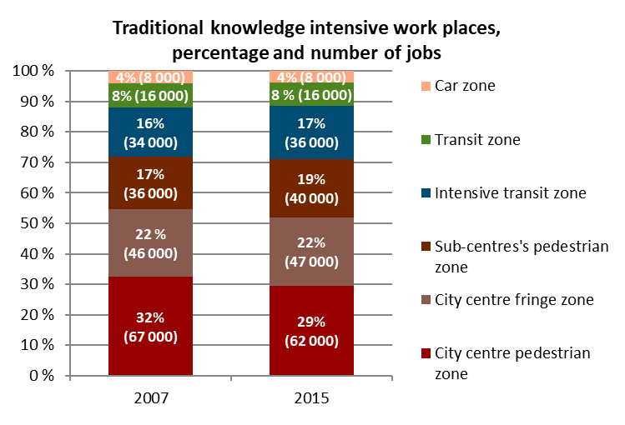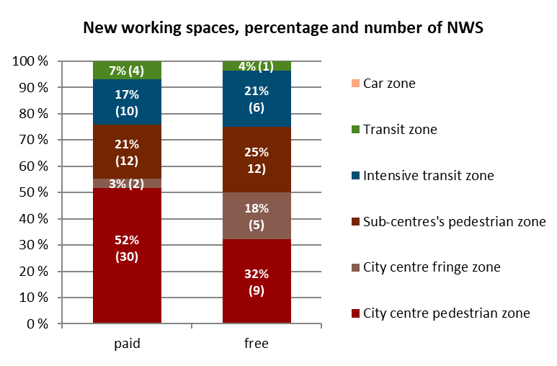

Table 3 Location of traditional knowledge-intensive workplaces and NWS in the HMA. Data on workplaces are from 2015 and NWS from 2019.

Accessibility to intensive public transport is crucial for NWS. Very few NWS are located in an area that does not provide intensive transit connections and none in the car-oriented zone (Fig.1). Of the traditional knowledge-intensive jobs, 8% are found in ordinary public transport zones (Table 3).

In addition to public transport, NWS are dependent on other services. Almost all paid NWS are located close to food, beverage, and accommodation services. Four out of five paid NWS are also located in the vicinity of a grocery shop. Traditional knowledge-intensive workplaces are located close to cafés, restaurants, and shops almost as often. However, less than half of the free NWS, typically in libraries or learning institutions, have cafés or shops in their immediate surroundings.

The use of NWS can potentially decrease the length of home-to-work trips. Among those employees in knowledge-intensive industries with location data on home-to-work trips (92% of employees) and who both live and work in the urban core area of HMA, the average direct home-to-work distance according to the register data is approximately 7 km. The average distance to the nearest NWS is nonetheless considerably shorter, only 1.5 km. As NWS are located very close to transport hubs, their accessibility in time is also much better than the accessibility of traditional workplaces.

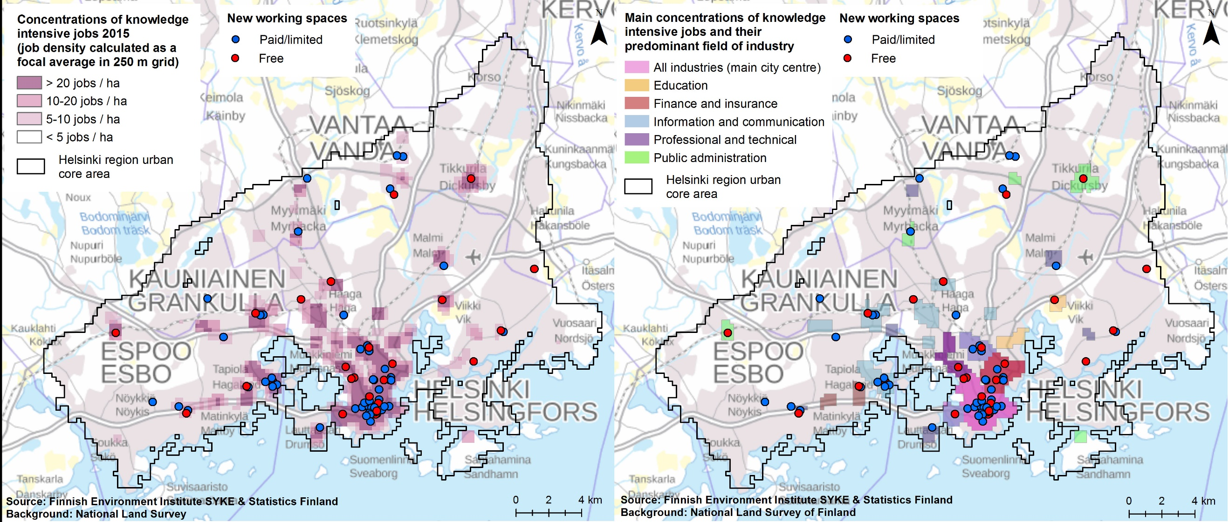

Fig. 2 Concentrations of knowledge-intensive jobs according to their job density (left) and predominant industry (right) as well as the locations of NWS in the HMA. Data on workplaces are from 2015 and NWS from 2019.

Figure 2 shows the locations of NWS in relation to the main concentrations of knowledge-intensive jobs in HMA. Over 90% of NWS are located in the concentrations of knowledge-intensive jobs. Other locations of NWS include sizeable shopping centres, libraries, and education institutions which do not have a large number of knowledge-intensive jobs in their vicinity.

However, many concentrations of knowledge-intensive jobs lack any kind of NWS or have only one co-working space available. In the fringe zone of the main city centre, there are job concentrations that include a high number of knowledge-intensive jobs but only a very limited capacity of NWS. A short distance outside the city centre fringe zone, several job concentrations include only traditional workplaces and no NWS. Jobs in these areas are typically in information and communication as well as in professional and technical services. Almost all concentrations of knowledge-intensive jobs are located in or very close to multifunctional centre areas and offer potential for NWS as they can provide services for the users of NWS.

Knowledge-intensive jobs and many NWS are typically located in office buildings. New office buildings that provide modern working environments are typically occupied by the knowledge-intensive sector, administrative services and other industries. However, only few NWS are located in new office buildings built since 2000. Because of the trend to intensify the use of office space, the construction of new office buildings has gradually slowed down after 2000. During 2010s, the yearly constructed new office floor space equals approximately 1% of the whole office building stock (YKR 2020). However, almost the same amount of existing office floor space is at the same time turned into housing and hotel accommodation (Kaleva et al. 2021).

According to the monitoring data on urban form, only 52% of new office building floor space constructed since 2000 is located in multifunctional centre areas (YKR 2020). The rest is usually situated along main streets and public transport corridors. The reasons for locations being situated outside multifunctional centre areas might include the availability of suitable building lots, affordable land rents, and conventional location decisions emphasising accessibility by private car. Thus, new office development seems to clearly differ from the locational patterns of the knowledge-intensive sector and NWS. Therefore, current investments can lead to office spaces that will lose their attractiveness in the future if employees seek more central job locations. In this situation, NWS can draw increasing attention in the future and complement or even replace traditional offices in many companies.

Discussion

The outcomes from the HMA contribute to a more comprehensive understanding of location factors of NWS (Table 1) Findings from this study can also contribute to elaborating new planning strategies for workplaces in the HMA and other metropolitan cities and urban regions displaying similar characteristics.

First, proximity factors discovered in previous research were also confirmed in this study, particularly concerning the close connection to knowledge-intensive jobs in business, research, information sector and public services (Babb et al., 2018; Mariotti et al. 2017; Moriset 2014). However, compared to traditional knowledge intensive workplaces NWS are more concentrated to best accessible locations in the pedestrian zones of the city centre and sub-centre. This could be explained by the fact that NWS attract users of different company backgrounds, commuting patterns, and working practices (see e.g. Ohnmacht et al. 2020).

In addition to the development of neighbourhoods and impacts on the communities (Stam and van de Vrande 2017), the concentration of NWS in core pedestrian zones of centre areas has further implications for urban planning and land use (in terms of mixed use and multifunctional areas). In the new Helsinki city plan, the aim is to extend the mix-use patterns of central areas. If the target is also to increase the number of NWS in the fringe zone around the city centre, there is a need for mixed-use development, more services, and diverse industries in the fringe zone. In suburban areas, sub-centres have a very restricted selection of NWS. However, certain sub-centres are currently developing into denser and more multifunctional areas including the development of significant concentrations of knowledge-intensive jobs (Helminen et al. 2014; Söderström et al. 2014). If growing sub-centres provided multiple options for NWS, they might attract new companies and knowledge workers, thus increasing their liveability.

Many concentrations of knowledge-intensive jobs are characterized by a certain industry or mix of industries. For example, university campuses may offer synergies between universities and companies, and good opportunities for start-ups to develop their business (Mariotti et al., 2017). NWS are closely entwined with the functioning transport system. Employees in knowledge-intensive industries might choose their working location from a variety of options.

If NWS are available, employees can choose according to their mobility needs. The location of present NWS highlights the importance of intensive public transport connections. If sub-centres are to be developed, they need improved public transport connections not only to the city centre, but also between one another. In the light of recent changes in urban form, developing job concentrations in car-based locations appears not only to be outdated, but also evidence of poor investments.

Secondly, results show that there is an evolution on the NWS (Kojo and Nenonen, 2016), in this sense, the study contributes to the limited studies on the comparison between free and paid or limited use NWS and related location factors. The study shows that, on one hand, paid NWS are mainly located in multi-functional centres and big sub centres, while free NWS are also located in suburban centres (Fig.1). The variety of services in the surroundings of paid NWS is higher than free NWS. In the multifunctional centre areas of the HMA, the diversity of services increases the opportunities to combine different activities. Cultural, leisure and fitness services as well as a variety of meeting spaces increase the attractiveness of the area as a working environment and as a creative milieu for companies, leading to agglomeration effects and attracting new services to the area (Coll-Martinez and Arauzo-Carod 2017).

Free NWS, such as the new Helsinki Central Library Oodi (which offers a variety of NWS, e.g., co-working spaces and maker spaces), seem to be very popular among freelancers and students, indicating a growing demand for this kind of spaces. Free and paid NWS might have different types of users on the basis of their location and services provided. Thus, in addition to the reputation of the districts (Babb et al., 2018), this study suggests to further investigate the multitude of service categories that can change the characters of both central and peripheral districts.

Thirdly, NWS could potentially reduce car commuting to suburban knowledge industry workplaces, particularly in combination with road pricing and parking restrictions at these workplaces. According to the results, distance to the closest NWS is usually much less than average home-to-work trip. Presently, most of the suburban workplaces are easily accessible by car even when located in sub-centres meeting the criteria of intensive transit zone. If driving to such workplaces is rendered less attractive, working in a NWS in the residential neighbourhood some days of the week could become more popular. Providing NWS in a larger number of residential neighbourhoods (such as the suburban sub-centres that have a very restricted selection of NWS) could additionally contribute to reducing the number of car commuters and transport emissions reflecting the findings by Ohnmacht et al. (2020). However, the NWS users may pursue certain networks and working milieus that are not available in the closest facility.

The proliferation of NWS is a new phenomenon and can be part of a sustainable urban development. The implications for the functioning of the whole urban system and its planning concerning accessibility in general and accessibility by public transport would need further investigation. This has not yet been included in the spatial agenda of several metropolitan areas. In the future of the HMA and other urban regions with similar economic and workforce characteristics, work will be carried out in multiple places with NWS playing an increasing role in flexible work. This trend is supported by increasingly high usage of technology within working practices and flexible work contracts. In this context, a more efficient use of business premises, changing preferences for a working environment, and the development of the mixed-use concept can contribute to developing new sustainable ways in which job areas are planned in metropolitan areas

The rapid growth of NWS has resulted in increased uncertainty in monitoring the locational changes of jobs, particularly in knowledge-intensive industries. The users of NWS come predominantly from knowledge-intensive industries. Some of the employees and entrepreneurs may be registered to the address of the NWS, but the majority might not. In the future envisioning and planning of urban form, there is a need to consider the relational aspects of changing working patterns and locations. More detailed data is required on the users of NWS and their mobility. The development of multifunctional centres and NWS changes people’s daily mobility as well as use of space and services. This is particularly important when solutions to current sustainability challenges are developed (see the spatial balance and sustainable transportation in the polycentric HMA). New working practices might help to promote sustainable mobility and cut emissions from building use and car transport.

Conclusions

The aim of the study was to contribute to the growing literature on NWS by providing a comprehensive review of the evolving concepts (in terms of access, use, and functions). In addition to paid NWS, which are mainly analysed in current literature, the study focuses on free NWS, such as public libraries, which provide coworking spaces. This study has also elaborated on the knowledge on NWS by analysing location factors previously noted within the scientific debate (e.g. accessibility, proximity to university) and by using additional location factors (e.g. travel modes opportunities and multi-functional centres). This approach provides a comprehensive understanding of the possible factors which influence the location of the NWS. The study shows that the preferred location factors of NWS in HMA are the accessibility by public transport, proximity to university campuses and concentration of knowledge-intensive jobs. Moreover, the NWS in the HMA are mainly located in the multifunctional centres (which are defined on the basis of the density of people and jobs, and diversity of services), in the core and sub-centre pedestrian zones. Further studies should combine additional quantitative and qualitative analyses (e.g., interviews and surveys) in order to integrate users’ and managers’ perspectives. There are also limited statistical data on working opportunities and facilities in cafeterias. Despite the growing interest among academics on the phenomenon, and there is also a lack of suitable datasets and data on NWS in statistical databases, research publications and official reports of the HMA and the City of Helsinki. The way of analysing the NWS used in this study can be used in cities that present similar characteristics in terms of urban form and multifunctional districts, as well as provision of paid and free NWS. However, national policies, local economic factors and approaches to the NWS should also be evaluated for a more comprehensive analysis. All these themes should be relevant for policymakers and planners when discussing several aspects of urban mono-and polycentricity and urban sustainability, as well as the degree of multi-functionality of urban districts and the issue of commuting distances. The understanding of workplaces is dramatically evolving with the use of NWS potentially influencing the planning of workplaces and other urban functions in our cities. However, this study is limited to the understanding of the proliferation of NWS and the implications for planning prior to the COVID-19. Therefore, it is crucial to further study this increasing phenomenon and its distinct impacts on cities and urban regions within the context of the current pandemic as well as future waves of new viruses.

Acknowledgements

The project was supported by the Academy of Finland, SRC on Urbanizing Society. Beyond MALPE-coordination: Integrative Envisioning –BeMInE- (under Grant number 13303549 STN) and by COST Action CA18214 'The geography of New Working Spaces and the impact on the periphery', which is funded by the Horizon 2020 Framework programme of the European Union https://www.cost.eu/actions/CA18214

References

Avdikos, V. & Merkel, J. (2020). Supporting open, shared and collaborative workspaces and hubs: recent transformations and policy implications, Urban Research & Practice. 13(3) 348-357

Babb C., Curtis C., & McLeod S. (2018). The Rise of Shared Work Spaces: A Disruption to Urban Planning Policy? Urban Policy and Research. 36 (4): 496-512.

Batty M. (2021). Science and design in the age of COVID-19Urban Analytics and City Science.48(1):3–8.

Berg J, Florenxe B., & Sergei S. (2020). Working from home: Estimating the worldwide potential https://voxeu.org/article/working-home-estimating-worldwide-potential

Bertolini L., Curtis C., & Renne J L. (2016). Introduction. The context for transit-oriented development. In Transit Oriented Development: Making it Happen (Eds.) Curtis C., Renne J.L, & Bertololini L., 3-13. London: Routledge.

Bertolini L. & Le Clercq F. (2003). Urban development without more mobility by car? Lessons from Amsterdam, a multimodal urban region. Environment and Planning A. 35: 575–90.

Bilandzic, M. and Foth, M. 2013. "Libraries as Co-working Spaces: Understanding User Motivations and Perceived Barriers to Social Learning." Library Hi Tech. 31(2): 254–273.

Brown, J. (2017). Curating the ‘third place’? Coworking and the mediation of creativity. Geoforum:
Journal of Physical, Human, and Regional Geosciences. 82: 112–126.

Bouncken R.B. & Reuschl A.J. (2018). Coworking-spaces: how a phenomenon of the sharing economy builds a novel trend for the workplace and for entrepreneurship. Review of Managerial Science. 12 (1): 317-334.

Capdevila I. (2015). Co-working spaces and the localised dynamics of innovation in Barcelona. International Journal of Innovation Management. 19(3): 1–25.

City of Helsinki (2013). Vision 2050, urban plan – The New Helsinki City plan. http://www.hel.fi/
hel2/ksv/julkaisut/yos_2013-23_en.pdf

City of Helsinki (2016). Helsinki’s new master plan (HELSINGIN YLEISKAAVA Selostus.
Helsingin kaupunki KaupunkisuunnitteluvirastoKaupunkikaava – Helsingin uusi yleiskaava).
https://www.hel.fi/hel2/ksv/julkaisut/yos_2016-3.pdf

Coll-Martinez E. & Arauzo-Carod J.-M. (2017). Creative milieu and firm location: An empirical appraisal. Environment and Planning A 49(7): 1613–1641.

De Paris S.R. & Lopes C. N. L. (2018) Housing flexibility problem: Review of recent limitations and solutions
Frontiers of Architectural Research. 7(1): 80-91.

Di Marino, M., and I. Mariotti. 2020. “Location Factors of NeWSps in the Peripheries.” In Definition and Typologies of the New Working Spaces, Deliverable D 1.1. Internal Working Paper. COST Action CA18214: The Geography of new Working Spaces and Impact on the Periphery (2019-2023), edited by G. Micek, I. Mariotti, M. Di Marino, M. Akhavan, S. Di
Vita, B. Lange, T. Paas, A. Sinitsyna, L. Alfieri, and M. Chebotareva, 30–36.

Di Marino M. & Lapintie K. (2018). Exploring multi-local working: challenges and opportunies in contemporary cities. International Planning Studies, 25(1):1-21.

Di Marino M., Lilius J. & Lapintie K. (2018). New forms of multi-local working: Identifying multi-locality in planning as well as public and private organizations in Helsinki Region. European Planning Studies, 26(10): 2015-2035.

Di Marino M. & Lapintie K. (2017). Emerging workplaces in the post-functionalist cities. Journal of Urban Technology, 4 (3): 5-25.

Di Marino M. & Lapintie K. (2015). Library as transitory workspaces and spatial incubators. Library and Information Science Research, 37:118-129.

Eurofound (2020). Living and Working and COVID https://www.eurofound.europa.eu/publications/report/2020/living-working-and-covid-19

Finnish Environment Institute (2020). Travel-related Urban Zones 2015 (Yhdyskuntarakenteen vyöhykkeet 2015). Dataset. https://ckan.ymparisto.fi/dataset/yhdyskuntarakenteen-vyohykkeet-2015

Foord J. (2010). Mixed-Use Trade-Offs: How to Live and Work in a Compact City Neighbourhood. Built Environment. 36, (1) 47-62.

Fuzi A. (2015). Co-working spaces for promoting entrepreneurship in sparse regions: the case of South Wales, Regional Studies, Regional Science. 2 (1): 462-469.

Gandini A. (2015). The rise of coworking spaces: A literature review. Ephemera, theory and politics in organization.http://www.ephemerajournal.org/contribution/rise-coworking-spaces-literature-review

Granqvist K., Sarjamo S. & Mäntysalo R. (2019). Polycentricity as spatial imaginary: the case of Helsinki City Plan. European Planning Studies 27(4): 739-758.

Grant J. (2002). Mixed Use in Theory and Practice. Canadian Experience with Implementing a Planning Principle. Journal of the American Planning Association. 68(1): 71–84.

Hamnett, C. and Whitelegg, D. 2007. "Loft Conversion and Gentrification in London: From Industrial to Postindustrial Land Use." Environment and Planning A. 39(1): 106-124.

Hayter, R. 1997. The Dynamics of Industrial Location. The Factory, the Firm and the Production System. New York: Wiley.

Helsinki Uusimaa Region (2016). Regional land use plan, Maakuntakaava. https://www.uudenmaanliitto.fi/en/development_and_planning/regional_land_use_planning

Helminen V., Kosonen P., Kalenoja H., Ristimäki M., Tiitu M., & Tiikkaja H. (2014) . Helsingin metropolialueen yhdyskuntarakenne – Alakeskukset ja liikkuminen. Suomen ympäristökeskuksen raportteja 18/2014.

Houghton K., Foth M., & Hearn G. N. (2018). Working from the other office: Trialling coworking spaces for public servants. Australian Journal of Public Administration. doi:10.1111/1467-8500.12317.

Inkinen T. & Kaakinen I. (2016). Economic Geography of Knowledge-Intensive Technology Clusters: Lessons from the Helsinki Metropolitan Area, Journal of Urban Technology. 23(1): 95-114.

Kaleva H., Kumpula S. & Rantanen P. (2021). Toimitilamarkkinat Helsingissä ja pääkaupunkiseudulla 2020/2021. Helsingin kaupunki, kaupunginkanslia, kaupunkitieto, tilastoja 2021: 3.

Kiuru J. & Inkinen T. (2017). Predicting innovative growth and demand with proximate human capital: A case study of the Helsinki metropolitan area. Cities 64: 9-17.

Kojo I. & Nenonen S. (2014). Evolution of co-working places: drivers and possibilities. Intelligent Buildings International. 9 (3): 164-175.

Kojo I. & Nenonen S. (2016). Typologies for co-working spaces in Finland – what and how? Facilities. 34 (5-6): 302-313.

Koroma, J., Hyrkkänen, U., & Vartiainen, M. (2014). Looking for people, places and connections: Hindrances when working in multiple locations. New Technology, Work and Employment, 29(2), 139–159.

Kosonen L. (2015). The three fabrics strategy in Finland. In Barton, H., Thompson, S., Burgess, S. &, Grant M. (Eds.), The Routledge handbook of planning for health and well-being: Shaping a sustainable and healthy future (1st ed.), Routledge, London, 521–539.

Lang R., Sanchez T. & Ceylan Öner A. (2009) Beyond Edge City: Office Geography in the New Metropolis. Urban Geography, 30(7): 726-755.

Lange B. (2011). ‘Re-scaling governance in Berlin’s creative economy’ Culture Unbound. 3: 187-208.

Leskinen, T. (2020). Säännöllisesti kotona työskenteleminen on kaksinkertaistunut. Tieto & trendit
22.12.2020. https://www.stat.fi/tietotrendit/blogit/2020/saannollisesti-kotona-tyoskenteleminen-on-kaksinkertaistunut/

Lloyd, P. & Dicken P. (1992). Location in Space. A Theoretical Approach to Economic Geography. 2nd ed. London: Harper & Row.

Louw E., Needham B., Olden H. & Pen C.J. (2004). Planning van Bedrijventerreinen. Sdu Uitgevers, Den Haag

Louw, E. and Bruinsma, F. 2006. "Multiple Land Use: The South-Axis Project in Amsterdam." Journal of Housing and the Built Environment. 21 (1): 1-13.

Lyly-Yrjänäinen M. (2018). Työolobarometri 2017 – Ennakkotiedot (in Finnish). Työ- ja elinkeinoministeriön julkaisuja 3/2017. http://urn.fi/URN:ISBN:987-952-327-293-4

Mariotti I., Akhavan M. & Rossi F. (2021): The preferred location of coworking spaces in Italy: an empirical investigation in urban and peripheral areas, European Planning Studies, DOI: 10.1080/09654313.2021.189508

Mariotti I., Pacchi C. & Di Vita, S. (2017). Coworking Spaces in Milan: ICTs, Proximity, and Urban Effects. Journal of Urban Technology. 24(3): 47-66.

Merkel J. (2019). ‘Freelance isn’t free.’ Co-working as a critical urban practice to cope with informality in creative labour markets. Urban Studies. 56(3): 526–547

Moriset B. (2014). Building New Places of the Creative Economy. The Rise of Co-working Spaces,” paper presented at the 2nd Geography of Innovation International Conference (Utrecht, January 23 January 25, 2014) https://halshs.archives-ouvertes.fr/halshs-00914075

Nepa (2018). Digitaaliset elämäntavat -tutkimus 2018 – Etätyö (in Finnish). DNA telecommunications company. Retrieved from: https://www.sttinfo.fi/data/attachments/00926/ab682199-7989-475f-885f-7c708c4ec7ca.pdf

Newman, P., Kosonen, L. & Kenworthy, J. (2016). Theory of urban fabrics: Planning the walking, transit/public transport and automobile/motor car cities for reduced car dependency. Town Planning Review. 87 (4): 429–458, doi.org/10.3828/tpr.2016.28.

Official Statistics of Finland (2019). Population structure [e-publication]. Helsinki: Statistics Finland. Access method: http://www.stat.fi/til/vaerak/index_en.html. 1.2.2019.

Ohnmacht, T., Z'Rotz, J. & Dang, L. (2020). Relationships between coworking spaces and CO2 emissions in work-related commuting: first empirical insights for the case of Switzerland with regard to urban-rural differences. Environmental Research Communications. 2, 125004

Priemus H., and Hall P. 2014.Multifunctional Urban Planning of Mega-City-Regions. Built Environment, 30 (4): 338-349.

Ricarda B.B. & Reuschl A.J. (2018) Coworking-spaces: how a phenomenon of the sharing economy builds a novel trend for the workplace and for entrepreneurship. Review of Managerial Studies. 12(1): 317–334.

Rehunen, A., Helminen, V., Kosonen, P., Viinikka, A., Ahonen, O., & Käyhkö, H. (2014). City centres and retail services in urban regions (in Finnish). Reports of the Ministry of the Environment, Vol. 8Helsinki: Ministry of the Environment 2014.

Rodenburg C.A., Nijkamp P., De Groot H.L.F. & Verhoef E.T. (2011). Residents' Benefits of Multi-functional Land-use Projects: A Stated Preference Approach to a Case Study in Amsterdam. International Planning Studies. 16 (4): 397-417.

Söderström P., Schulman H. & Ristimäki M. (2015). Urban Form in the Helsinki and Stockholm City Regions. Development of Pedestrian, Public Transport and Car Zones. reports of the Finnish Environment Institute 16/2015.

Spinuzzi, C. 2012. “Working Alone Together. Co-working as Emergent Collaborative Activity.” Journal of Business and Technical Communication 26 (4): 399–441.

Stam E., van de Vrande V. (2017). Solopreneurs and the rise of co-working in the Netherlands. In Entrepreneurial Neighbourhoods. Towards an Understanding of the Economies of Neighbourhoods and Communities (Eds)M. van Ham, D. Reuschke, R.Kleinhans, C. Mason & S.Syrett, 65-79, Edward Elgar Publishing.

Taloustutkimus (2020). Panel survey on remote work. Summary of results.

Tiitu M., Naess P. & Ristimäki M. (2020). The urban density in two Nordic capitals – comparing the development of Oslo and Helsinki metropolitan regions. European planning studies. https://doi.org/10.1080/09654313.2020.1817865

TOL, statistical standard industrial classification 2008. https://www.stat.fi/til/tol2008_en.html

Torppa T (2020) Korona hidastaa yhteistyötilojen kasvuahttps://toimitilat.kauppalehti.fi/Artikkeli/korona-hidastaa-yhteistyotilojen-kasvua
van der Panne G. & van Beers C. (2006). On the Marshall-Jacobs Controversy: It Takes Two to Tango. Industrial and Corporate Change 15 (5): 877-890.

Wardner P. (2014). Explaining Mixed-Use Developments: A Critical Realist’s Perspective. 20th Annual Pacific-Rim Real Estate Society Conference Christchurch, New Zealand http://www.prres.net/papers/Wardner_Explaining_mixed_use_Developments.pdf

Wolday F. & Næss P. (2019). Workplace location, polycentricism, and car commuting. Journal of Transport and Land Use 12(1):785-810. DOI:10.5198/jtlu.2019.1488

Wyatt D., McQuire S. & Butt D. (2015). Public Libraries in a Digital Culture,
http://web.archive.org/web/20180511012905/https://arts.unimelb.edu.au/__data/assets/pdf_file/0005/1867865/PublicLibrariesinaDigitalCulture.pdf

YKR (2020). Monitoring data on urban form. Finnish Environment Institute SYKE and Statistics Finland.
https://www.ymparisto.fi/fi-fi/elinymparisto_ja_kaavoitus/yhdyskuntarakenne/tietoa_yhdyskuntarakenteesta/Yhdyskuntarakenteen_seurannan_aineistot

