ETH Learning and Teaching Journal

Dr. Angela Schwarm, D-USYS, IAS, Animal Nutrition
Present address: Norwegian University of Life Sciences, Department of Animal and Aquacultural Sciences, PO Box 5003, 1432 Ås, Norway, angela.schwarm@nmbu.no

Replacing lectures with exercises to promote learning in Life Sciences

Abstract
The aim of this teaching project was to reduce frontal lectures and to increase the activity of students in a course with a maximum of 10 students. The overall aim was to advance students' learning. The students' activity consisted of individual reading of selected sections of a peer-reviewed article per group, discussion within group and oral presentation by all group members to the other group. It was implemented in two consecutive autumn semesters and was compared with the autumn semester before the implementation of the activity. After its first implementation, the activity was prolonged and its conceptual structure was improved by using a handout with questions to be answered during individual reading and discussion within group. Students' perception and satisfaction of this approach to teaching and the course in general were examined using a questionnaire. The overall satisfaction with the course was not increased with the first implementation of the activity, but with the improved conceptual structure of the activity in the second year. In conclusion, the greater replacement of frontal lectures with a well-structured activity resulted in advanced students' perception and satisfaction of the approach to teaching and the course in general.

Keywords: paper exercise, group discussion, oral presentation, active learning

1. Introduction
Tanner and Allen (2004) stated "the quality of student learning is directly, although not exclusively, related to the quality of teaching” and "educators must move beyond the traditional practices of telling as teaching and memorizing as learning". In order to connect learning with teaching in one joint practice of learning as teaching, a large part of the frontal lectures was replaced with students’ activity in the present teaching project. I was teaching the one credit point course “Ruminal Digestion” as sole lecturer in three consecutive autumn semesters. It was an elective course at master’s degree level. I received the lecture notes and slides from my predecessor and was free to change or emphasize course contents according to my preferences. The course consisted of lectures, a lab exercise and non-contact hours to prepare a graded student lecture or a written report. In the course evaluation of the first autumn semester most participants answered "partly satisfied" when asked "How satisfied were you in general with the course unit?". It was not only the students being "partly satisfied", I myself was not satisfied with my teaching. The number of course participants was usually not more than ten. I did not feel comfortable to give a frontal lecture in front of such a small group. Instead I had the feeling that the students' activity should be increased. I assumed this could be a win-win situation by improving the satisfaction of the students and of the lecturer (myself). The course was suitable for reducing the proportion of frontal lectures, as the graded semester performance did not consist of an examination on certain lecture contents, but of a student lecture or a written report on a self-chosen topic in the field of ruminal digestion.

2. Teaching concept
2.1 Didactic considerations
Tanner and Allen (2004) stated that “one of the most promising ways to improve learning is to improve teaching". Nevertheless, the associated intentions or motives of the teachers are assumed to be related to the strategies (e.g. lecturing style) and the methods (e.g. individualised instructions) used by the teachers (Trigwell et al. 1994). For example, a lecturer with an information transmission intention sees learning to occur in lectures or as a result of the transmission of lecture notes and might interprete students' activity as lost learning time. In a survey of 24 university teachers, Trigwell et al. (1994) identified five approaches to teaching with different intentions and strategies which are summarized in Table 1. The approaches are based on four different intentions of the teachers from solely information transmission to conceptual change as well as on three different strategies of the teachers from teacher-focused to student-focused. These authors concluded that "in the process of improving teaching through academic development, the intentions and conceptions of teachers need as much attention as strategies if any improvement in student learning is anticipated". According to Trigwell et al. (1994), a student/teacher interaction strategy is an approach where the teacher believes the students need to be active in their learning, and this motivates the teacher to engage in an interaction with the students. As for the student-focused strategy, the students are encouraged to accept responsibility for their own learning, i.e. what the students do (not what the teacher does) determines what the students learn (Trigwell et al. 1994).

Table 1. Five approaches to teaching (modified from Trigwell et al. 1994)
Intention | Strategy
 | Teacher-focused | Teacher/student interaction | Student-focused
Information transmission | Approach A: With the intention of transmitting information to students
Concept acquisition | Approach B: With the intention that students acquire the concepts of the discipline | Approach C: With the intention that students acquire the concepts of the discipline
Conceptual development |  |  | Approach D: Aimed at students developing their conceptions
Conceptual change |  |  | Approach E: Aimed at students changing their conceptions

My original approach to teaching in the course “Ruminal Digestion” was basically a teacher-focused strategy (Approach A/B, Table 1), meaning that students had little (or no responsibility) for the teaching-learning situation (Trigwell et al. 1994). In the revised course structure, I employed a mixture of teaching approaches indicated in Table 1, adopting also a student/teacher interaction strategy (Approach C) as well as a student-focused strategy (Approach D) in addition to the teacher-focused strategy (Approach A/B).
The ability of students to think, use and retain information is enhanced by their active participation in the learning process (Perry and Smith 2004). In contrast to memorizing facts only, this active participation will create the "need to know" which facilitates learning (Kauffmann et al. 1971, Newcomb et al. 2004). In courses without compulsory attendance (as in my course), students enter the classroom with expectations to learn and advance their knowledge, and active learning could be an approach where students stay motivated. Therefore, the objective of this teaching project was to increase the students' activity by replacing frontal lectures with paper exercises and student presentations related to the topics of the frontal lectures. The implemented activity was intended to be useful for the students in understanding and applying the scientific content and the concepts of ruminal digestion. In addition, it was intended that the students train the reading and understanding of journal articles and exercise the extraction of information from such articles. This should prepare them for the graded semester performance consisting of an oral presentation or written report on a self-chosen topic related to ruminal digestion. Furthermore, the students were provided with occasions to practice oral presentations (in English).

2.2 Classroom implementation
In 2015, the course consisted of 7 × 2 contact hours with 4 × 2 hours of lab exercise (day 4), student and guest lectures (day 7), frontal lecture with unchanged activity (day 1 and 6) and 3 × 2 hours pure frontal lecture (day 2, 3 and 5; Table 2). In 2016 and 2017 the new student activity was implemented on the originally purely frontal lecture days 2, 3 and 5 (Table 2). For the implemented activity, the students (max. 10) could choose between two peer-reviewed publications (footnote to Table 2) and were then split in two groups. The students' activity is constructively aligned in Figure 1 and consisted of individual reading of selected sections of the article (e.g. Abstract, Table 1 and Figure 2 and related text), brief discussion within the group, and oral presention to the other group. During the oral presentation, the selected tables or figures of the article were presented as slides, an example is given in Appendix 1. Selected journal articles were examples from in vitro and in vivo ruminant research related to the topics of the course days (footnote to Table 2). In 2016 and 2017, 22 and 44% of the frontal lecture, respectively, was replaced by the implemented activity (Figure 2). The activity in 2017 was 40 minutes long instead of 20 minutes as in 2016 (Figure 2) and differed also by using a handout with questions to be answered in order to structure the activity. Appendix 2 shows an example of a handout with leading questions (see Appendix 1 for related table and figure in the article). These questions were also an active instruction for improving the content-wise presentation skills.

Table 2. Agenda of the course “Ruminal Digestion” in three consecutive autumn semesters with implemented student activity (+) and extended activity (++).
Day | Topics in 2015, 2016 & 2017 | Frontal lecture (component) | Original students' activity component | Implemented  students' activity |  |  | Articles for activity
 |  | 2015 - 2017 | 2015 - 2017 | 2015 | 2016 | 2017
1 | Introduction & Historical Development | yes | yes
2 | Systematics & Methods | yes | no |  | + | ++ | a,b
3 | Interactions & Degradation I | yes | no |  | + | ++ | c,d*
4 | Rumen simulation lab exercise | no | yes
5 | Degradation II & Efficiency | yes | no |  | + | ++ | e,f
6 | Manipulation & Hindgut | yes | yes
7 | Guest lecture & Student lectures | yes | yes
*Example of the activity for article d is given in Appendix 1 (selected table and figure) and Appendix 2 (handout with leading questions used in extended activity in 2017).
ªHenderson G, Cox F, Ganesh S, Jonker A, Young W, Global Rumen Census Collaborators and Janssen PH (2015) Rumen microbial community composition varies with diet and host, but a core microbiome is found across a wide geographical range. Scientific Reports 5:14567. ^{b}Soliva, C, Hess, H (2007) Measuring methane emission of ruminants by in vitro and in vivo techniques. In 'Measuring methane production from ruminants'. (Eds HPS Makkar, PE Vercoe) pp. 15-31. (Springer, Dordrecht, The Netherlands). ^{c}Lee SS, Ha JK, Cheng KJ (2000) Relative contributions of bacteria, protozoa, and fungi to in vitro degradation of orchard grass cell walls and their interactions. Applied and Environmental Microbiology 66: 3807-3813. ^{d}Grandl F, Luzi SP, Furger M, Zeitz JO, Leiber F, Ortmann S, Clauss M, Kreuzer M, Schwarm A (2016) Biological implications of longevity in dairy cows: 1. Changes in feed intake, feeding behavior and digestion with age. Journal of Dairy Science 99: 3457-3471. ^{e}Soliva CR, Amelchanka SL, Kreuzer M (2015) The requirements for rumen-degradable protein per unit of fermentable organic matter differ between fibrous feed sources. Frontiers in Microbiology, 6: 715. ^{f}Dewhurst RJ, Davies DR, Merry RJ (2000) Microbial protein supply from the rumen. Animal Feed Sciences and Technology 85: 1-21.
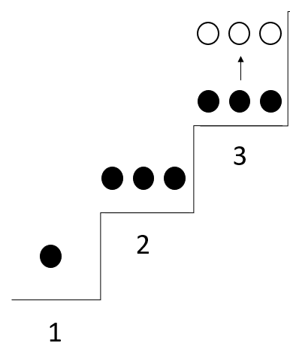  Figure 1. Scaffolding of the activity: 1 student (dot) reading, 2 group discussion, 3 oral presentation (arrow) to the other group (open circles). | 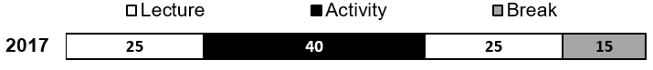  Figure 2. Teaching scheme 2017, 2016 and 2015 for course days 2, 3 and 5: Sequence and average duration (minutes) of frontal lecture, implemented students' activity and break.

3. Analysis of student satisfaction
Students' perception and satisfaction of the approach to teaching and the course in general were examined using a questionnaire described below. Course participants of each of the three consecutive autumn semesters (2015, 2016 and 2017) participated. The course took place every second week in autumn semester 2015 and 2017 and every week in the second half of autumn semester 2016. However, in all three consecutive years the evaluation took place at the end of the term. The Educational Development and Technology department at ETH Zurich designed the questionnaires in 2015 and 2016; in 2017, the lecturer (myself) used five questions of ETH and three course-specific questions (Format: Table 3, Content: Table 4).

Table 3. Details on the evaluation of the course unit performed by the “Educational Development and Technology” department of ETH Zurich at the end of term
 | 2015 | 2016 | 2017
Type of evaluation | Standard evaluation of the course unit | Standard evaluation of the course unit | Special evaluation of the course unit (semester feedback)
Status of evaluation | Exceptional case | Regular | Exceptional case
Total number of questions | 19 | 20 (19 the same as in 2015) | 8 (5 were identical as in 2015 and 2016)
Number of course-specific questions | 0 | 0 | 3

The standard evaluation of the course units by ETH Zurich takes regularly place every second autumn semester, which was in 2016. In 2015, the lecturer (myself) applied exceptionally for the standard evaluation of the course unit at ETH because it was the first time that I was the sole lecturer of the course. In 2017, the “Educational Development and Technology” department of ETH Zurich could not perfrom the standard course evaluation upon request, but an evaluation in the format "semester feedback" was feasible. This type of evaluation is usually consisting of not more than eight course-specific questions, and it is performed at mid-term. The ETH Zurich agreed on an exception for the evaluation to be performed at the end of term to allow a ceteris paribus comparison in the frame of my teaching project. Thus, in 2017 I designed three questions by myself, and used five questions from the standard evaluation to allow a direct comparison between years. The total number of questions varied between years, with a maximal number of 20 questions, whereof only five to eight questions were analysed in the frame of this teaching project because of their relation to the implemented activity.
Students were asked to complete a max. 10-minute questionnaire about their opinions on the quality of the teaching. The questionnaire was answered electronically on an own device (mobile phone, laptop) by following a link sent via email by the Educational Development and Technology department of ETH Zurich. The objective was to collect information from a representative sample of students at the end of the semester. Students completed the questionnaires anonymously, without assistance and without being rewarded.

Questionnaire
The questions evaluated in this teaching project can be found along with the answers in the Result section (Table 4). Seven questions, including the course-specific questions, used the following 5-point response scale: not true (1), not really true (2), partly true (3), mostly true (4), and absolutely true (5). The overall satisfaction with the course unit was assessed by asking students whether they were not satisfied (1), not really satisfied (2), partly satisfied (3), mostly satisfied (4) and absolutely satisfied (5).
Altogether, there were two questions not answered in 2015 by the minimum number of three students required by ETH Zurich to allow evaluation.

Data analysis
All data were analysed descriptively using Excel (Microsoft). Results were given as average percentage of students' votes on each possible answer (5-point response scale) in each semester. Results of all three semesters are presented for each question.

Results
The statement A The lecturer motivated me to take an active part was answered with absolutely true by 0, 14 and 50% of the votes of the students in the years 2015, 2016 and 2017 (Table 4). The answer not true to this statement was given only in 2015 and 2016 (by one to two students), but not in 2017. The statement B The materials made available (e.g. lecture notes, textbook, handouts, etc.) helped me to understand and address the course content was answered with mostly true and absolutely true by 71, 86 and 100% of the votes in the years 2015, 2016 and 2017 (Table 4). In 2015, the feedback of less than three students on the statements C and D addressing the exercises was too few to make an evaluation. In 2016, already 80% of the participating students answered mostly true to the statement C The exercises helped me to understand and apply the lecture content. Finally in 2017, the answer absolutely true was given by almost 70% of the participating students to this statement C. Fifty percent of the students participating in the survey in 2016 answered only partly true to the statement D The exercises were supervised helpfully by the assistant/lecturer; whereas in 2017 all participating students answered mostly true (17%) and absolutely true (83%). In 2015 and 2016 the majority (40-60%) of the students taking part in the evaluation were only partly satisfied when asked How satisfied were you in general with the course unit (statement E). In contrast, in 2017 the overall satisfaction was higher with >80% of the participating students answering mostly satisfied to this statement E and one student answering even absolutely satisfied. The statements F, G and H on paper exercises were part of the evaluation in 2017 only. Both, the statement F The paper exercises helped me to train the extraction of specific scientific information within a short period of time and the statement G The paper exercises helped me to train (short) oral presentations of scientific research contents were answered with 50% of the votes of the students with absolutely true and with the other 50% of the votes with mosty true. For the majority (67%) of the participating students, the statement H The paper exercises helped me to get ideas for a topic of my final oral presentation or written report was only partly true.

Table 4. Questionnaire and students' answers.
Statements | Answers (% of students’ votes)
A, The lecturer motivated me to take an active part | 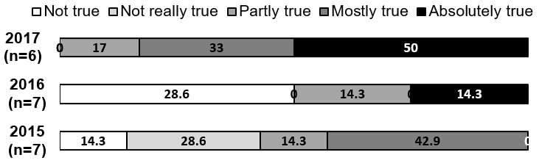
B, The materials made available (e.g. lecture notes, textbook, handouts, etc.) helped me to understand and address the course content | 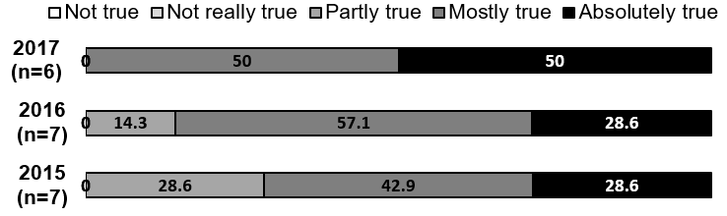
C, The exercises helped me to understand and apply the lecture content | 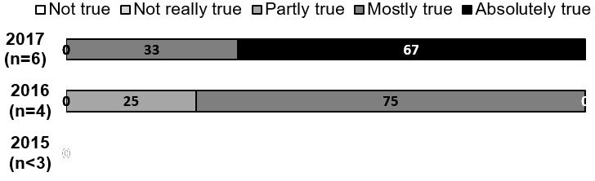
D, The exercises were supervised helpfully by the assistant/lecturer | 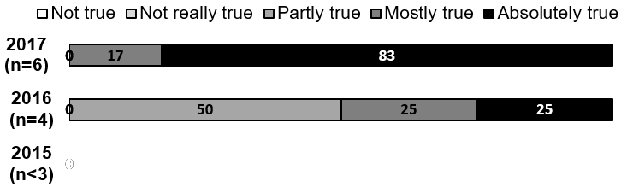
E, How satisfied were you in general with the course unit | 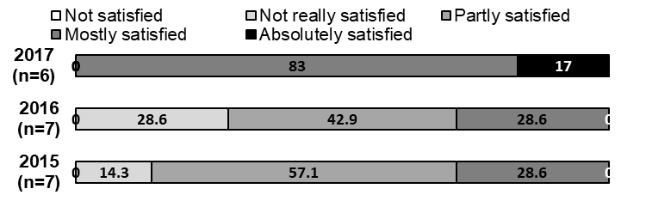
F, The paper exercises helped me to train the extraction of specific scientific information within a short period of time | 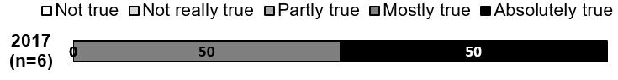
G, The paper exercises helped me to train (short) oral presentations of scientific research contents | 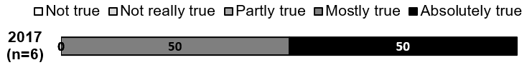
H, The paper exercises helped me to get ideas for a topic of my final oral presentation or written report | 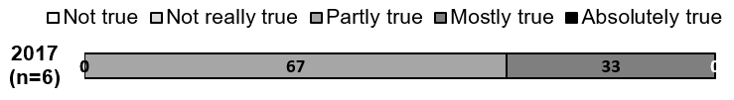
Note, the statements F, G and H were part of the survey only in one of the three years. Data are presented for n > 3 students.
4. Discussion and lessons learnt
In the following, the results of the student feedback are discussed in the context of didactical considerations as well as in retrospective view of my experiences as a lecturer.
In the revised course structure, I moved from a teacher-focused strategy to a student/teacher interaction as well as a student-focused strategy according to Trigwell et al. (1994; Table 1). I utilized active learning methods like group discussions and peer presentations with the intention that students stay motivated because they are involved in knowledge construction as they actively participate in learning. The paper exercises might be particularly suitable for smaller classes where the short oral presentations (peer-teaching) are held in front of only a few people rather than a large class. In 2016, the year where the paper exercises were implemented in the course, the overall satisfaction of the students was not better than in 2015 without this activity. From this it is concluded that the sheer introduction of students' activity does not necessarily lead to improved students' perception (and potentially their learning) compared to frontal lectures. Although the feedback on single statements of the evaluation was more positive in 2016 than 2015, I was unsatisfied about the outcome of the paper exercise. The guidance on the relevant information to be taken from the papers and presented during the short oral presentation was obviously too weak to allow the presenting group and the audience to understand the content and meaning. Therefore, in 2017 I extended the paper exercise in time as well as conceptually by providing questions to be answered during the reading. Thus, the student-focused approach to teaching was extended, where students develop rather than acquire concepts (Trigwell et al. 1994; Table 1). This was intended to help the students to extract the relevant information and enable them to present it to the other group based on their own answers to these questions. As a result, the students were much more satisfied in 2017 than in the previous years, as was I. Comparing the years 2016 and 2017 (first vs. second time activity), the greater replacement of frontal lectures with a more structured, student-focused activity improved the students perception and satisfaction of this approach to teaching, of the supervision of the exercises and of the course in general. It can only be speculated that the extended activity has advanced student learning, because this teaching project did not compare the (improvement in) student grades among the autumn semesters.

Ideally, teachers provide students with opportunities to learn in ways they most likely benefit from. One option is to individualize the learning experience of the students, which can promote the personal and professional development. In my teaching project, the students' learning was individualized by letting the students choose their preferred topic for reading and group discussion and by letting the students organize their role during the short oral presentation by themselves (who starts, which content/questions are presented by whom). Some students stated that the paper exercises were a good opportunity to practice the reading, understanding and presenting of scientific content in English and that the more we practiced it, the easier it got. Interestingly, at the end of the course some of the students for which the oral presentation was more challenging, voluntarily chose the graded oral presentation instead of a written report. Thus, the paper exercises were evidently an effective teaching strategy because they successfully encouraged students to engage in active learning.

One challenge with the paper exercises was that some students were more familiar with the reading of scientific literature in English than others and that the oral presentation in English was more challenging for some students than for others. In that case, one group started earlier with the group discussion than the other group. An option to deal with this issue could be that some students start group discussion before having answered all questions.
During the paper exercises students were faced with science as a process. With the task of summarizing and explaining a result or relationship in an article, some students became frustrated that there was not always a clear result or explanation. As in life, answers in the life sciences can be unavailable, contradictory or different depending on the circumstances. Thus, students questioned and developed their conceptions of the discipline. In future courses, the student-focused approach to teaching could additionally aim at students changing their conceptions (Trigwell et al. 1994; Table 1).

In future courses, it is recommended to reduce the number of questions to be answered during the first paper exercise, because it was more time consuming than expected. The second and third time, the students knew the concept and found their way around faster. When implementing paper exercises, it needs to be considered that every couple of years the activity needs to be completely updated with articles that are more recent. One opportunity for changing the activity in future courses would be to do the reading and answering of questions at home and start the in-class activity with the group discussion, which could then be extended together with the discussion after the oral presentation. However, this could not be implemented in the current course setting, because the one credit point course was designed to use the off-hours for the preparation of the (graded) written report or the oral presentation at the final course day.

What helped student satisfaction reveal about student learning for me? Student satisfaction and most likely student learning was improved in my course, by encouraging the students to accept responsibility for their own learning, i.e. what the students do determines what the students learn. In my experience, the implemented and further developed student activity was finally a win-win situation in that it also improved the satisfaction of the lecturer (myself). In addition to my increased experience with the implemented activity, I appreciated the personal and professional rewards of promoting students' perception and potentially learning. In the future, my teaching will include structured active learning methods continuous improvements based on student feedback. In conclusion, for learning and teaching in higher education and at ETH, a student-focused approach to teaching is highly recommended. This will enable students to develop and change their conceptions of the discipline.

Bibliography
Kauffman RG, Thompson JF, Anderson DB, Smith RE (1971) Improving the effectiveness of teaching animal science. Journal of Animal Science 32:161-164

Newcomb LH, McCracken JD, Warmbrod JR, Whittington MS (2004) Methods of teaching agriculture. Pearson Prentice Hall, Upper Saddle River, New Jersey, USA

Perry GA, Smith MF (2004) A simulation exercise to teach principles of bovine reproductive management. Journal of Animal Science 82: 1543-1549

Tanner K, Allen D (2004) Approaches to biology teaching and learning: From assays to assessments – on collecting evidence in science teaching. Cell Biology Education 3: 69-74

Trigwell K, Prosser M, Taylor P (1994) Qualitative differences in approaches to teaching first year university science. Higher Education 27: 75-84

Acknowledgements
I am grateful to Dr. Pia Scherrer, the programme coordinator at the Educational Development and Technology department, ETH Zurich, for her enthusiasm and valuable advice on my teaching and drafts of the manuscript. Many thanks also to Dr. Clarissa Schwab, Dr. Melissa Terranova and Prof. Michael Kreuzer for their valuable comments on the manuscript. Finally, I would like to thank the students attending the course Ruminal Digestion in the autumn semesters 2017, 2016 and 2015 for participating in the evaluation and in the teaching project. Special thanks to the students of the autumn semester 2017, Lucia Bernasconi, Martina Feierabend, Cédric Furrer, Paul Leparmarai, Flavian Tschurr and Andres Weber, for their engagement in the extended activity.

Appendix 1: Example of selected tables or figures of a peer-reviewed journal article presented as slides during the students' activity in 2016 and 2017
For the implemented activity, the students (max. 10) could choose between two peer-reviewed publications and were then split in two groups. The students' activity consisted of individual reading of selected sections of the article (e.g. Abstract, Table 1 and Figure 2 and related text), brief discussion within the group, and oral presention to the other group. During the oral presentation, the selected tables or figures of the article were presented as slides.
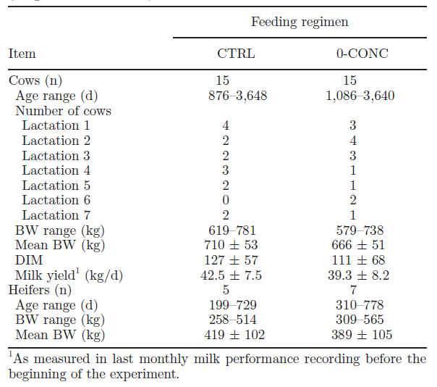
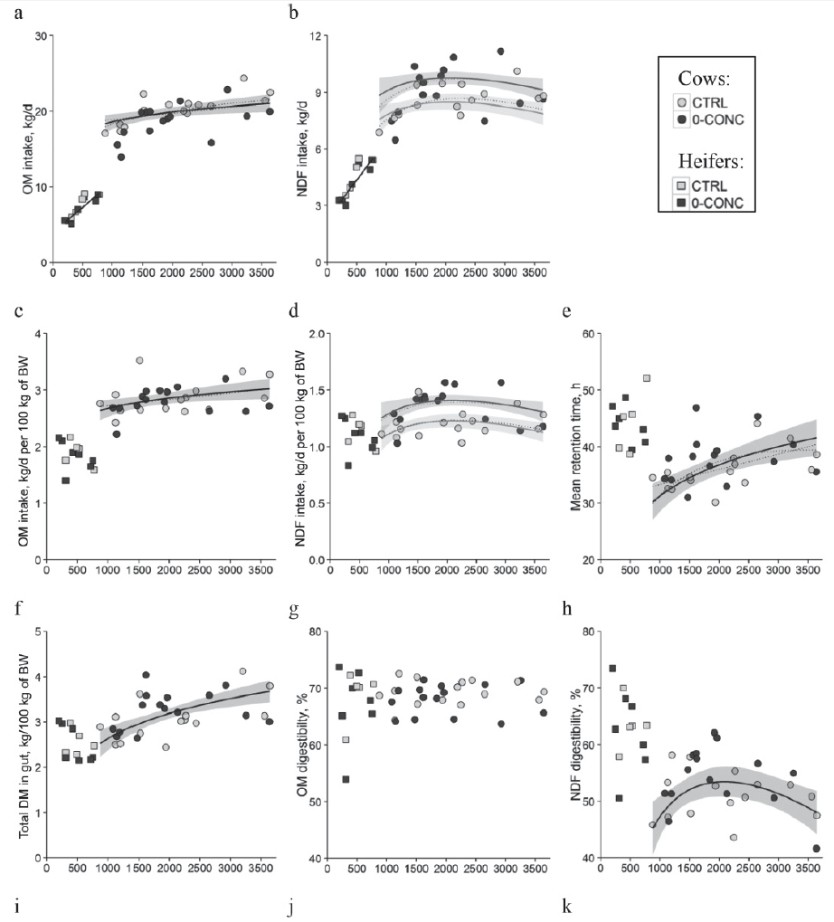
Source: Grandl et al. (2016), J Dairy Sci, 99, 3457-3471
Appendix 2: Example of handout with leading questions (implemented in 2017) along with a peer-reviewed journal article for the students' activity

The activity in 2017 was 40 minutes long instead of 20 minutes as in 2016 and differed also by using a handout with questions to be answered in order to structure the activity.

Paper exercise – Carbohydrate degradation
Source: Grandl F, Luzi SP, Furger M, Zeitz JO, Leiber F, Ortmann S, Clauss M, Kreuzer M, Schwarm A (2016) Biological implications of longevity in dairy cows: 1. Changes in feed intake, feeding behavior and digestion with age, J Dairy Sci, 99, 3457-3471
Abstract
Table 1 and related method text: Description of experimental animals
Figure 2 and related result text: Nutrient intake and digestibility characteristics

- Explain the overall aim of the study / Why did the authors study animals from 0.5 to 10 years of age and from two feeding regimes?

- Table 1:
-explain the meaning of «CTRL» and «0-CONC», what was the difference in diet between the groups?
-mention number of animals, age range and mean body weight (BW) of cows and heifers
-mention average days in milk (DIM) and milk yield of each group

- Explain format of Figure 2a-h:
-what is depicted on the x-axis and y-axis?
-explain the meaning of symbol shape (circle/square) and color (grey/black)
-explain the meaning of the presence or absence of one or two lines/shadings (note:
separate lines for heifers and cows)

Explain content of Figure 2a-h:
-mention if organic matter (OM) and neutral detergent fiber (NDF) increase with age and
if they differ between groups (CTRL and 0-CONC)
-mention if OM and NDF digestibility increase with age and if they differ between groups
-mention if mean retention time increase with age. How long is feed retained in the
gastrointestinal tract of heifers and cows?
-how do authors explain that NDF digestibility decreases although digesta retention time
increases? (see discussion page 3468)

- Please ask the audience if they have questions.

