|  |
| --- |
| NIBIO RAPPORT | VOL. 3 | NR. 101 | 2017 |

|  |
| --- |
| Environmental monitoring of the archaeo-logical deposits at Øvregaten 19, Bergen Concluding report 2013-2017 |

|  |
| --- |
| TITTEL/TITLE |
| Environmental monitoring of the archaeological deposits at Øvregaten 19, Bergen  Concluding report 2013-2017 |
| FORFATTER(E)/AUTHOR(S) |
| Ove Bergersen, Thor Endre Nytrøen & Øistein Johansen |

|  |  |  |  |  |  |
| --- | --- | --- | --- | --- | --- |
| Dato/Date: | Rapport nr./ Report No.: | Tilgjengelighet/Availability: | | Prosjektnr./Project No.: | Saksnr./Archive No.: |
| 01.09.2017 | 3/101/2017 | Åpen | | 8462 | 17/02480 |
| ISBN: | | | ISSN: | Antall sider/ No. of pages: | Antall vedlegg/ No. of appendices: |
| 978-82-17- 01914-2 | | | 2464-1162 | 18 | 2 |

|  |  |
| --- | --- |
| Oppdragsgiver/Employer:  Riksantikvaren Distriktskontor Vest | Kontaktperson/Contact person:  Rory Dunlop  Norsk institutt for kulturminneforskning (NIKU), Distriktskontor Bergen |

|  |  |
| --- | --- |
| Stikkord/Keywords: | Fagområde/Field of work: |
| Redox conditions, preservation, organic remains, degradation, soil moisture & temperature | Environmental Monitoring, Archaeology - Soil chemistry |
|  |  |

|  |
| --- |
| Sammendrag/Summary:  This concluding report contains all the monitoring data collected in the course of five years, from Jan. 2013 to Aug. 2017 from the protected archaeological deposits at Øvregaten 19, Bergen. The deposits had high contents of organic material and high water content before monitoring started. Data showed minimum temperatures close to 0-2°C under winter conditions and maximum temperatures at 14°C during the first year of monitoring 2013. In 2014 the minimum temperature increased to 6-7°C and the maximum temperature increased to 17-18°C. Data recorded in 2015 showed minimum temperature 7-9°C and maximum temperature at 16-19°C. The average and median values calculated in the last two years 2016 & 2017 were increased to 22°C in the upper part of the pit and stable at 14°C in the deeper layers. This high temperature in the upper part of the pit, which is higher than mean ambient air temperature, may be due to the new house and the flagstones placed over and close to the pit where the monitoring equipment was installed.High soil moisture was found in all layers, and fluctuated with precipitation. This increased more frequently in 2014 and 2015 under periods with high precipitation. This high precipitation frequency and the infiltration of roof water has decreased the redox potential to more anoxic conditions, which is positive for the preservation of the archaeological remains.  The previous status report II, written in 2015, states that the redox sensors in layers 2 and 3 were malfunctioning, based on great curve drop in 2014. During the rest of the monitoring period, the redox sensors all show more stable conditions of anoxic and negative values from -400, up to -60mV in layers 2 and 3, and positive values less than +200 mV, which represent low content of oxygen at 1-4 mgL-1 in water. Despite the high water content and the anoxic conditions in the pit, the increased soil temperature could still significantly accelerate degradation of organic material in the area around the monitoring pit irrespective of whether oxygen is present or not. |
|  |

|  |  |
| --- | --- |
| Land/Country: | Norway |
| Fylke/County: | Hordaland |
| Kommune/Municipality: | Bergen |
| Sted/Lokalitet: | Øvregaten 19 |

|  |  |  |  |  |  |
| --- | --- | --- | --- | --- | --- |
| |  | | --- | | GODKJENT /APPROVED | | Navn/name | | |  | | --- | | PROSJEKTLEDER /PROJECT LEADER | | Navn/name | |

Contents

1 Introduction 5

1.1 Background 5

1.2 Fault report 5

2 Methods and equipment 7

2.1 Initial preservation conditions at the monitoring site 7

2.2 Equipment used for monitoring in unsaturated deposits 8

3 Results and discussion 10

4 Conclusion 17

References 18

Appendix 19

# Introduction

## Background

NIBIO has been commissioned by the Directorate for Cultural Heritage, through NIKU distriktskontor Bergen, to conduct monitoring of protected archaeological deposits at Øvregaten 19, Bergen. NIKU’s project leader is archaeologist Rory Dunlop.

After analysing the preservation condition of soil samples from the site in 2012 (Bergersen, 2013), the monitoring equipment was installed in Jan. 2013, and monitoring has been conducted for five years. The main goal is to find out what happens when organic archaeological layers are exposed to infiltrated surface water in the ground close to a new building.

One of the most important issues is to protect the deposits from decay by keeping them as wet as possible. This can be done by infiltrating rainwater from neighbouring roofs into the ground. The principal objectives are to keep the deposits’ water content high and stable so that the redox potential will remain as low as possible, and to ensure that these soil conditions will prevail for a long time. The monitoring data has shown how well these goals have been achieved.

NIBIO’s task is to evaluate the preservation conditions and their stability in the various archaeological deposits at Øvregaten 19 (Bergersen, 2013). More information on the site and data from the first year of monitoring are presented in Bergersen, O. (2014a, 2015 & 2016).

This concluding report provides a summary of the situation after five years of monitoring, and it is also interesting to compare data from 2013, when the new building was constructed, with data from 2014 to 2017, after its completion.

## Fault report

After one year of monitoring at the site, sensor 4 measuring soil temperature and moisture in the top layer (layer 1) started to show signs of instability and finally broke down. In the status report II (Bergersen, 2015), we assumed that the redox sensors 2 and 3 were providing unreliable data. In 2015 we observed that the redox sensors in layers 2, 3 and 4 showed low redox-potential values. We trust the data since it corresponds with the heavy precipitation period between 2014 and 2015. These redox sensors’ data continued stable at the same level in 2016 and 2017 and the site has high values of soil moisture in the final period. Sensor 1 measuring soil temperature and moisture in the bottom layer (layer 4 at 1.88 masl) started to show instability and finally broke down in Aug. 2016, and the last sensor to break down was the moisture sensor in layer 3, in Feb. 2017.

Table 1 gives an overview of the sensors and their status in the period Jan. 2013 to Aug. 2017. The logger battery was recharged in late June 2015 (see appendix 2).

Table 1. Overview of functioning status of the sensors in the profile at Øvregaten 19 in the whole monitoring period 2013 -2017.



# Methods and equipment

## Initial preservation conditions at the monitoring site

Evaluations of the degree of preservation prior to monitoring for each specific soil sample at the site where the sensors were installed are listed and presented in Appendix 1 (Bergersen, 2013). The monitoring site – a soil profile on the southwestern side of a small test-pit (Figure 1) – was 40 cm deep and 40 cm in diameter. Sensors 1 & 2 were installed 30-25 cm below the surface while sensors 3 and 4 were installed approximately 15-10 cm below the surface, which lays at an elevation of ca. 12.35 masl.

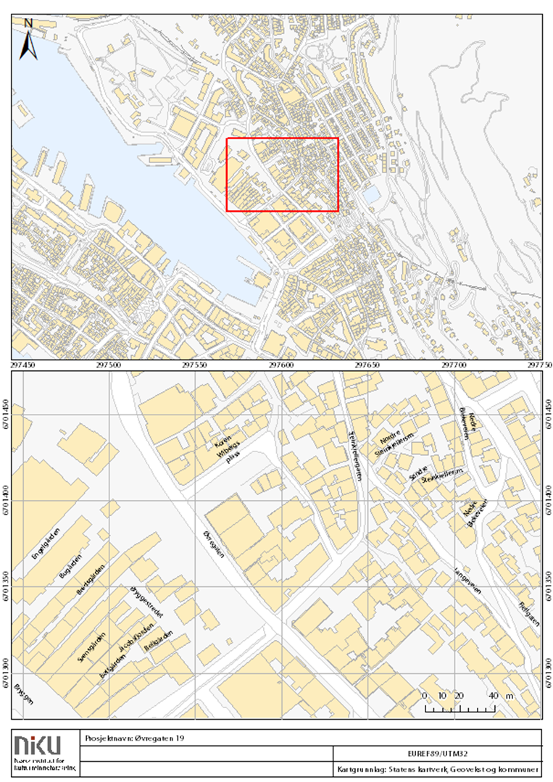

Figure 1. The red dot marks the approximate position of the monitoring site.

The values in Appendix 1 follow the ranking system from 1 to 5: 1 (lousy), 2 (poor), 3 (medium), 4 (good), 5 (excellent) (in accordance with Riksantikvaren & NIKU 2008; Standard Norge 2009). In the chemical analysis, the concentration levels and relationship between reduced and oxidized state, indicate a preservation status from the scale of 1 to 5.

## Equipment used for monitoring in unsaturated deposits

The sensors that have been installed are TRIME-PICO 32 from IMKO Modultechnik Gmbh. These sensors can be installed in a heterogeneous and sandy stone-rich type of soil that is often found at archaeological sites. The sensors have universal calibration for mineral soils as standard. All sensors were connected to an automatic standard logger from SEBA Hydrometrie GmbH (<http://www.seba-hydrometrie.de/en/applications.html>). The data is made accessible on a website via mobile modem technology. The logger and battery were placed in a waterproof cabinet close to the site (Figure 2).

The four sensors for monitoring soil temperature and moisture were placed in different layers as illustrated in Figure 3. In addition, three sensors for monitoring redox potential (Hanna instrument no. HI2930B/5) were installed in three layers with high moisture content. All redox potential values are recalculated with + 171mV (inf. from contractor).

Sensors for soil temperature, moisture and redox potential were installed in the profile in January 2013, connected and activated to the logger and battery placed in a waterproof cabinet with the very excellent help of Thor Endre Nytrøen from NIBIO.

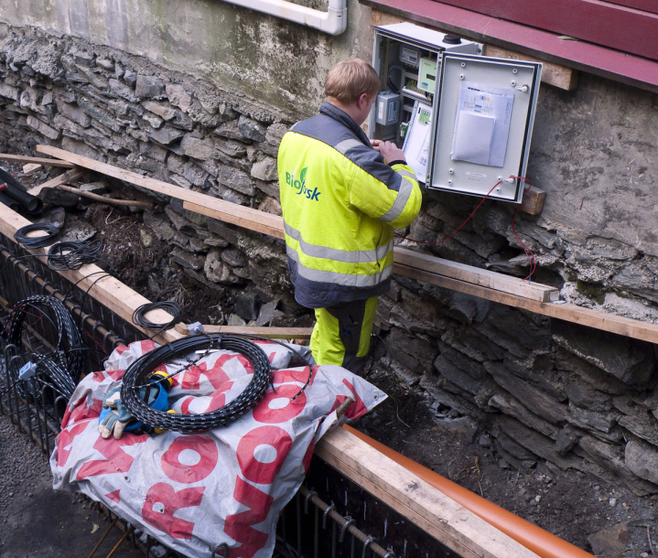

Figure 2. A waterproof cabinet for the automatic logger from SEBA Hydrometrie GmbH was installed on the wall close to the site.

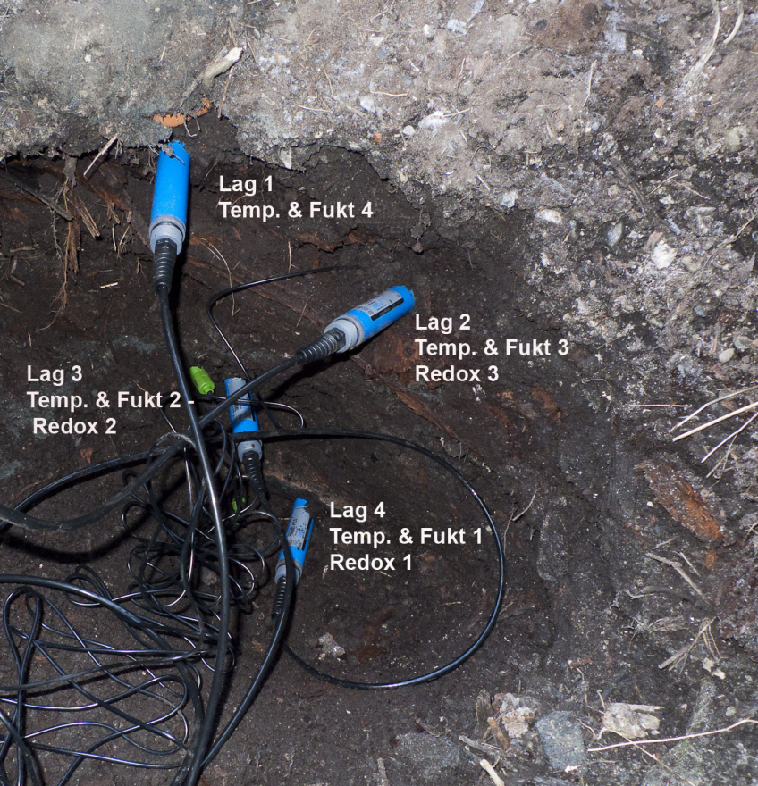

Figure 3. Profile where monitoring sensors were installed in four layers. Blue sensors measure temperature and moisture, and the green sensor measures redox.

* Layer 1 between 12,30 and 12,35 masl. Relatively porous humus/woodchips (Sensor 4)
* Layer 2 between 12,20 and 12,25 masl. Compact humus/woodchips (Sensors 3)
* Layer 3 between 11,95 and 12,00 masl. Relatively porous humus/woodchips (Sensors 2)
* Layer 4 between 11,75 and 11,80 masl. Compact humus/woodchips (Sensors 1)

Quite decayed timber was found under a dark fire stratum between layers 4 and 3 (sensors 1 and 2). A timber stratum, probably a floor, was observed under layers 1 and 2 close to redox, temperature and moisture sensor no. 3 and close to temperature and moisture sensor no. 4 (data from Utne, 2011).

Climate data (mean daily air temperature and precipitation) has been obtained from the Florida meteorological station, Bergen, at [*www.yr.no*](http://www.yr.no)

# Results and discussion

This report contains all the data collected in the course of five years, from Jan. 2013 to Aug. 2017. The measured values from the different sensors at the excavation site are presented in figures 4, 5 and 6 and table 2, 3 and 4. Tables 2, 3 and 4 compare min., max., median and average data measured from each year 2013 to 2017. In these tables we have also calculated the median* value for the data series from all sensors.

*\* Median value: In statistics, median is defined as the value of the number that divides a selection into two parts, so that each part has an equal amount of elements. The advantage of using the median value instead of a mean or average value is that the median is stable in the event of extreme observations (which can arise due to e.g. measurement errors).*

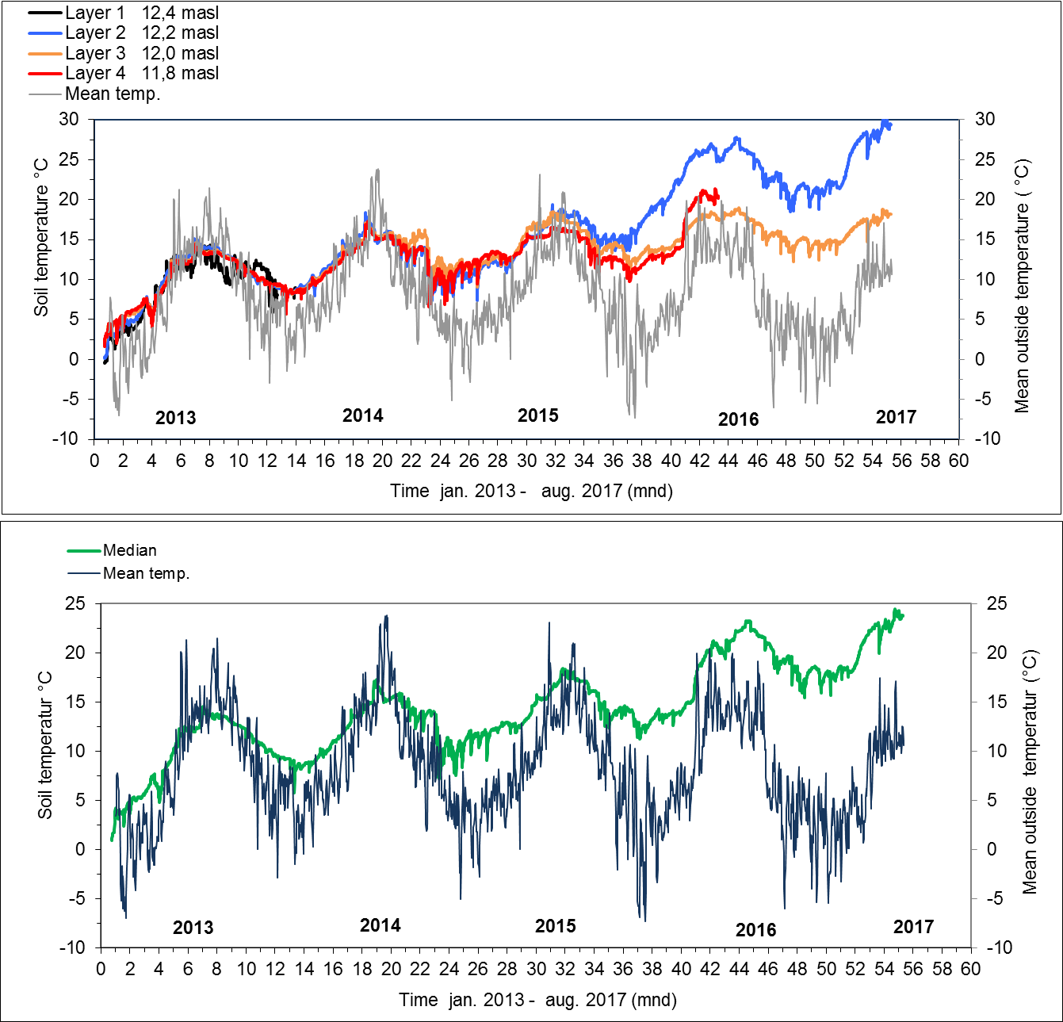

Figure 4. The five years (2013 to 2017) of monitoring data for soil temperature and estimated median of all temperature sensors at Øvregaten 19 compared with middle temperature per day in centre of Bergen ([www.yr.no](http://www.yr.no)).

The average and median temperature in the profile was estimated to about 10°C in 2013, but increased to 12-13°C in 2014 and around 14°C in 2015 (Table 2). An extra increased temperature was observed in upper layer 2 from the beginning of 2016 and the rest of monitoring period in 2017 (Figure 4).

The average and median temperature was found to be at 22°C with a maximum temperature at 27°C. The maximum temperature is higher than the mean ambient air temperature in summer 2016, so something has to be interfering with the normal soil temperature. In layers 3 and 4 increased average and median temperature was measured up to 15°C (Table 2). This temperature increase is difficult to explain, but it seems to be connected to the new house built close to the monitoring site, since the mean ambient air temperature and weather report in Bergen has been colder during the last two years of monitoring (Figure 4). Figure 4 presents the soil temperature in the different layers and the median curve illustrates increased temperature in the last three years from 2015 to 2017.

Table 2. Minimum, maximum, median and average values for soil temperature measured in all years.



Increased average temperatures from 9, 14 and up to 22°C in the soil profile in the pit will possibly accelerate the degradation of organic material. Research on decay of organic matter from anoxic soil samples in Trondheim (Petersén & Bergersen, 2015) and soil samples from Bryggen in Bergen carried out at the National Museum in Denmark (Hollesen & Matthiesen, 2011) shows that a rise in temperature from 10 to 15°C will increase the degradation rate of organic matter considerably, and particularly so when oxygen is present.

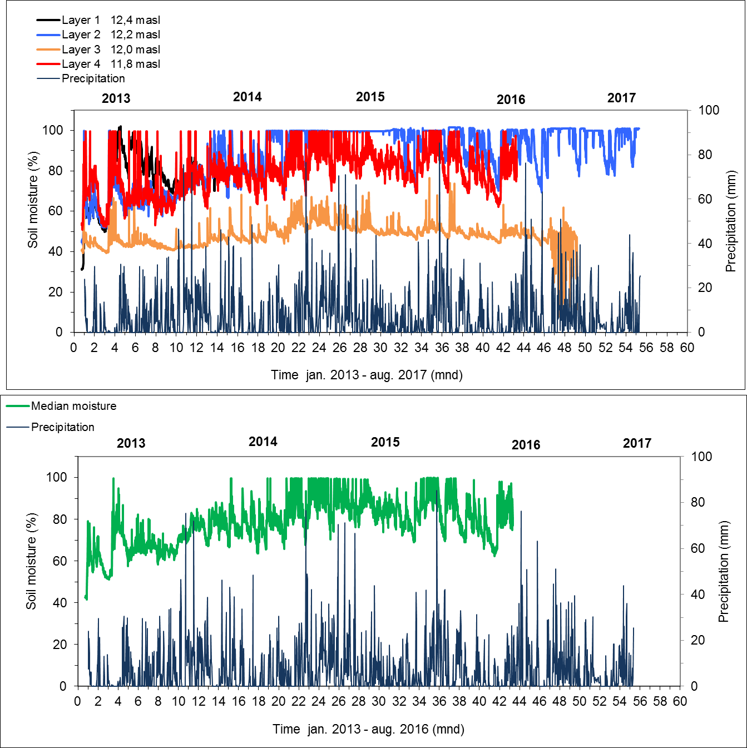

Figure 5. The five years (2013 to 2017) of monitoring data for soil moisture and estimated median of all soil moisture sensors at Øvregaten 19 compared with average precipitation per day in centre of Bergen ([*www.yr.no*](http://www.yr.no)).

The soil moisture is high in layer 1, 2 & 4 (80-99 %), compared to layer 3 where moisture content was measured about 50 % (Table 3 & Figure 5). The median value was found to be similar to that of the average water content. Precipitation and collection of roof water into the pit has had a considerable effect on the soil moisture content and during 2015 and 2017, with more frequent precipitation, the calculated median moisture level at the site increased, and fluctuation can still be observed (Figure 5). From the end of 2016 and up to Feb. 2017, before sensor 3 stopped working, moisture content was found fluctuating up and down even more frequent precipitation was observed in this period. Why this happened is difficult to explain. The sensor in layer 2 had an average moisture content of 93% in 2016 and 95% in 2017. In layer 4, the moisture content was measured at 80% in 2016 before the sensor broke down.

This more frequent precipitation influenced the redox conditions in the monitoring site from 2014 and 2015. The latter continue in 2016 and 2017. This observation also shows that the infiltration of roof water into the site has improved the preservation conditions during the last years of monitoring – with decreased redox potential and more anoxic soil.

Table 3. Minimum, maximum, median and average values for soil moisture measured all years.



The first status reports have presented redox values that are too low (Bergersen, 2014a & 2015). In this report we have recalculated all redox potential values in the soil profile.

The lowest redox potential was measured in layers 2 & 3. The redox potential was also negative the first year 2013 in the deepest area (layer 4), as shown in table 4 and figure 6. From 2013 and to 2014 we measured data with variation in redox over a very small vertical distance in the pit of 40 cm (Bergersen, 2015). We thought that the redox sensor was malfunction because of the great curve drop in 2014 for sensors in layer 2 and 3 (Figure 6). Table 4 show average redox values from 2013 to 2017 range from +750 down to -368 mV layer 2. For layer 3 it range from +591 to -63 mV. For layer 4 it start low at -2 mV and range to +181mV. In 2015 and to 2017, the redox sensors all show more stable conditions of average/median values at (-399, to -368 mV, layer 2) (-268, to -63 mV, layer 3) and (+155, to +181 mV, layer 4). All calculations are illustrated in table 4. It is difficult to explain this difference since the sensors are quite close to each other. Values lesser than +150 to +200mV has shown low content of oxygen at 1-4 mgL-1 in ground water wells (Bergersen, 2014b).

After the last three years of monitoring from April 2014 to April 2016, it can be observed that conditions in the upper part of the digging depression have an increasingly positive impact on the organic cultural layer. The moisture level has increased to approximately 99% and 86% in layers 2 and 4 and 50 % in layer 3 after infiltration of high frequent precipitation (Figur 5 & 6). In the end of monitoring 2016/2017 the moisture is still stable high. The water content in the profile was relatively low compared with the present situation (2017) and varied between 50% and 75% (Appendix 1).

All layer of the pit has medium to high contens of organic material which can absorb and store water. This will help to maintain low redox and anoxic conditions in the pit in the future. Even layer 3, which has lesser organic matter and moisture contents, shows anoxic conditions in 2017 (Table 4 & Figure 6). Hopefully, stable anoxic conditions will continue. We are more concerned about the high average temperature that has increased in the pit since 2014; this represents a definite threat to at least the upper deposits.

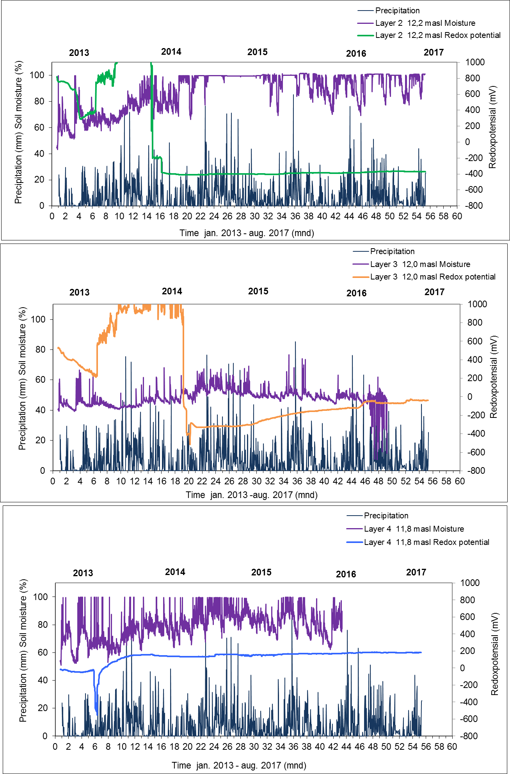

Figure 6. The five years (2013 to 2017) of monitoring soil moisture compared to redox potential at 12.2 masl, 12.0 masl and 11.8 masl at Øvregaten 19 compared with average precipitation per day in centre of Bergen ([*www.yr.no*](http://www.yr.no)).

Table 4. Minimum, maximum, median and average values for soil redox potential measured in all years.



# Conclusion

Data collected from Jan. 2013 to Aug. 2017 at Øvregaten 19, Bergen, and show that the soil temperature followed the mean air temperatures in 2013 before the new house was finished. The average and median values calculated in 2013 were about 11°C, 13°C in 2014, and 14°C in 2015. In the last two years of monitoring, the calculated average and median temperatures also increased by 4-5°C in the monitoring pit, even though the middle air temperature looks to have remained unchanged. In 2016 & 2017 the temperature was calculated as having increased to up to 22 °C in the upper part of the pit, which is higher than the mean ambient air temperature. The presence of the new building with a heated crawl-space, (see appendix 2) are possible explanations for this measured rise in the sub-surface temperature. Temperature fluctuation increased more frequently in 2014 and 2015 under periods with high precipitation.

High precipitation frequency the last years, coupled with the infiltration of roof water, has decreased the redox potential to more stable, reducing, anoxic conditions in the upper part of the pit as well, which is a positive result for the continued preservation of the archaeological remains in the immediate area.

However, despite the high water content and anoxic conditions in the pit, the increased soil temperature could still accelerate degradation of organic material in the pit significantly, regardless of whether oxygen is present or not.

# References

Bergersen, O. 2013. Geochemical analysis of samples after drilling to explain the preservation condition archaeological deposits at Øvregaten 19, Bergen. Bioforsk Report, Vol 8 (53) 2013.

Bergersen, O. 2014a. Environmental monitoring of the archaeological deposit at Øvregaten 19, Bergen. Status report I 2014. Bioforsk Report, 9 (42) 2014.

Bergersen, O. 2014b. Ett års miljøovervåking av grunnvann omkring kulturminner i området Anders Madsens gate i Tønsberg. Status rapport 2013-2014. Bioforsk Rapport, 9 (104) 2014.

Bergersen, O. 2015. Environmental monitoring of the archaeological deposit at Øvregaten 19, Bergen. Status report II 2015. Bioforsk Report, 10 (35) 2015.

Bergersen, O. 2016. Environmental monitoring of the archaeological deposit at Øvregaten 19, Bergen. Status report III 2015. NIBIO Report, Vol 2 (84) ISBN – nr 2016 978-82-17-01663-2.

Hollesen, J. & Matthiesen, H. 2011.The effect of temperature on the decomposition of urban layers at Bryggen in Bergen. Nationalmuseet in Denmark. Report n0. 11031048. 2011.

Petersen, A. H. & Bergersen, O. 2015. In situ preservation in the unsaturated zone: Results from environmental investigations at the “Schultz gate” case study in the medieval town of Trondheim, Norway. *Conservation and Management of Archaeological Sites* 2015. Vol. 18. Bioforsk & NIKU (in press).

Riksantikvaren & NIKU 2008. *The Monitoring Manual. Procedures and Guidelines for Monitoring, Recording, and Preservation Management of Urban Archaeological Deposits*.

Standard Norge 2009. Norwegian Standard 9451:2009. Cultural Property. Requirements for Environmental Monitoring and Investigation of Archaeological Deposits.

Utne, E. 2011. Øvregaten 19, Bergen: Arkeologisk etterundersøkelse, 2010. NIKU Oppdragsrapport 95/2011.

# Appendix

|  |  |
| --- | --- |
| No | Subject |
| 1 | Preservation conditions and chemical analysis of the soil samples from the monitoring site (2013) |
| 2 | Field report battery shift (2016) |

Appendix 1

Information about the preservation conditions in the soil where the monitoring is being conducted at Øvregaten 19 (Bergersen, 2013).

*Physical conditions in different soil sample at Øvregaten 19.*



*Chemical conditions in different soil sample Øvregaten 19. The abbreviation “DM” = dry matter*



*Chemical and physical conditions in different soil sample Øvregaten 19.*



*Comparing the archaeological preservation state with chemical preservation conditions for organic and inorganic materials and redox condition.*



Appendix 2

Technical report - sensor maintenance at Øvregaten 19, Bergen

Sensors and logger were checked in June 2015.

The logger battery was recharged in late June 2015.

The battery capacity for the monitoring equipment is still satisfactory and is expected to work well for the rest of the monitoring period.

Øistein Johansen

Senior instrumentation engineer

NIBIO instrumentation department, Ås

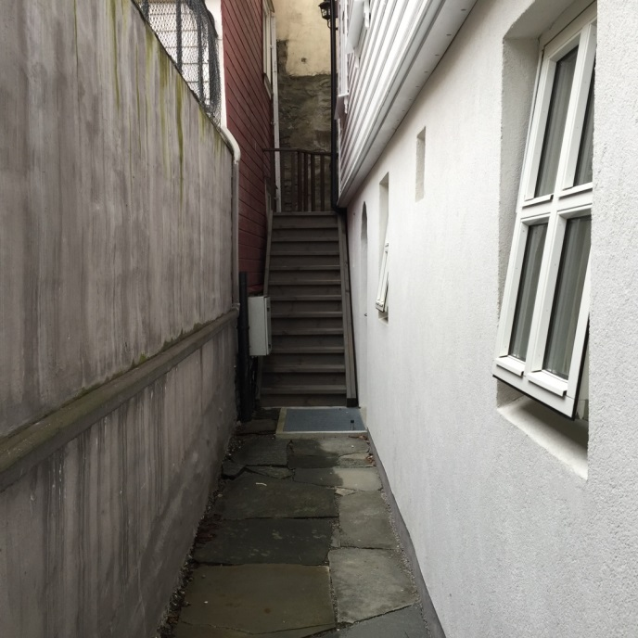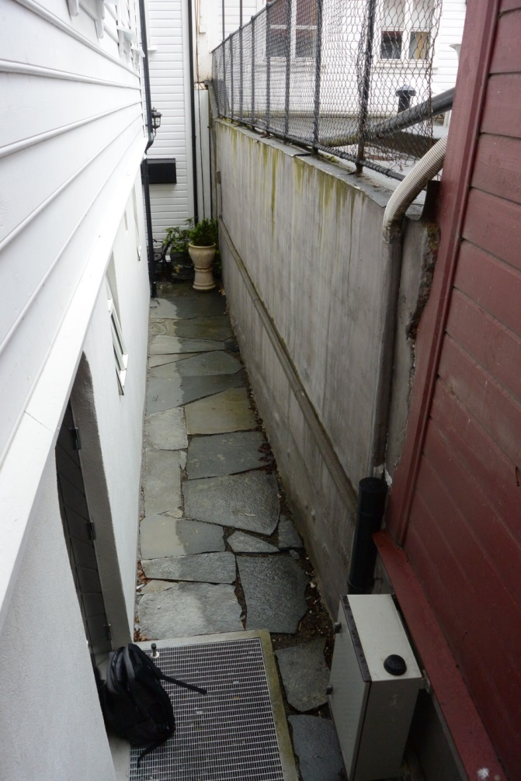

*Location of Cabinet with the logger at Øvregaten 19 (June 2016)*

Norsk institutt for bioøkonomi (NIBIO) ble opprettet 1. juli 2015 som en fusjon av Bioforsk, Norsk institutt for landbruksøkonomisk forskning (NILF) og Norsk institutt for skog og landskap.

Bioøkonomi baserer seg på utnyttelse og forvaltning av biologiske ressurser fra jord og hav, fremfor en fossil økonomi som er basert på kull, olje og gass. NIBIO skal være nasjonalt ledende for utvikling av kunnskap om bioøkonomi.

Gjennom forskning og kunnskapsproduksjon skal instituttet bidra til matsikkerhet, bærekraftig ressursforvaltning, innovasjon og verdiskaping innenfor verdikjedene for mat, skog og andre biobaserte næringer. Instituttet skal levere forskning, forvaltningsstøtte og kunnskap til anvendelse i nasjonal beredskap, forvaltning, næringsliv og samfunnet for øvrig.

NIBIO er eid av Landbruks- og matdepartementet som et forvaltningsorgan med særskilte fullmakter og eget styre. Hovedkontoret er på Ås. Instituttet har flere regionale enheter   
og et avdelingskontor i Oslo.

Forsidefoto: [Sett inn fotografens navn]